Game Time!
Check out the different coins on the table. In how many ways can you form 50 cents? The person who comes up with the most number of possible combinations wins!!

- A drawer contains 10 purple socks and 10 yellow socks, but it is dark and you can’t see which socks are purple and which socks are yellow. What is the smallest number of socks that you can take from the drawer to guarantee that two of the socks you took are the same color?

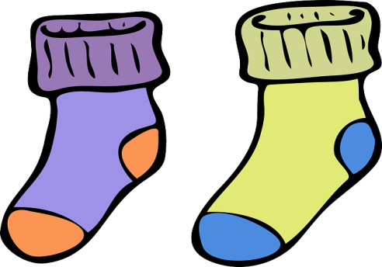

- There are three boxes on a table. One of them is labeled APPLES, one is labeled ORANGES, and one is labeled APPLES AND ORANGES. Unfortunately, each of the boxes is mislabeled. You can reach into each of the boxes, but you cannot see what is inside any of them. Is it possible to pick ONE piece of fruit from ONE of the boxes and then correctly relabel all of the boxes?

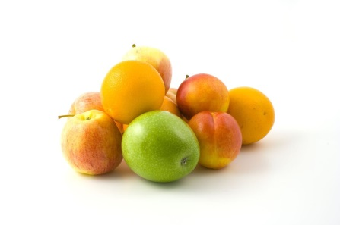

- A prince has a 5 × 8 foot flying carpet. While visiting the Kingdom of Samhop he was attacked by a fire breathing dragon. A strip of his carpet was burned away as seen in the figure below.

The magic carpet only flies well when it has rectangular shape, so he enlists the help of a princess. She cuts the carpet into 3 rectangular strips and sews them back together to form a 6 × 6 carpet. How did she cut the magic carpet?

