- There are 100 cats living in a barn, all are either brown or orange. There is at least one orange cat. For every two cats, at least one is brown. How many orange cats and how many brown cats are there?
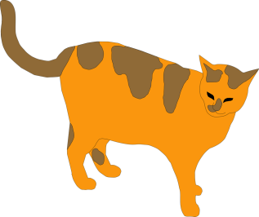

- You’rein a corridor in Hogwarts with 2 doors. Filch wants to give you a detention. Behind each door, your will find either Filch or your escape. BecauseHogwarts is a magical place, Filch could be behind multiple doors.
  - On the first door, there is a sign that says “Filch is behind this door, the other door is your escape” and the second door says “One of these doors is an escape, and the other leads to Filch”. Dumbledore says that one of the signs is true and the other is false. Can you escape?

Door 1 Door 2
One of these doors is an escape, and the other leads to Filch
Filch is behind this door, the other door is your escape

  - The next day at Hogwarts, you find yourself in the same situation. This time, the sign on one door says “At least one door is an escape”and the other says “Filch is behind the other door”. Dumbledore says that either both signs are true or both are false. Can you escape?
Filch is behind the other door
Door 1 Door 2
At least one door is an escape

  - So you picked a door… and managed to escape! However, you find yourself in another corridor with two more doors. This time, the first door says: “Either Filch is in this room or an escape is in the other room” and the other says “An escape is behind the other door” Dumbledore says that either both signs are true or both are false. Can you escape?

Door 1 Door 2
An escape is behind the other door
Either Filch is in this room or an escape is in the other room

- Fifty-six biscuits are to be fed to ten pets; each pet is either a cat or a dog. Each dog is to get six biscuits, and each cat is to get five. How many dogs and how many cats are there?

- 74 sheaves of corn are fed to 10 animals; each animal is either a unicorn or a deer. Each deer gets six sheaves and each unicorn gets 8. How many deer and unicorns are there?
