- You’re in a corridor in Hogwarts with 2 doors. Filch wants to give you a detention. Behind each door, your will find either Filch or your escape. Because Hogwarts is a magical place, Filch could be behind multiple doors. On the first door, there is a sign that says “Filch is behind this door” and the second door says “One door contains Filch and the other contains an escape”. Dumbledore says that either both signs are true or both are false. Can you escape?
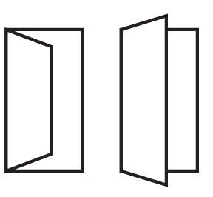
Door 1 Door 2

Challenge problem
- A certain pet shop sells large birds and small birds; each large bird fetches twice the price of a small one. A lady came in and purchased five large birds and three small ones. If, instead, she had bought three large birds and five small birds, she would have spent $20 less. What is the price of each bird?

