Finish 9.4 (Mixing, Air Resistance and Summary)

Mixing Problems:
“Rate of change equals rate IN minus rate OUT.”

Example 1:
A 12 Liter vat contains 7 kg of salt initially.
A pipe pumps in salt water (brine) at 3 L/min with a concentration of 2 kg/L of salt.
The mixture drains at 3 L/min.
The vat is well mixed.

Let $y(t)$ = “kg of salt in vat at time t”.
- Find $y(t).$
- Find the limit of $y(t)$ as $n→∞$.

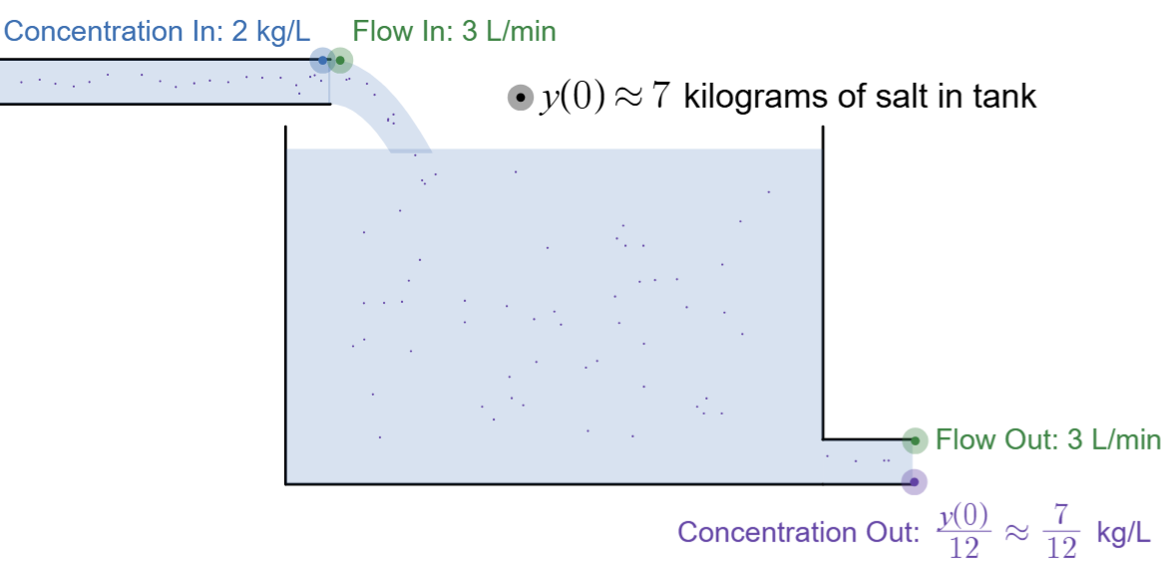
https://www.desmos.com/calculator/o7vcgrzg4t

Mixing Problem Summary
$$\frac{dy}{dt} = Rate In - Rate out$$
$=\left(? \frac{kg}{L}\right)\left(? \frac{L}{min}\right) -\left(\frac{y}{V} \frac{kg}{L}\right)\left(? \frac{L}{min}\right)$

$y\left(0\right)= ?$ kg

Example 2: How is this different?
A 50 Liter tank currently has 20 Liters of water with 24 kg of dissolved salt. A pipe pumps in pure water at 6 L/min. The mixture drains at 4 L/min.
Let $y(t)$ = “kg of salt in vat at time t”.

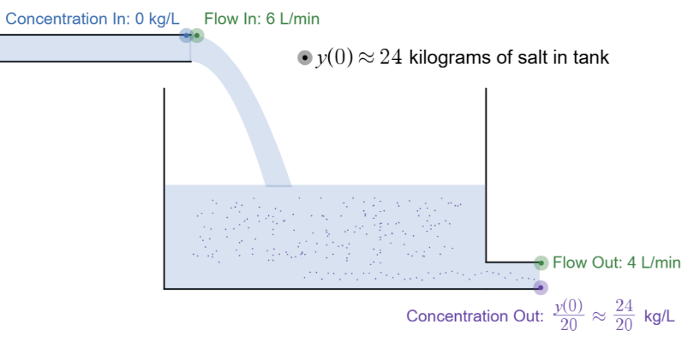

https://www.desmos.com/calculator/v5itrp8xt1

4. Air Resistance:
A skydiver steps out of a plane 4,000 meters high with and initial velocity of 0 m/s.
The skydiver has a mass of 60 kg.
(Treat downward as positive).

Newton’s 2nd Law says:
$$m\frac{d^{2}y}{dt^{2}}=sum of forces on the object$$

Forces
Gravity:
$F_{g}= mg= 60∙9.8=588$ N
Air resistance: (linear drag model)
$F_{d}= -k v$ N
Assume k = 12 is the drag constant

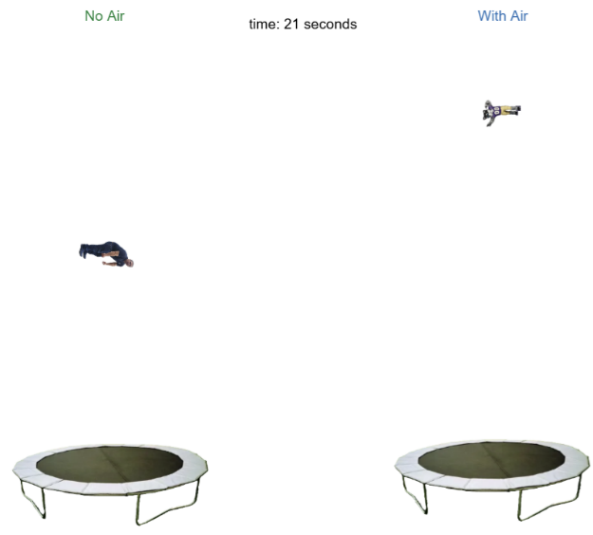

https://www.desmos.com/calculator/etfy3nebtb

Final Layout:
Pages 1, 2: Integrals
Page 8, 9: Diff. equations
Pages 3-7: Other concepts…

- Foundations
  - Riemann sums (idea/notation)
  - What an integral represents
  - FTOC (part 1)
- Acceleration/Velocity
  - “Tomato” problems
  - Net Change / Total Change
- Volumes of Revolution
- Simpson’s/Trapezoid Rules
- Improper Integrals
- Other Applications
  - Average Value
  - Arc Length
  - Center of Mass
  - Work

