Ch. 9: Be able to
- 1. Solve separable diff. eq.
- 2. Use initial conditions & constants.
- 3. Set up and do ALL the applied
problems from homework.

Worried about applied problems?
Pay attention today and Monday in lecture. Know the homework and worksheet well.

Newton’s Cooling Law Experiment
Hot water is in the cup. We will try to predict the temp. at the end of class.
1st measurement:

Time = Temp =

2nd measurement:

Time = Temp =

9.4 Differential Equations Applications

1. Law of Natural Growth/Decay:
Assumption: “The rate of growth/decay is proportional to the function value.”
$\frac{dP}{dt}=kP with P\left(0\right)=P_{0}$

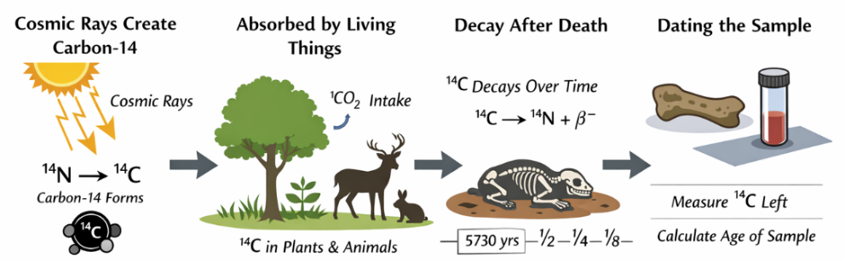

Example:
The half-life of cesium-137 is 30 years. Suppose we start with a 100-mg sample. Find the formula for the mass after t year.

2. Newton’s Law of Cooling:
Assumption: “The rate of temperature change is proportional to the difference between the temperature of the object and its surroundings.”

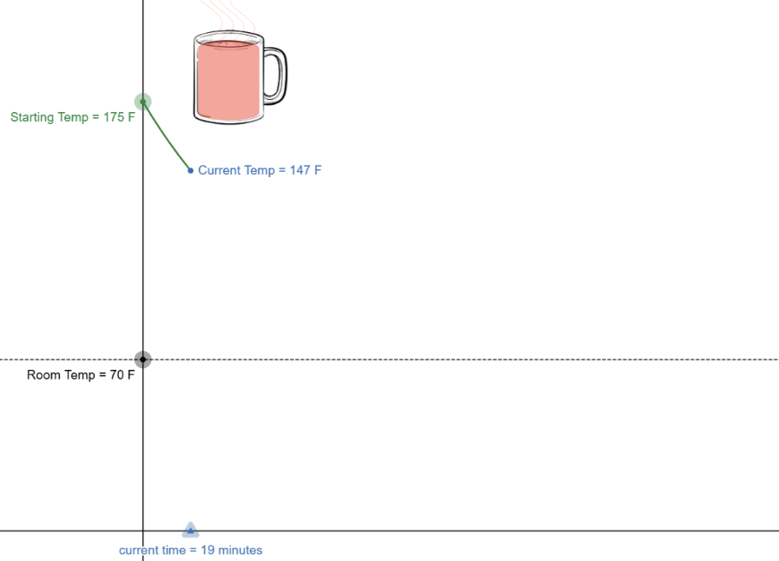

https://www.desmos.com/calculator/ed2xcdq2vg

3. Mixing Problems:
Assume a vat of water has a contaminant entering at some rate and exiting at some rate:

“The rate of change of the contaminant is equal to the rate at which the contaminant is coming IN minus the rate at which it is going OUT.”

Mixing Problem Summary
$$\frac{dy}{dt} = Rate In - Rate out$$
$=\left(? \frac{kg}{L}\right)\left(? \frac{L}{min}\right) -\left(\frac{y}{V} \frac{kg}{L}\right)\left(? \frac{L}{min}\right)$

$y\left(0\right)= ?$ kg

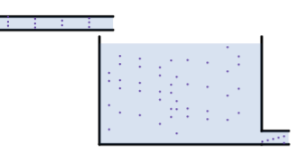

https://www.desmos.com/calculator/znoyrjtkjp

Example:
A 12 Liter vat contains 7 kg of salt initially.
A pipe pumps in pure water at 3 L/min.
The mixture drains at 3 L/min.
The vat is well mixed.

Let $y(t)$ = “kg of salt in vat at time t”.

Example:
A 12 Liter vat contains 7 kg of salt initially.
A pipe pumps in salt water (brine) at 3 L/min with a concentration of 2 kg/L of salt.
The mixture drains at 3 L/min.
The vat is well mixed.

Let $y(t)$ = “kg of salt in vat at time t”.
- Find $y(t).$
- Find the limit of $y(t)$ as $n→∞$.

More examples!
The following pages have a LOT more examples from old exams. Check them out (solutions on my handwritten notes page)

Example:
Assume a 100 Liter vat contains 5kg of salt initially. Two pipes (A & B) pump in salt water (brine).

Pipe A: Enters at 3L/min with 4kg/L of salt.
Pipe B: Enters at 5L/min with 2kg/L of salt.
The mixture leaves the vat at 8L/min.
The vat is well mixed.

Let $y(t)$ = “kg of salt in vat at time t”.
How would you set this up?

Example:
Assume a 50 Liter container currently has 20 Liters of water with 24 kg of dissolved salt.
A pipe pumps in pure water at 6 L/min.
The mixture drains at 4 L/min.
The vat is well mixed.

Let $y(t)$ = “kg of salt in vat at time t”.
- What is different about this problem?

4. Air Resistance:
A skydiver steps out of a plane 4,000 meters high with and initial velocity of 0 m/s.
The skydiver has a mass of 60 kg.
(Treat downward as positive).

Newton’s 2nd Law says:
$$m\frac{d^{2}y}{dt^{2}}=sum of forces on the object$$

Forces
Gravity:
$F_{g}= mg= 60∙9.8=588$ N

Air resistance: (linear drag model)
$F_{d}= -k v$ Newtons
Assume k = 12 is the drag constant

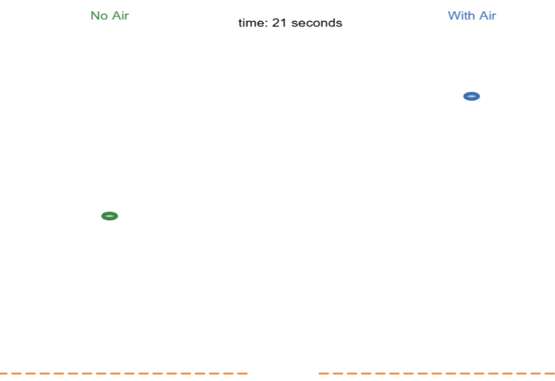

https://www.desmos.com/calculator/etfy3nebtb

The Logistics Equation
Consider a population scenario where there is a limit to the amount of growth (spread of a rumor).

Let $P(t)$ = population size at time t.
$M$ = maximum population size.

We want a model that
- …is like natural growth when P(t) is significantly smaller than M;
- …levels off (with a slope approaching zero), then the population approaches M.

One such model is the so-called logistics equation

$\frac{dP}{dt}=kP\left(1-\frac{P}{M}\right)$ with $P(0) = P_{0}$

Random old final questions

Spring 2011 Final:
Brief summary of what it says:
$v(t)$ = velocity of an object
$$F = mg - kv$$
Recall: $$F = ma=m\frac{dv}{dt}$$
You are given m, g, and k and asked for solve for $v(t)$.

Spring 2014:
A lake has a volume of 1000 cubic meters and contains pure water. A farm near the lake begins using a pesticide. Runoff from the farmland into the lake is 10 cubic meters of water per day, with a concentration of 50 grams of pesticide per cubic meter of water. The lake drains to the ocean at a rate of 10 cubic meters per day.

Winter 2011
Your friend wins the lottery, and gives you P₀ dollars to help you pay your college expenses. The money is invested in a savings account that earns 10% annual interest, compounded continuously, and you withdraw the money continuously (a pretty good approximation to reality if you make regular frequent withdrawals) at a rate of $3600 per year.

Fall 2009
The swine flu epidemic has been modeled by the Gompertz function, which is a solution of
$$\frac{dy}{dt} = 1.2 y (K -ln(y)),$$
where $y(t)$ is the number of individuals (in thousands) in a large city that have been infected by time t, and K is a constant.

Time t is measured in months, with t = 0 on July 9, 2009.
On July 9, 2009, 75 thousand individuals had been infected.
One month later, 190 thousand individuals had been infected.

