9.1 Intro to Differential Equations

A differential equation is an equation involving derivatives.

A solution to a differential equation is any function that satisfies the equation.

Entry Task:
Find $y=y\left(x\right)$ such that
$\frac{dy}{dx}-8x=x^{2} and y\left(0\right)=5$.
Check your final answer

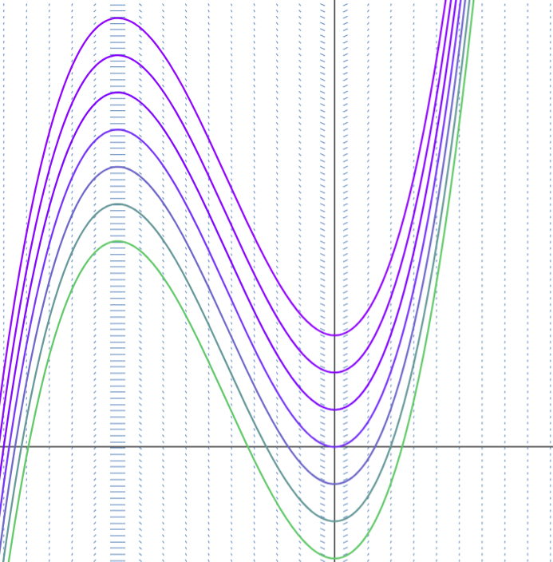

https://www.desmos.com/calculator/ng33fpyf3h

What is a solution? and
How to check solutions?

Example 1
Consider the differential equation:
$$\frac{dP}{dt}=2P$$

- Is P(t) = 8e^{2t} a solution?
- Is P(t) = t³ a solution?
- Is P(t) = 0 a solution?

The general solution to $\frac{dP}{dt}=2P$
is $P\left(t\right)=Ce^{2t},$ for any constant C.
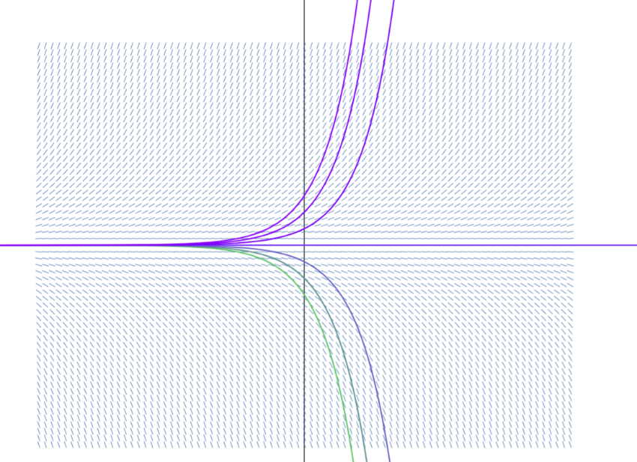

https://www.desmos.com/calculator/ng33fpyf3h

Example 2
Consider the 2nd order differential equation
$y’’ + 2y’ + y = 0$.
- Is y = e^{-2t} a solution?
- Is y = t e^{-t} a solution?
- There is a sol’n that looks like
$y = e^{rt}$. Can you find r?

Side Note (NOT in m125, but is in m207)
A 2nd order differential equation tends to have two unknown constants, the general solution in this example looks like
$$y=\left(C_{1}+C_{2}t\right)e^{-t}$$

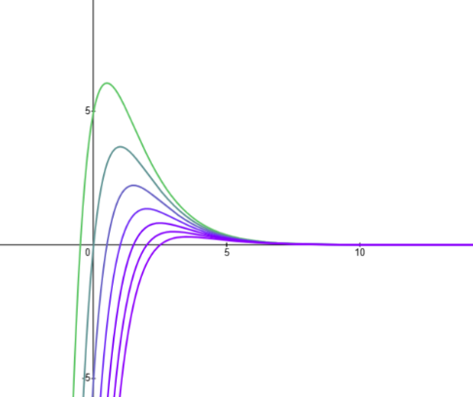

Q: Can you think of a 2nd order equation we have solved in this class?

9.1 HW example….
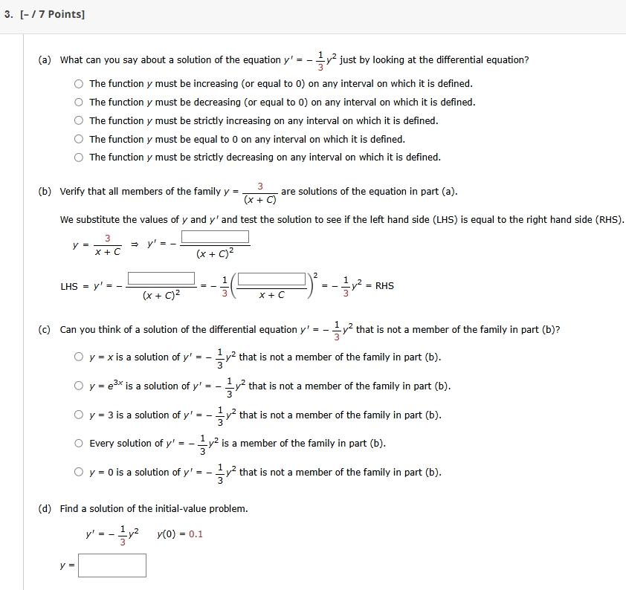

Motivation and Fun Examples

1. Natural Unrestricted population

P(t) = population at year t

$\frac{dP}{dt}=$ instantaneous change in
population/year

Assumption:
“The rate of growth of a population is proportional to the size of the population”

which is equivalent to

$$\frac{dP}{dt}=kP,$$

for some constant k.

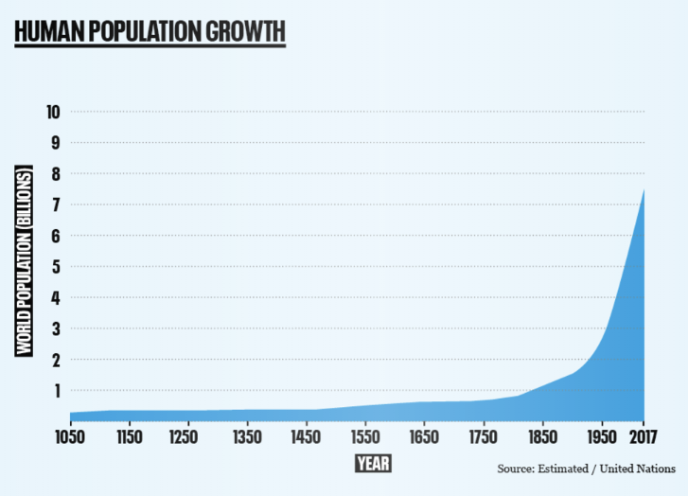

2. Newton’s Law of Cooling

$T\left(t\right) =$ temp. of the object at time t,
$\frac{dT}{dt} =$ rate of change of temp

$T_{s} =$ constant temp. of surroundings
$T-T_{s}=$ temp. difference.

Assumption:
“The rate of cooling is proportional to the temperature difference between the object and its surroundings”

which is equivalent to

$$\frac{dT}{dt}=k(T-T_{s}),$$

for some constant k.



3. Mixing Problems
Assume a 50 gallon vat is initially full of pure water. A salt water mixture is being dumped into the vat at 2 gal/min and this mixture contains 3 grams of salt per gal. At the same time, the mixture is coming out of the vat at 2 gal/min.

Let y(t) = grams of salt in vat at time t.
$\frac{y(t)}{50}=$ salt per gallon in vat at time, t.
$\frac{dy}{dt}=$ the rate (g/min) at which salt is changing with respect to time.

RATE IN = $\left(3\frac{\text{g}}{\text{gal}}\right)\left(2 \frac{\text{gal}}{\text{min}}\right)= 6 \frac{\text{g}}{\text{min}}$
RATE OUT = $\left(\frac{y}{50}\frac{\text{g}}{\text{gal}}\right)\left(2\frac{\text{gal}}{\text{min}}\right)= \frac{y}{25} \frac{\text{g}}{\text{min}}$

Thus,
$$\frac{dy}{dt}=6-\frac{y}{25}$$

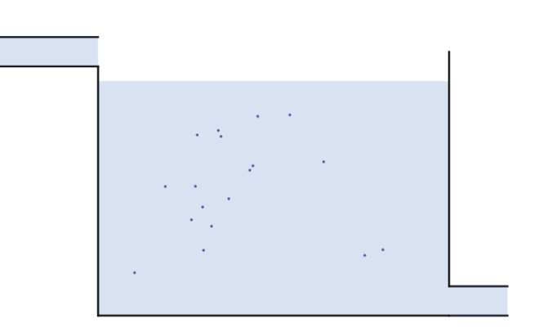

https://www.desmos.com/calculator/n7t1bfrq86

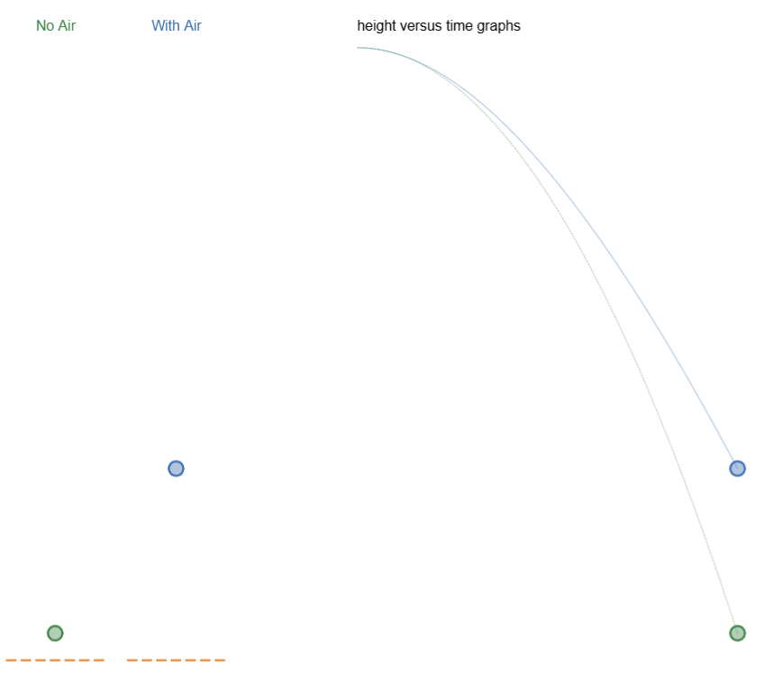
4. All motion problems!
Consider an object of mass m kg moving up and down on a straight line.
Let y(t) = `height at time t’
$\frac{dy}{dt}=$ `velocity at time t’
$\frac{d^{2}y}{dt^{2}}=$ `acceleration at time t’

Newton’s 2nd Law says:
$$m\frac{d^{2}y}{dt^{2}}=sum of forces on the object$$

No air
$m\frac{d^{2}y}{dt^{2}}=-mg$

With air
$m\frac{d^{2}y}{dt^{2}}=-mg-k\frac{dy}{dt}$

https://www.desmos.com/calculator/etfy3nebtb

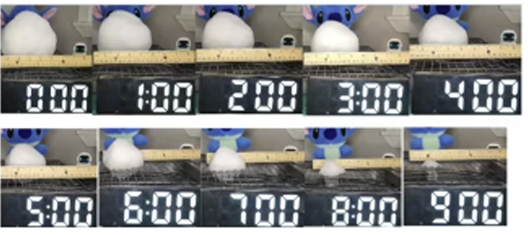
5. Many, many others:
Example:
A common assumption for melting snow/ice is “the rate at which the object is melting (rate of change of volume) is proportional to the exposed surface area.”

Consider a melting snowball:
$$V=\frac{4}{3}πr^{3}, S=4πr^{2}$$
Write down the differential equation for r.

My experiment with this problem…


