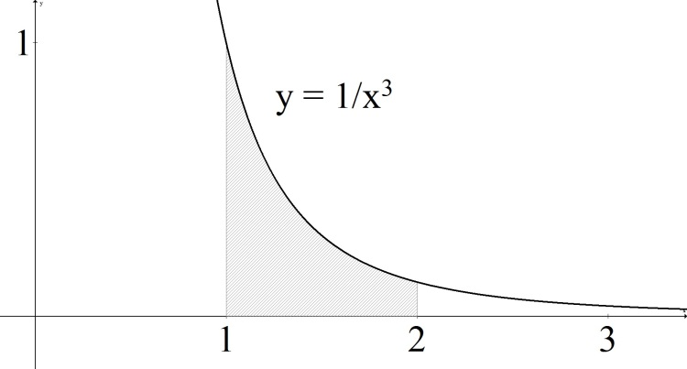
7.8 Improper Integrals
Motivation:
Consider the function $f\left(x\right)=\frac{1}{x^{3}}$.
Compute the area under the function…
- …from $x=1$ to $x=t$
- …from $x=1$ to $x=10$
- …from $x=1$ to $x=100$
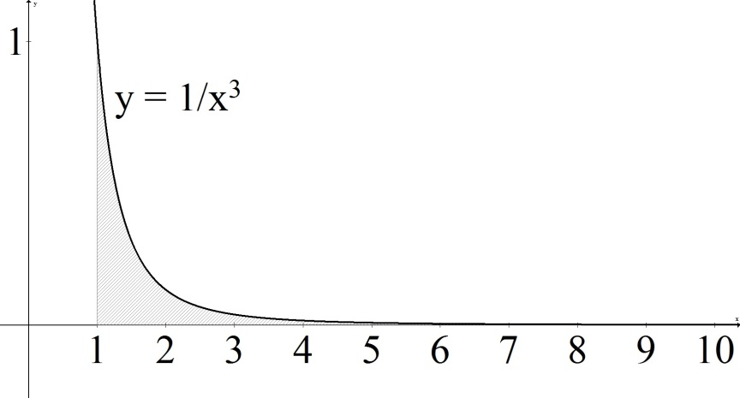

Def’n: Improper type 1 -
$$\int_{a}^{∞}{f\left(x\right)dx=}\lim_{t→∞}{\int_{a}^{t}{f\left(x\right)dx}}$$
$$\int_{-∞}^{b}{f\left(x\right)dx=}\lim_{t→-∞}{\int_{t}^{b}{f\left(x\right)dx}}$$
If the limit exists and is finite, then we say the integral converges. Otherwise, we say it diverges.

Example:
$$\int_{1}^{∞}{\frac{1}{x^{3}}dx=}$$

Example:
$$\int_{-∞}^{3}{e^{2x}dx=}$$

Example:
$$\int_{1}^{∞}{\frac{1}{x}dx=}$$

Example:
$$\int_{-∞}^{∞}{\frac{1}{{1+x}^{2}}dx}$$

Def’n:
$$\int_{-∞}^{∞}{f\left(x\right)dx=}\lim_{r→-∞}{\int_{r}^{0}{f\left(x\right)dx}}+\lim_{t→∞}{\int_{0}^{t}{f\left(x\right)dx}}$$
In this case, we say it converges only if both limits separately exist and are finite.

Def’n: Improper type 2 -
If$f(x)$ has a discontinuity at x = a, then
$$\int_{a}^{b}{f\left(x\right)dx=}\lim_{t→a^{+}}{\int_{t}^{b}{f\left(x\right)dx}}$$
If $f(x)$ has a discontinuity at x = b, then
$$\int_{a}^{b}{f\left(x\right)dx=}\lim_{t→b^{-}}{\int_{a}^{t}{f\left(x\right)dx}}$$
If the limit exists and is finite, then we say the integral converges. Otherwise, we say it diverges.

Example:
$$\int_{0}^{1}{\frac{1}{\sqrt{x }}dx=}$$

Example:
$$\int_{0}^{2}{\frac{x}{x-2}dx=}$$

If $f(x)$has a discontinuity at $x = c$ which is between a and b, then
$$\int_{a}^{b}{f\left(x\right)dx=}\lim_{r→c^{-}}{\int_{a}^{r}{f\left(x\right)dx}}+\lim_{t→c^{+}}{\int_{t}^{b}{f\left(x\right)dx}}$$
In this case, we say it converges only if both limits separately exist and are finite.

Example:
$$\int_{0}^{π}{\frac{1}{\cos^{2}{(x)}}dx=}$$

Limits Refresher
- If stuck, plug in values “near” t.

- Know your basic functions/values:
$$\lim_{t→∞}{\frac{1}{t^{a}}=0}, if a>0.$$
$$\lim_{t→∞}{\frac{1}{e^{at}}=0}, if a>0.$$
$$\lim_{t→∞}{t^{a}=∞}, if a>0. \\ \lim_{t→∞}{ln⁡(t)=∞}.$$
$$\lim_{t→0^{+}}{\ln\left(t\right)=-∞}.$$

- For indeterminant forms, use algebra and/or L’Hopital’s rule
Examples:
$$\lim_{t→1}{\frac{t^{2}+2t-3}{t-1}}=$$

$$\lim_{t→∞}{\frac{ln⁡(t)}{t}} =$$

$$\lim_{t→∞}{t^{2}e^{-3t}}=$$

A few general notes on comparison

Suppose you have two functions f(x) and g(x) such that $0 ≤ g(x) ≤ f(x)$ for all values.

- If $\int_{1}^{∞}{f\left(x\right)dx}$ converges,
then $\int_{1}^{∞}{g\left(x\right)dx}$ converges.

- If $\int_{1}^{∞}{g\left(x\right)dx}$ diverges,
then $\int_{1}^{∞}{f\left(x\right)dx}$ diverges.

You can verify that
$$\int_{1}^{∞}{\frac{1}{x^{p}}dx}, converges for p>1. \\ \int_{1}^{∞}{e^{px} dx}, converges for p<0.$$

And you can compare off of these to sometimes quickly tell if something else is converging or diverging (without calculating anything)!

