How would you start these?
$$1. \int{\frac{x^{2}+7}{x^{2}(3-x)}dx}$$
$$2.\int{\sqrt{x} ln(x)dx}$$
$$3.\int{\frac{1}{{\left(x^{2}+6x+13\right)}^{3/2}}dx}$$
$$4.\int{\tan^{-1}{(x)}dx}$$
$$5.\int{\sin^{2}(x){\cos^{3}{(x)}}dx}$$
$$6.\int{\frac{1}{x^{2}\sqrt{25-x^{2}}} dx}$$
$$7.\int{\frac{\sqrt{x}}{x-9}dx}$$
$$8.\int{\tan^{4}(x){\sec^{4}{(x)}}dx}$$
$$9.\int{x\sqrt{4-x} dx}$$

7.7 Approximating Integrals
We have learned how to integral some important situations.

But many, many, many integrals CANNOT be done with any of our methods.

So, in a great many applications, we have to approximate!

$$L_{n}=∆x\left[f\left(x_{0}\right)+f\left(x_{1}\right)+…+f\left(x_{n-1}\right)\right] (Left endpoint) \\ R_{n}=∆x\left[f\left(x_{1}\right)+f\left(x_{2}\right)+…+f\left(x_{n}\right)\right] (Right endpoint) \\ M_{n}=∆x\left[f\left({\overline{x}}_{1}\right)+f\left({\overline{x}}_{2}\right)+…+f\left({\overline{x}}_{n}\right)\right] (Midpoint)$$

New - Trapezoid Rule: (all the “middle terms” are multiplied by 2)
$T_{n}= \frac{1}{2}∆x\left[f\left(x_{0}\right)+2f\left(x_{1}\right)+…+2f\left(x_{n-1}\right)+f\left(x_{n}\right)\right]$

New - Simpson’s Rule: n must be even! (alternating multiplying middle terms by 4 and 2)
$$S_{n}=\frac{1}{3}∆x\left[f\left(x_{0}\right)+4f\left(x_{1}\right)+2f\left(x_{2}\right)+4f\left(x_{3}\right)+…+2f\left(x_{n-2}\right)+4f\left(x_{n-1}\right)+f\left(x_{n}\right)\right]$$

To approximate $\int_{a}^{b}{f\left(x\right)dx}$
- Compute $∆x=\frac{b-a}{n}$.
Label the tick marks: $x_{i}=a+i∆x$
- Use an approximation method, see below…

Example: Using n = 4 subdivisions, estimate
$$\int_{0}^{4}{\sqrt{100-x^{3}}dx}$$

Step 1: $∆x=\frac{4-0}{4}=1$. $x_{0}=0, x_{1}=1,x_{2}=2,x_{3}=3, x_{4}=4$
Step 2: Here is each method:

$$\left(1\right)\left[\sqrt{100-{\left(0\right)}^{3}}+\sqrt{100-{\left(1\right)}^{3}}+\sqrt{100-{\left(2\right)}^{3}}+\sqrt{100-{\left(3\right)}^{3}}\right]≈38.0855=L_{4} \\ \left(1\right)\left[\sqrt{100-{\left(1\right)}^{3}}+\sqrt{100-{\left(2\right)}^{3}}+\sqrt{100-{\left(3\right)}^{3}}+\sqrt{100-{\left(4\right)}^{3}}\right]≈34.0855=R_{4} \\ \left(1\right)\left[\sqrt{100-{\left(0.5\right)}^{3}}+\sqrt{100-{\left(1.5\right)}^{3}}+\sqrt{100-{\left(2.5\right)}^{3}}+\sqrt{100-{\left(3.5\right)}^{3}}\right]≈36.5672=M_{4}$$

NEW – Trapezoid rule
$$\frac{1}{2}\left(1\right)\left[\sqrt{100-{\left(0\right)}^{3}}+2\sqrt{100-{\left(1\right)}^{3}}+2\sqrt{100-{\left(2\right)}^{3}}+2\sqrt{100-{\left(3\right)}^{3}}+\sqrt{100-{\left(4\right)}^{3}}\right]$$
$$T_{4}≈36.0855$$
NEW – Simpson’s rule
$\frac{1}{3}∙(1)\left[\sqrt{100-{\left(0\right)}^{3}}+4\sqrt{100-{\left(1\right)}^{3}}+2\sqrt{100-{\left(2\right)}^{3}}+ 4\sqrt{100-{\left(3\right)}^{3}}+\sqrt{100-{\left(3\right)}^{3}}\right]$
$$S_{4}≈36.3863$$

“Actual” Value (to 8 places after the decimal) $≈36.40897795$

7.7 Derivation Notes
Trapezoid Rule:
$$Shaded Area =\frac{h}{2}(y_{i}+y_{i+1})$$
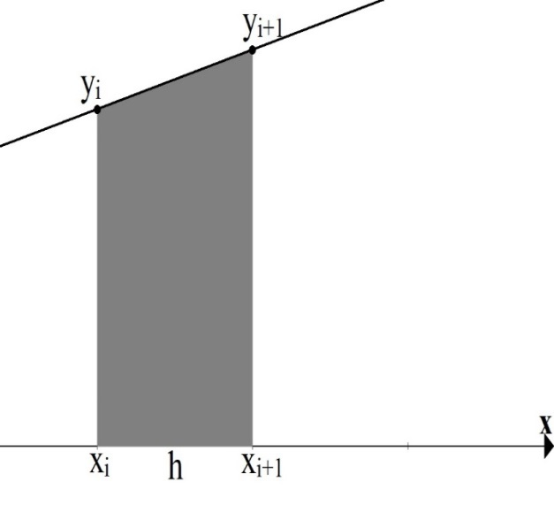

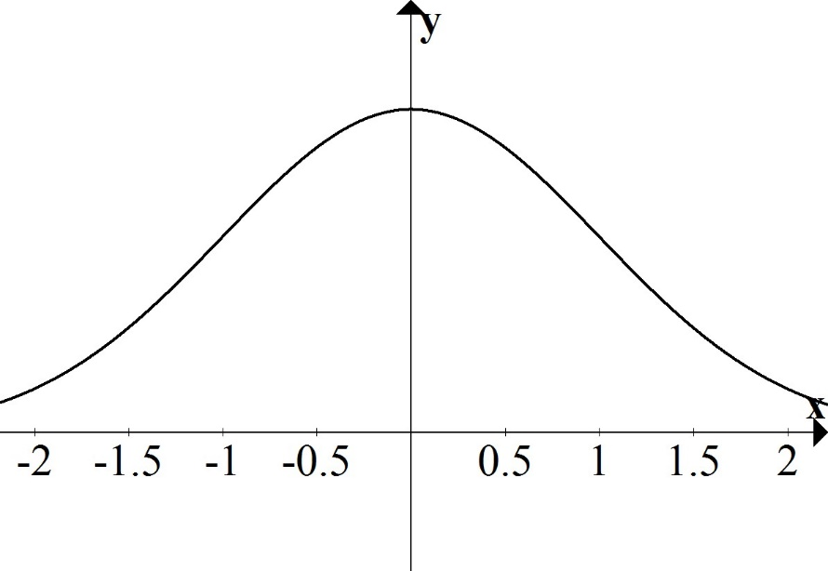

Simpson’s Rule:
The parabola,$y = ax^{2} + bx + c$, thru the three indicated points, satisfies
$$Shaded Area=\frac{h}{3}(y_{i}+{4y}_{i+1}+y_{i+2})$$
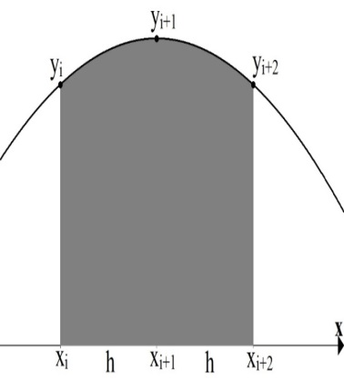

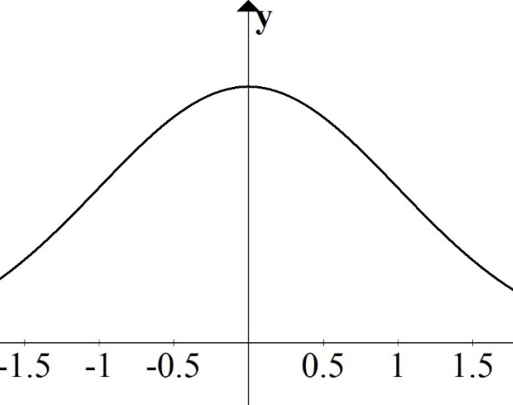

Example:
With n = 4, use both new methods to approximate (just set up):
$$\frac{1}{\sqrt{2π}}\int_{-1}^{1}{e^{-\frac{1}{2}x^{2}}dx}$$

7.8 Improper Integrals (motivation and intro)
Motivation:
Consider the function $f\left(x\right)=\frac{1}{x^{3}}$.
Compute the area under the function…
- …from $x=1$ to $x=t$
- …from $x=1$ to $x=10$
- …from $x=1$ to $x=100$

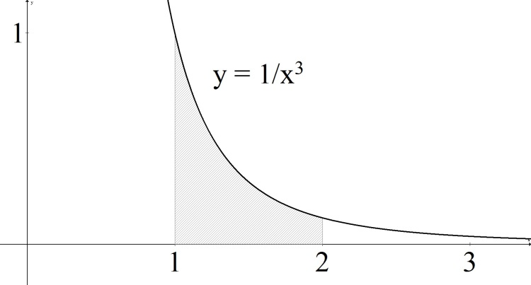

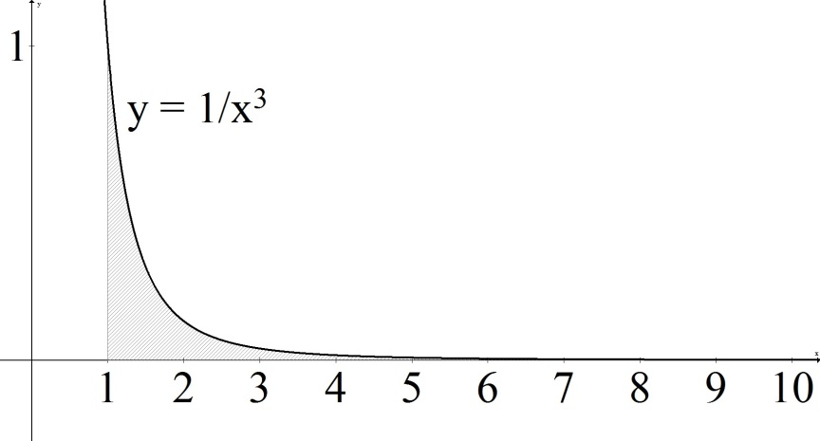

Def’n: Improper type 1
$$\int_{a}^{∞}{f\left(x\right)dx=}\lim_{t→∞}{\int_{a}^{t}{f\left(x\right)dx}}$$
$$\int_{-∞}^{b}{f\left(x\right)dx=}\lim_{t→-∞}{\int_{t}^{b}{f\left(x\right)dx}}$$
If the limit exists and is finite, then we say the integral converges. Otherwise, we say it diverges.

Example:
$$\int_{1}^{∞}{\frac{1}{x^{3}}dx=}$$

Example:
$$\int_{-∞ }^{2}{e^{3x}dx=}$$

Example:
$$\int_{1}^{∞}{\frac{1}{x}dx=}$$

Example:
$$\int_{-∞}^{∞}{\frac{1}{{1+x}^{2}}dx}$$

Def’n:
$$\int_{-∞}^{∞}{f\left(x\right)dx=}\lim_{r→-∞}{\int_{r}^{0}{f\left(x\right)dx}}+\lim_{t→∞}{\int_{0}^{t}{f\left(x\right)dx}}$$
In this case, we say it converges only if both limits separately exist and are finite.

