Entry Task: Show me “step 0” of these HW problems, that is complete the square…

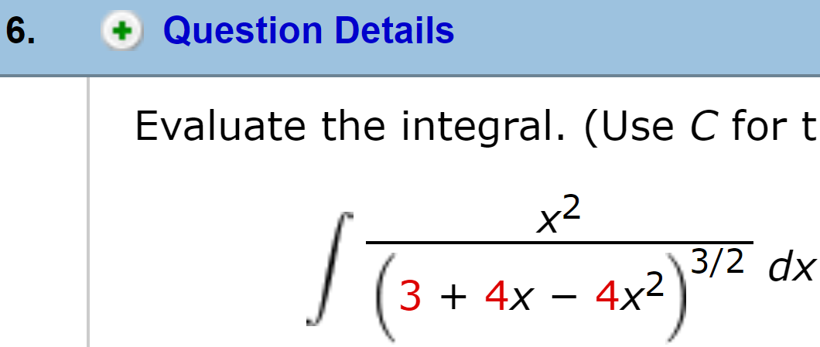

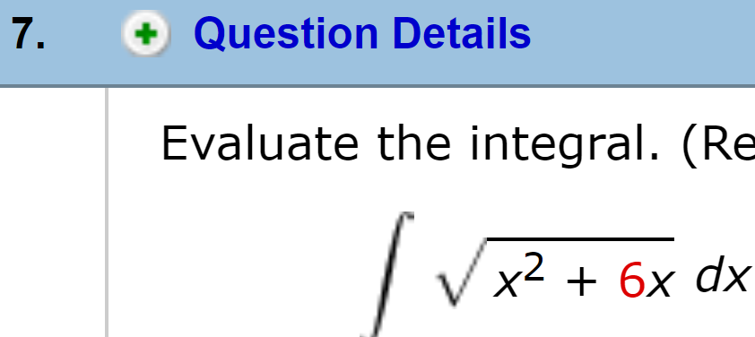

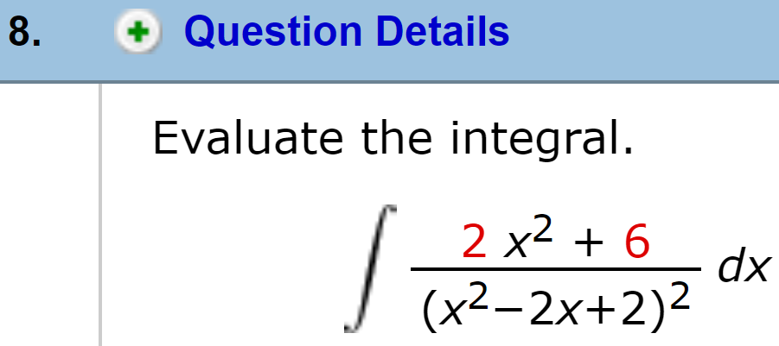

7.4 Partial Fractions
Goal: Method for rational functions.

Motivation

$$\int{\frac{x^{3}+4x-4}{x^{2}(x^{2}+4)}dx} = ??$$

We learn to break the fraction into:
$$\frac{x^{3}+4x-4}{x^{2}(x^{2}+4)}=\frac{1}{x}-\frac{1}{x^{2}}+\frac{1}{x^{2}+4}$$

Then we integrate separately.
$$\int{\frac{x^{3}+4x-4}{x^{2}(x^{2}+4)}dx}=\int{\frac{1}{x}-\frac{1}{x^{2}}+\frac{1}{x^{2}+4}}dx$$

Partial Fraction Decomposition

Step 0: Is the fraction reduced?
- If yes, move to step 1.
- If not, divide, then move to step 1.

A fraction skill:
Reduce the “improper” fraction:
$$\frac{576}{11} = ? + \frac{?}{11}$$

Is the highest power on top is strictly smaller than the highest power on bottom?

Example:
$$\int{\frac{x^{2}+x}{x+3}dx}$$

Partial Fractions Method Summary
Step 0: Reduce (if needed).

Step 1: Factor & write decomposition.
- Distinct Linear: $\frac{x^{2}-3}{x(x-1)(x+4)}=\frac{A}{x}+\frac{B}{x-1}+\frac{C}{x+4}$

- Repeated Linear: $\frac{5+2x}{(x+3){(x-2)}^{3}}=\frac{A}{x+3}+\frac{B}{x-2}+\frac{C}{{(x-2)}^{2}}+\frac{D}{{\left(x-2\right)}^{3}}$

- Irreducible Quadratic: $\frac{4x}{(x+1)(x^{2}+9)}=\frac{A}{x+1}+\frac{Bx+C}{x^{2}+9}$

Step 2: Solve for A, B, C...

Step 3: Integrate

All the integrals end up like one of:

$$\int{\frac{1}{2x+5}dx} =\frac{1}{2}\ln\left|2x+5\right|+C$$
$$\int{\frac{1}{{\left(x-4\right)}^{2}}dx}=-\frac{1}{x-4}+C \\ \int{\frac{1}{{\left(x+7\right)}^{3}}dx}=-\frac{1}{2}\frac{1}{{\left(x+7\right)}^{2}}+C$$
$$\int{\frac{1}{x^{2}+9}dx}=\frac{1}{3}\tan^{-1}\left(\frac{x}{3}\right)+C$$
$$\int{\frac{x}{x^{2}+9}dx=\frac{1}{2}\ln\left|x^{2}+9\right|+C}$$

The method uses algebra to rewrite any rational function as a sum of integrals like these.

Example:$$\int{\frac{x+1}{x^{2}-4}dx}$$

Example:
$$\int{\frac{x+1}{x^{3}+3x^{2}}dx}$$

Example:
$$\int{\frac{x^{2}-x+6}{x^{3}+3x}dx}$$

Example:
$$\int{\frac{x}{x^{2}+4x+5}dx}$$

Section 7.5: Integration Summary

How to integrate
- Simplify and look for substitutions

- Products/Logs/Inv. Trig BY PARTS
Sin/Cos/Tan/Sec combos TRIG
Quadratic (under radical) TRIG SUB
Rational Function PART FRAC.

- If nothing seems to work, substitution.
(u = inside, u = , u = trig, u = e^{x})

Common Substitution Examples:
$$1. \int{e^{\sqrt{x}}dx}$$

$$2.\int{\frac{3}{x-2\sqrt{x}}dx}$$

$$3.\int{\frac{cos⁡(x)}{4-\sin^{2}{(x)}}dx}$$

$$4.\int{e^{x}\cos\left(e^{x}\right)\sin^{3}{(e^{x})}dx}$$

How would you start these?
$$1. \int{\tan^{3}\left(x\right)\sec\left(x\right)dx}$$

$$2.\int{x^{2}\ln\left(x\right)dx}$$

$$3\int{x \sqrt{5-x^{2}}dx}$$

$$4.\int{\frac{\sqrt{x^{2}-1}}{x^{2}}dx}$$

$$5.\int{\frac{x^{2}+1}{x^{2}-2x-3}dx}$$

$$6.\int{x tan^{-1}(x)dx}$$

$$7.\int{\frac{dx}{\sqrt{4x^{2}+8x-12}}dx}$$

