6.3 Volumes by Cylindrical Shells

Motivational Example:
Let R be the region bounded by
$$y= \frac{1}{x^{2}}+\frac{1}{x} , y=0, x=1, x=2.$$
Consider the solid obtained by rotating about the y-axis.

Try to use cross-sectional slicing… why is this difficult/messy?

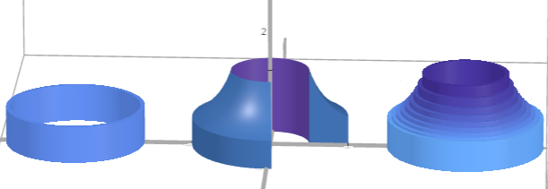

https://www.desmos.com/3d/rtbnpyq6hh

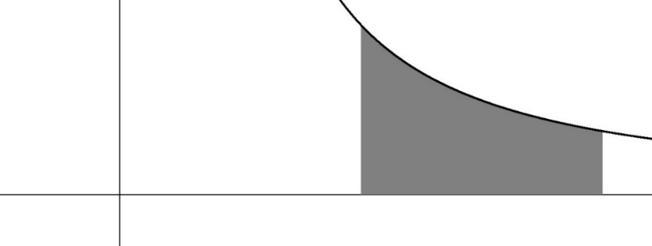

Visual Motivation: Consider the solid

Derivation
Volume of one thin shell
≈ (surface area)(thickness)
= SA(x_{i}) ∆x
= 2π(radius)(height)(thickness)
$$Total Volume ≈\sum_{i=1}^{n}{SA(x_{i}) ∆x}$$
$$Exact Volume=\lim_{n→∞}{\sum_{i=1}^{n}{SA\left(x_{i}\right)∆x}}$$

Thus,
$$Volume =\int_{a}^{b}{SA\left(x\right)dx} \\ =\int_{a}^{b}{2π(radius)(height)dx}$$

Volume using cylindrical shells
- Draw region. “Cut” parallel to rotation axis.
Label x if cut crosses the x-axis.
Label y if cut crosses the y-axis.
Label everything in terms this variable.

- Surface area of cylindrical shell?
SA = (Circumference)(Height)
= 2π(Radius)(Height)
Fill in with labels from graph.

- Integrate the SA formula.

$$Volume =\int_{a}^{b}{2π(radius)(height)dx}$$

Example:
Let R be the region bounded by
$$y= \frac{1}{x^{2}}+\frac{1}{x} , y=0, x=1, x=2.$$
Set up an integral for the volume obtained by rotating R about the
y-axis.

Example: Let R be the region in the first quadrant that is bounded by
$x=\sqrt{y+1}$ and $y = 1$.

Find the volume obtained by
rotating R about the x-axis.

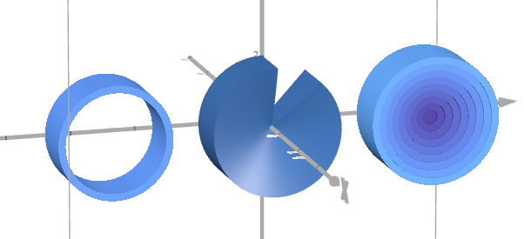

https://www.desmos.com/3d/ve4nqt91ak

Flow chart of all Volume of Revolution Problems

Step 0: Draw an accurate picture!!! (Always draw a picture)
Step 1: Choose and label the variable (based on the region and given equations)
If x, draw a typical vertical thin approximating rectangle at x.
If y, draw a typical horizontal thin approximating rectangle at y.
Step 2: Is the approximating rectangle perpendicular or parallel to the rotation axis?
Perpendicular Cross-sections:
$$Volume=\int_{a}^{b}{(π{\left(outer\right)}^{2} - π{\left(inner\right)}^{2})(dx or dy)}$$
Parallel Shells:
$$Volume=\int_{a}^{b}{2π(radius)(height)(dx or dy)}$$
Step 3: Write everything in terms of the desired variable and fill in patterns.
Then integrate.

If you are still having trouble seeing which variable goes with which method here is a summary:
Axis of rotation | Disc/Washer | Shells
x-axis  (or any horizontal axis) | dx | dy
y-axis  (or any vertical axis) | dy | dx

Example 1:
Let R be the region bounded by $y= x^{3} , y=4x between x=1 and x=2.$
Set up an integral for the volume of the solid obtained by rotating R about the y-axis.

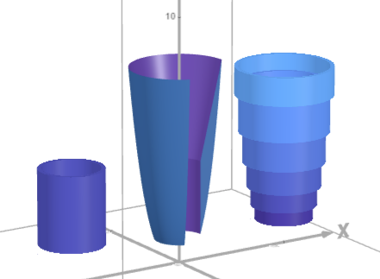

https://www.desmos.com/3d/opdtsrdoxa

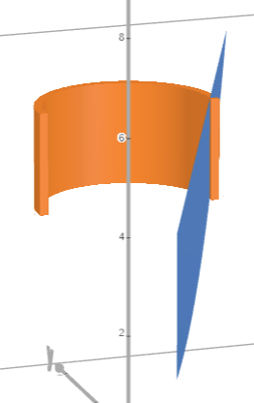

Example 2: Same region, different axis
Let R be the region bounded by $y= x^{3} , y=4x between x=1 and x=2.$
Set up an integral for the volume of the solid obtained by rotating R about the x-axis.

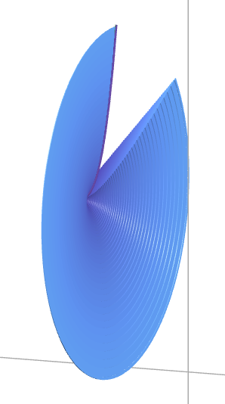

https://www.desmos.com/3d/x86yrs3hf5

Example 3: Same region again, different axis
Let R be the region bounded by $y= x^{3} , y=4x between x=1 and x=2.$
Set up an integral for the volume of the solid obtained by rotating R about the vertical line x = 3.
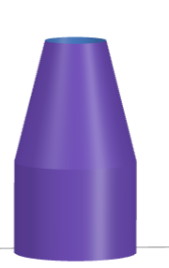

https://www.desmos.com/3d/opdtsrdoxa

