Math 120 – Ch 6 & 7 Test Prep – Dr. Loveless

Take 5 minutes to try to complete this problem. Grade yourself to see how you did. Then discuss the solution with your TA. Then get to work on homework… ask lots and lots of chapter 7 questions!
Participation Code: Please remember to ask your TA for the participation code for today and don’t forget to enter it in the corresponding Canvas quiz.
[F06 Exam 1 - Loveless]
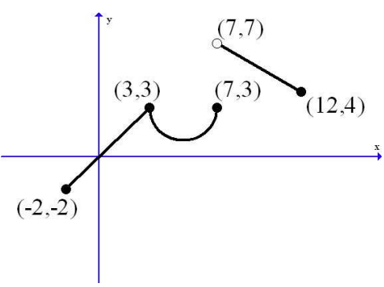
Problem 1: Let $y=f\left(x\right)$ be the function given by the graph below which consists of two line segments and a lower semicircle. *(see the bottom of this page for a written description of the graph).
- Find the multipart rule for $f\left(x\right).$

- Compute $f(4).$

*written description of graph
Graph has three parts:
- a line segment from (-2,-2) to (3,3) with filled endpoints;
- a lower semicircle from (3,3) to (7,3) centered at (5,3) with filled endpoints;
- a line segment from (7,7) to (12,4) with an open endpoint at (7,7) and filled endpoint at (12,4).
- Challenge (this wasn’t on the test, but I think you can do it!)
Find all solutions to $f\left(x\right)=2$.

Outline of Solution with typical grade marks (some blanks have been left for you to fill in):
(10 pts) Problem 1:
- Find the multipart rule for $f\left(x\right).$
From x = -2 to x = 3, the function is a line through (-2,-2) and (3,3) so $m=\frac{3-(-2)}{3-\left(-2\right)}=1$, and the equation of the line is $y=\left(x-\left(-2\right)\right)-2=x.$ $(+1 line equation)$
From x = 3 to x = 7, the points are on a circle centered at (5,3) of radius 2. The equation satisfied by all points on the circle is $({x-5)}^{2}+{(y-3)}^{2}=4.$ Solving for y and using the negative root gives the lower semicircle equation $y=3-\sqrt{4-{(x-3)}^{2}}.$ $(+2 semicircle equation)$
From x = 7 to x = 12 (note that the line starts strictly after 7), the points are on a line through (7,7) and (12,4) so $m=\frac{4-7}{12-7}=-\frac{3}{5}$, and the equation of the line is $y=-\frac{3}{5}\left(x-7\right)+7.$ $(+1 line equation)$
$f\left(x\right)=\left\{\begin{matrix} x , if -2≤x≤3; \\ 3-\sqrt{4-{(x-5)}^{2}} , if 3≤x≤7; \\ -\frac{3}{5}\left(x-7\right)+7 , if 7<x≤12.\end{matrix}\right.$ $(+2 correct notation)$

- Compute $f(8).$
Since x = 8 is between 7 and 12, we use the last rule, so we get $(+1 correct evaluation)$
$$f\left(8\right)=-\frac{3}{5}\left(8-7\right)+7=-\frac{3}{5}+7=\frac{32}{5}=6.4$$
c) Find all solutions to $f\left(x\right)=2$.
We can see from the picture that the function will equal 2 once between x = -2 and x = 3 and twice between x = 3 and x = 7. So we need to solve…
When y = 2 in $y=x$, so x = 2. $(+1 found x= 2)$
When y = 2 in $y=3-\sqrt{4-{\left(x-5\right)}^{2}},$we get $3-\sqrt{4-{\left(x-5\right)}^{2}}=2$, which means
  - $\sqrt{4-{\left(x-5\right)}^{2}}=1$, which gives $(+1 found set up equation)$
  - $4-{\left(x-5\right)}^{2}=1$, which gives
  - ${\left(x-5\right)}^{2}=3$, which means
  - $x-5=±\sqrt{3}$
  - $x=5±\sqrt{3}$ $(+1 correctly solved)$

