Math 120 – Ch 5 & 6 Test Prep – Dr. Loveless

Take 5 minutes to try to complete this problem. After 5 minutes, flip to the 2nd page to see a solution outline and grading rubric. Grade yourself to see how you did. Then discuss the solution with your TA. If you have time you can also try the other problem on page 3 which has to do with chapter 6 material and is more of a challenge problem (or please switch to homework question if you have them!).
Participation Code: Please remember to ask your TA for the participation code for today and don’t forget to enter it in the corresponding Canvas quiz.
[W06 Exam 1 - Loveless]
Problem 1: Let $f(x) = 1 + 2x – 3x^{2}$. Simplify the following expression far enough so that plugging in $h = 0$ would be allowed:
$$\frac{f\left(x+h\right)-f\left(x\right)}{h}$$

Outline of Solution with typical grade marks (one blank has been left for you to fill in):

(5 pts) Problem 1: Let $f(x) = 1 + 2x – 3x^{2}$. Simplify the following expression far enough so that plugging in $h = 0$ would be allowed:
(-5 or -4 pt, depending on severity) For any major error in the first step below. That part is about conceptually understanding functional notation, we are not lenient on this.
$$\frac{f\left(x+h\right)-f\left(x\right)}{h}=\frac{\left[1+2\left(x+h\right)-3{\left(x+h\right)}^{2}\right]-[1+2x-3x^{2}]}{h} (+2 if this is correct)$$
$$=\frac{1+2\left(x+h\right)-3\left(x^{2}+2xh+h^{2}\right)-1-2x+3x^{2}}{h} (+1 expansion)$$
$$=\frac{1+2x+2h-3x^{2}-6xh-3h^{2}-1-2x+3x^{2}}{h} (+1 distribution)$$
$$=\frac{2h-6xh-3h^{2}}{h}= (+1 simplifying to final answer)$$

Challenge Problem: In my experience, students find the following question quite challenging at first as it requires geometric labeling and a solid understanding of how to label. For now, treat this as a challenge question. The reward if you can completely do and understand this is problem is that Math 125 will be much, much easier for you as you have to do things like this a lot in that class. (Small tip, the area of a trapezoid is $Area=\frac{1}{2} b \left(h_{1}+h_{2}\right)$)

[W06 Exam 1 - Conroy]
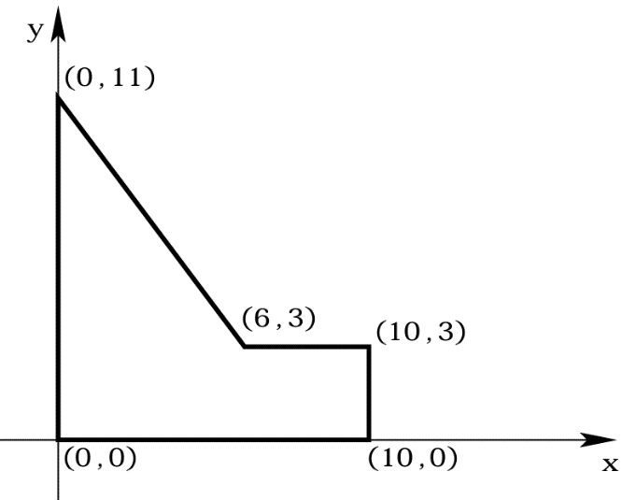
Problem 2: Alice is going into business selling pizzas shaped like the polygon in the figure below. The units are in inches.
If a vertical cut is made in the pizza, x inches from the left edge of the pizza, determine the area of the pizza to the left of the cut as a multipart function of $x$.

Outline of Solution with typical grade marks (a few blanks have been left for you to fill in):

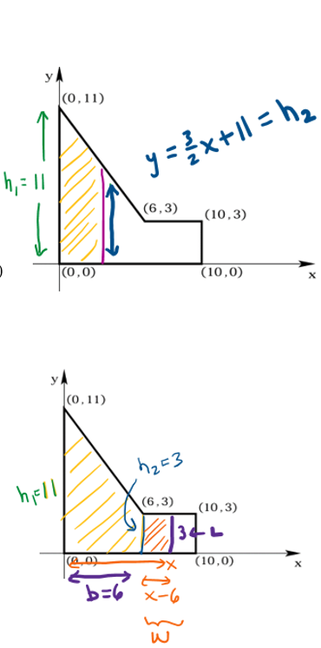
(10 pts) Problem 2:
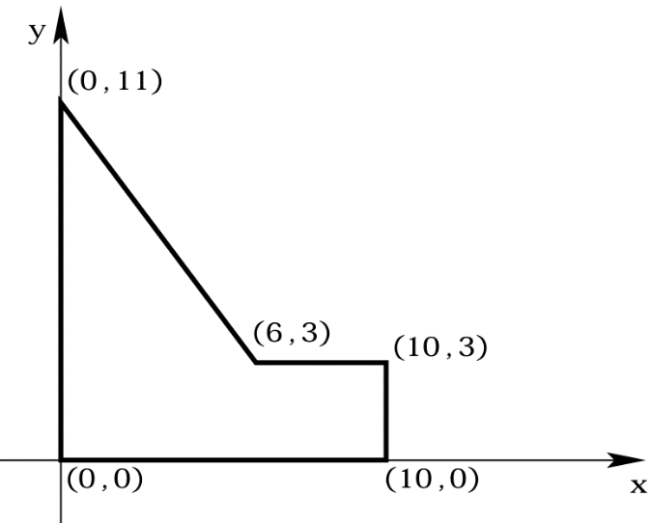
$(+3 equation for the line below)$
Equation for line through (0,11) and (6,3)
$$m=\frac{11-3}{0-6}=-\frac{4}{3}, so y=-\frac{4}{3}x+11$$
$$(+2 equation for area below)$$
For $0≤ x≤ 6$, we have a trapezoidal area so
$Area=\frac{1}{2} b \left(h_{1}+h_{2}\right)$
$$=\frac{1}{2}x \left(11-\frac{4}{3}x+11\right)$$
$$=11x-\frac{2}{3}x^{2}$$

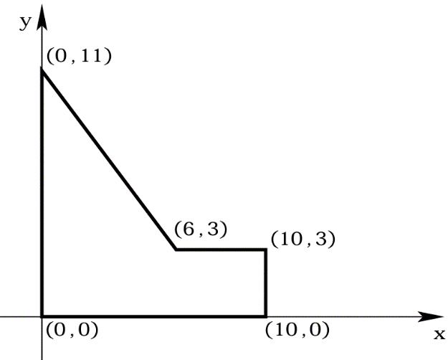
$(+3 equation for area below)$
For $6≤ x≤ 10$, we have a trapezoid plus a rectangle.
$Area=\frac{1}{2} b \left(h_{1}+h_{2}\right)+L⋅W$
$$=\frac{1}{2} 6 \left(11+3\right)+3⋅\left(x-6\right)$$
$=42+3x-18=3x+24$
$(+2 giving a correct multipart form)$
Area = $\left\{\begin{matrix}11x-\frac{2}{3}x^{2} , if 0≤x≤6; \\ 3x+24 , if 6≤x≤10.\end{matrix}\right.$

