Math 120 – Ch 19 sinusoidal modeling test prep – Dr. Loveless
Please begin the first problem as soon as quiz section starts (about 5–10 minutes). This problem is taken directly from an old exam. After working individually, compare your setup with classmates and ask your TA if anything is unclear. Participation Code: Ask your TA.
Since we have only recently started sinusoidal modeling, here is the general form (from the text):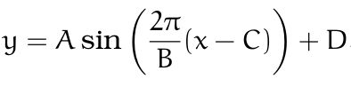
$$A=\frac{`max y-value` - `min y-value`}{2} =amplitude$$
$$B=horizontal distance between two peaks (or valleys) = wave length$$
$$C=`x-coordinate of a peak' - \frac{B}{4} =phase shift$$
$$D=\frac{`max y-value` + `min y-value`}{2} =mean$$

[Fall 2008 Loveless Exam 2] A weight is attached to a spring and is hanging from the ceiling. At some initial time, t = 0, the weight begins oscillating up and down so that the height off the ground is a sinusoidal function of time. At t = 5 second, the weight is at its lowest point of 5 inches off the ground. At t = 12 seconds, the spring is at its highest point of 25 inches off the ground.
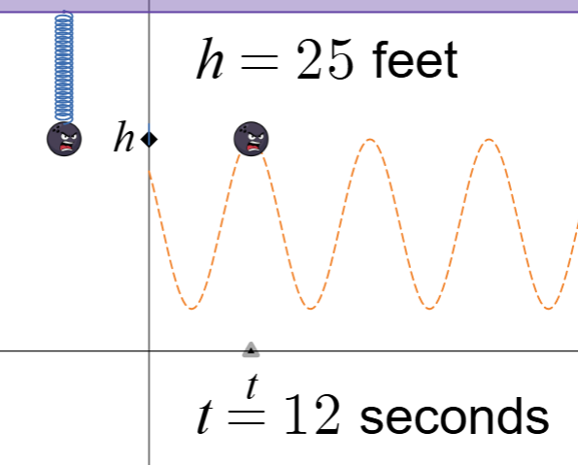
- Find the sinusoidal model which gives height in terms of time.

Just for fun: Desmos Animation

(b) Find the initial height of the weight.

Please move on to homework questions in quiz section. But if you want to try another sinusoidal modeling problem after class, here is one.
[Fall 2006 Loveless Exam 2] Mr. Pogo can bounce on his giant pogo stick for hours at a time. When he is bouncing, Mr. Pogo’s height off the ground changes according to a sinusoidal function of time. At time t =0 seconds, Mr. Pogo is at his lowest height of 0 inches. At time t = 2 seconds, Mr. Pogo reaches his highest point of 20 inches for the first time.
(a) Find the sinusoidal model, h(t), which gives height in terms of time.

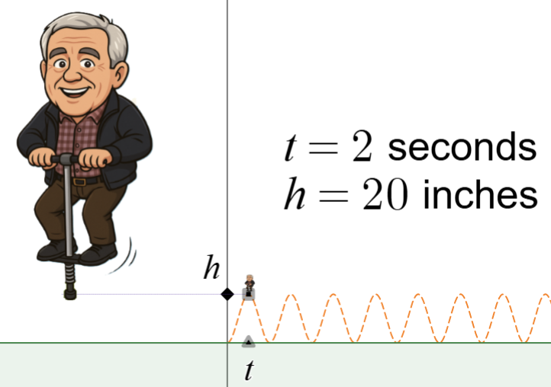

Just for fun: Desmos Animation

- Find the height of Mr. Pogo after t = 11 seconds.

Random Side Note:
Dr. Loveless’ dad often says he was a pogo-stick champion when he was a little kid. He says he could continuously pogo stick for hours. That is the origin on this problem.

