Math 120 – Ch 17 circular motion test prep – Dr. Loveless
Please attempt to start this first problem at the beginning of quiz section (5-10 minutes). This comes directly from an old exam. Then compare with classmates and discuss with your TA if you have questions.
Participation Code: Please ask your TA for the participation code.
[Fall 2008 Loveless Exam 2] Alfred is running counter-clockwise around a circular track.
He starts running, 𝑡=0, at some point in the southwestern quadrant of the track (i.e. third quadrant). Alfred completes one lap in 80 seconds and he is running at a (linear) speed of 15 feet/second. It takes Alfred 5 seconds to reach the southernmost point for the first time.

Give Alfred's x and y coordinates after 2 minutes.

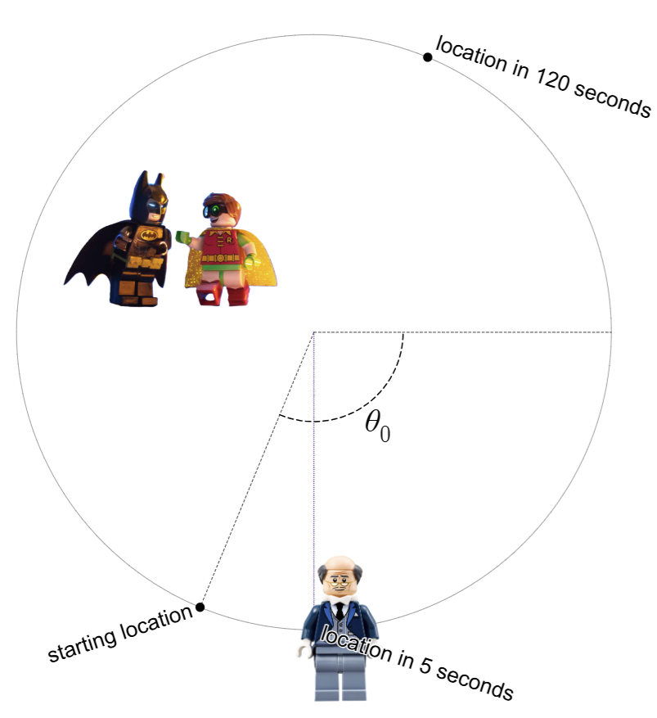

Just for fun: Desmos Animation Link
Please move on to homework questions in quiz section. But if you want to try another circular motion question after class, here is one.
[Fall 2006 Loveless Exam 2] Harry and Ron are both at the easternmost point of a circular track. The track has radius 60 feet. Ron runs in the counterclockwise direction at an angular speed of 0.02 radians per second. Harry runs in the clockwise direction. Impose a coordinate system with the middle of the track as the origin
(a) Find the x and y coordinates of Ron after 30 seconds.

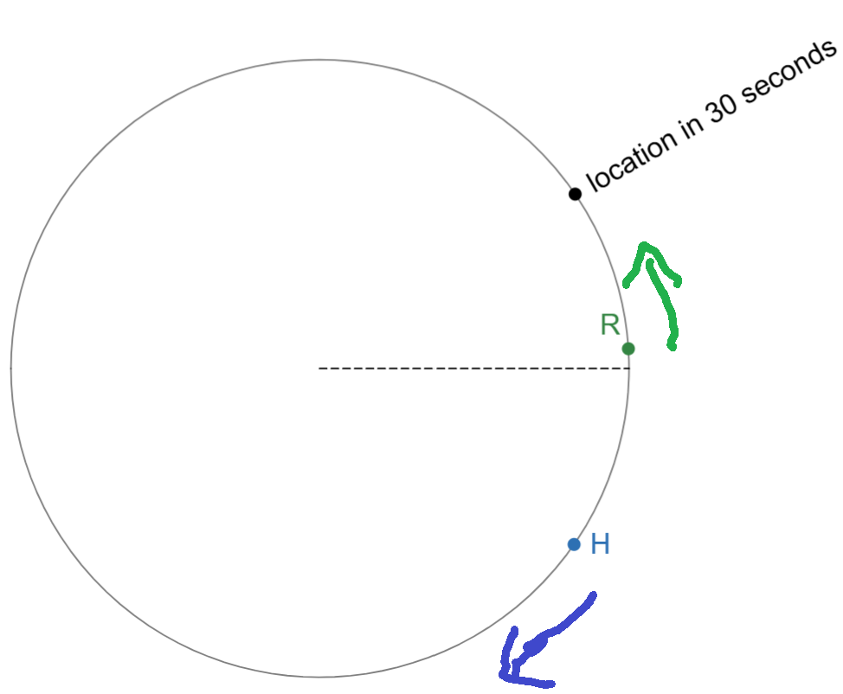

Just for fun: Desmos Animation

(b) How fast (in feet per second) must Harry run in order to be at the same location as Ron after 30 seconds? (Hint: You may want to consider the angle that Harry will travel.)

