Final Review Lecture 1
Goal: To talk about how to “start” questions on the final.

Entry Task (Do you know sinusoidal modeling?)

Fall 2018 Question 7
The temperature in Skiattle is a sinusoidal function of time. 120 days ago, the temperature was at its maximum value of 55 F. The temperature has been falling since then, and 20 days from today it will reach its minimum value of 10 F.
- Write a function f(t) for the temperature in Skiattle, in Fahrenheit, t days from today.

- The residents of Skiattle can only ski when the temperature is below 28 F. Over the next 500 days (starting from today), for how much time will it be cold enough to ski?

How would you start this? What is this about?
What could you do if stuck?

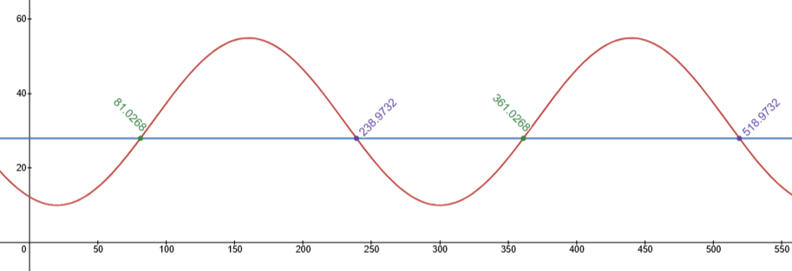

Final Details: Exam is comprehensive.
Layout: ~8 pages total

A starting checklist for you

~3 pages: Trig (ch 15-20)
- triangles
- circular motion
- sinusoidal waves

~3 pages: Models (ch 1-4,7,10-12,14)
- lines & circles
- quadratics
- exponentials
- linear-to-linear
- linear motion
- coordinates, distance, speed

~2 pages: Function skills (ch 5,6,8,9,13)
- notation
- multi-part
- labeling figures/graphs, height, area
- composition, inverses, algebra
- transformations

Please go through this checklist and think about what you need to review. Then check out my final exam review and go back to my review for that section.

Tip: Don’t leave anything blank. Treat each problem like an essay.
Things you can always do:
- Visualize & label.
- State the model.
- List givens & goals.
- Plug in data & solve the unknowns.
- Try examples.
- Reread the question.
- Check anything you can check.

Fall 2018 Question 6
You are standing somewhere between a mountain and a fountain, which are 100km apart from each other. You know that the mountain is 500 times as tall as the fountain. From where you stand, the mountain is at an angle of elevation of 3 degrees and the fountain is at an angle of elevation of 40 degrees.
How tall is the mountain?

How would you start this? What is this about?
What could you do if stuck?

Fall 2018 Question 2
At the beginning of 2001, Clovis invested $10,000 in an account. In 2013 his investment was worth $14,764. Isobel made an investment at the same time as Clovis. Her investment doubles every 7 years. In 2014, Clovis had 8 times as much in his account as Isobel had in hers. Assume the values of both investments are exponential functions of time.

(a) Give an exponential function relating the value of Clovis’s investment y to the year t.

(b) What is the annual growth rate of Clovis’ investment?

(c) What was the value of Isobel’s investment at the beginning of 2001?

(d) How many years after 2001 will Clovis have five times as much money as Isobel?

How would you start this? What is this about?
What could you do if stuck?

Fall 2018 Question 5
Midge is practicing her comedy act. The number of laughs she gets is a linear-to-linear rational function of how long she practices.
If she doesn’t practice at all, she’ll get 4 laughs.
If she practices for an hour, she’ll get 24 laughs.
If she practices for four hours, she’ll get 52 laughs.
- Write a function f(x) for the number of laughs Midge gets if she practices for x hours.

- Suppose the domain of f(x) is [0,∞). What is the range?

How would you start this? What is this about?
What could you do if stuck?

Fall 2018 Question 1
Fred and Ted are running around a circular track. The track has a radius of 60 meters. Fred starts from the westernmost point of the track, and runs clockwise. Ted starts at the same time from the southernmost point of the track, and runs counterclockwise. Fred runs at a constant speed of 9 meters per second, and passes Ted for the first time after 15 seconds.

- What is Ted’s speed in meters per second?

- After running for 200 seconds, who is farther North, Fred or Ted? Show all work.

How would you start this? What is this about?
What could you do if stuck?

Fall 2018 Question 3
Keoki and Nalani are moving in the xy-plane along straight lines at constant speeds. They both start at the same time.
Keoki starts from the point (-5, 9) and heads directly toward the point (11,1), reaching it in 8 seconds.
Nalani starts from the point (8, 9) and moves toward the y-axis along the line y = 3/4 x + 3.
Nalani takes twice as long to reach the y-axis as it takes Keoki to reach the y-axis.

- Find the parametric equations of motion for Keoki.

- Find the parametric equations of motion for Nalani.

- How long has Keoki been moving when the distance between Keoki and Nalani is as small as it ever gets?

How would you start this? What is this about?
What could you do if stuck?

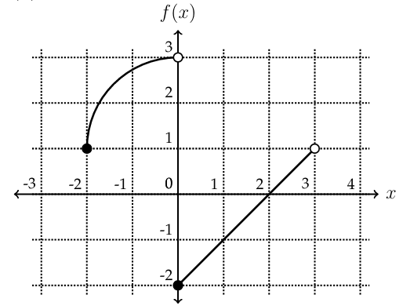
Fall 2018 Question 4
Here’s the graph of f(x).

Use the graph to answer the following questions.
- Compute $f(f(f(2))).$

- Is f one-to-one? Why or why not?

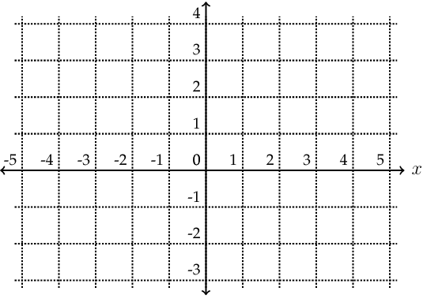
- Let $g(x)=f(2-x)+1$. Sketch a graph of $g(x)$.

How would you start this? What is this about?
What could you do if stuck?

