Ch 9: Inverse Functions
Goal: Learn the general ideas of inverse functions
Entry Task (motivation) A ball is thrown in the air. The height in feet after x seconds is given by $y=f\left(x\right)=-16x^{2}+43x.$
Try to answer the following questions…
- “Plug in question” What is the height after 1 second?
- “Inverse question” When is the ball 20 feet high?
- Challenge: Can you solve for x in terms of y in general?

Video Link
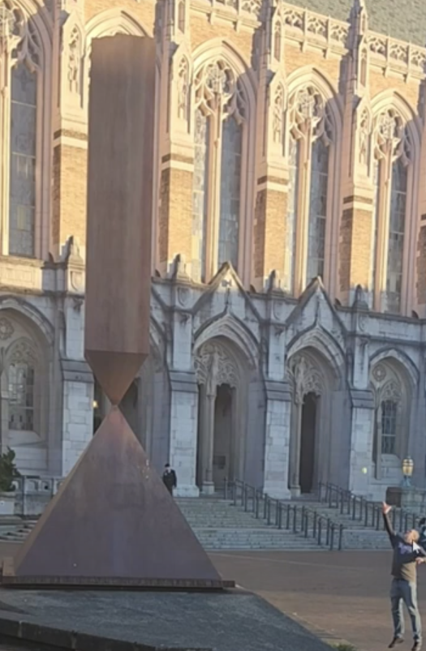

General Notes and Observations
Q: The sol’n for x in terms of y is NOT a function in the last problem, why?
In general: A parabola does not have one inverse function.

Horizontal Line Test and One-to-One
We say that parabolas function is not one-to-one. Meaning there is not just one x-value for every y-value. Visually, a one variable function is one-to-one if it passes the horizontal line test.

You do:
- Draw an example of a curve that is not a function.

- Draw two examples of functions that are one-to-one.

- Draw two examples of functions that are not one-to-one.

Notation:
When a function $y=f(x)$ is one-to-one, then we say it is invertible. That means we can solve for x in terms of y and get one function. We call this function the inverse and write
$$x=f^{-1}\left(y\right).$$
Example 1: Find the inverse of
$$y=f\left(x\right)=5x+1.$$

Checking work:
Plug in x = 2 to $y=f(x)$, then plug that $y$ into$x=f^{-1}\left(y\right)$.
What happens?

Observation: If are answer is correct, then
$$f^{-1}\left(f(x)\right)=x and f\left(f^{-1}(y)\right)=y$$

Example 2: Find the inverse of
$$y=g\left(x\right)=\frac{5}{x+3}.$$

Intermission – A brief review of inverse pairs
Do you know your current toolbox of solving skills?
Fill in the table below…
Equation | Inverse?
$$x+3=14$$  $$y-5=22$$ | $x=$  $y=$
$3t=16$  $$\frac{m}{0.2}=100$$ | $t=$  $m=$
$$x^{2}=7$$  $$\sqrt{y}=3$$ | $x=$  $y=$
$$t^{5}=20$$  $$\sqrt[5]{w}=3$$ | $t=$  $w=$

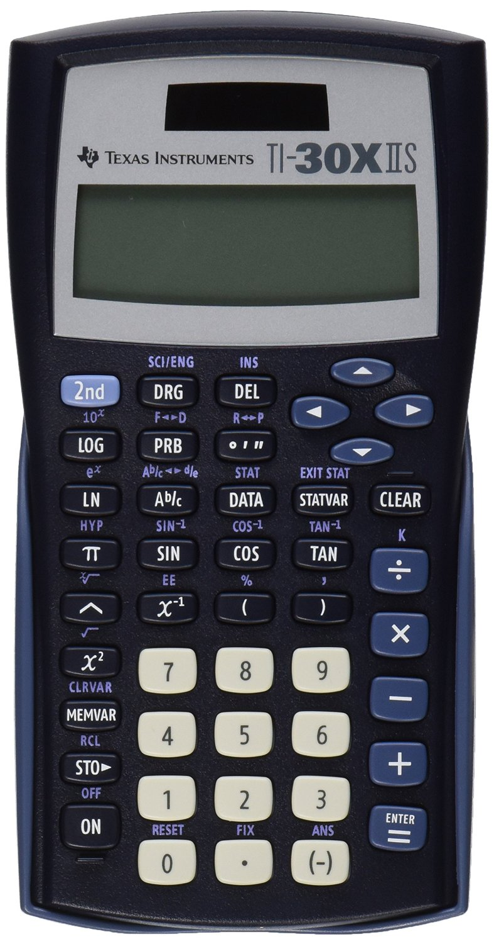
Example: If you know your inverses you can solve this by pushing five operations buttons in the correct order on your calculator.
Try it…
$$\sqrt[3]{{(2x-1)}^{5}-5}=3$$

Non-invertible functions and how we split them up
Graphical note: The inverse function is the mirror image of the function reflected across the line $y = x$.
Domain note: The domain of the inverse is the same as the range of the original function

If a function is not one-to-one, we typical split the domain into parts where the function is one-to-one and give an inverse for each part.
For each example below: Split up into two intervals, find both inverses, give domains.
Example 1: $y=g\left(x\right)=x^{2}$

Example 2: $y=f\left(x\right)=-16x^{2}+43x$

Example 3: $y=h\left(x\right)=\sqrt{4-x^{2}}$

Homework Challenges…
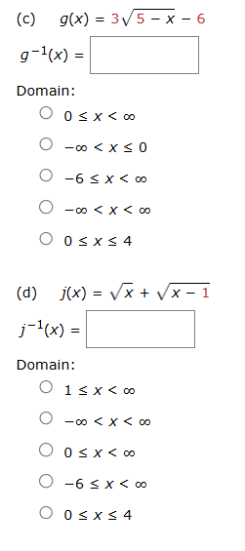

Homework Challenges
