Course Notes We’ve learned lines and quadratics as well as functional notation and graphs. We’ve used these tools in applied settings involving distance, speed, time, and circles.
What’s up for the next two weeks: Ch 8-9: Compositions and inverses. Ch 10-12: Exponentials and logarithms.
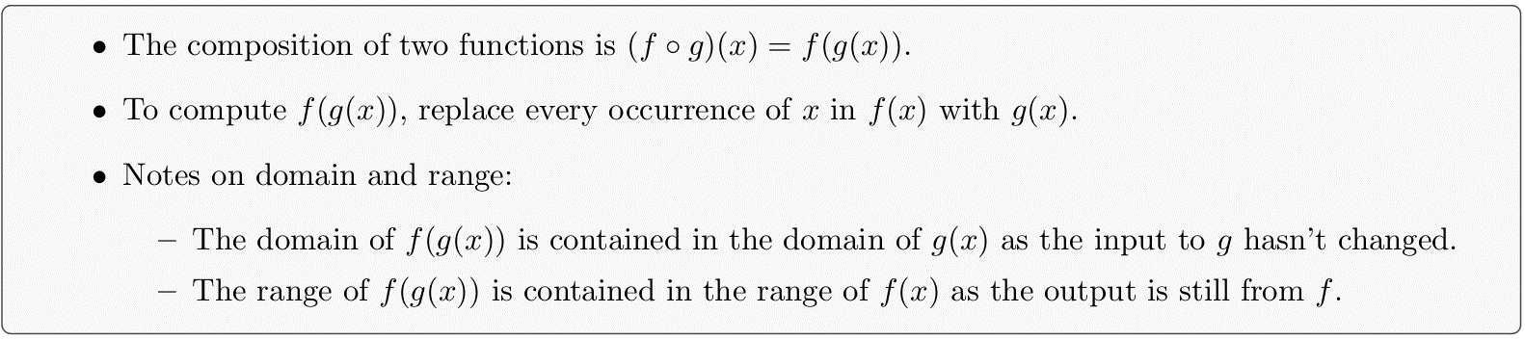

Ch 8: Composition
Goal: Learn composition of functions.
Entry Task
Consider $f\left(x\right)=2x+5,$ $g\left(x\right)=x^{2}-x+1,$and $h\left(x\right)=\sqrt{x}$.
- Compute $f\left(g(2)\right)$
- Find a formula for $f\left(g(x)\right)$.
- Find formula $h\left(f(x)\right)$ and $g\left(h(x)\right)$ and $f\left(f(x)\right)$.

Can you do these Ch 8 homework problems now?
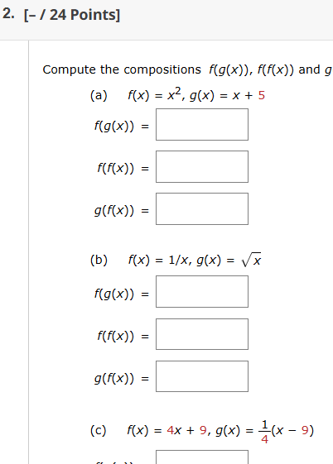
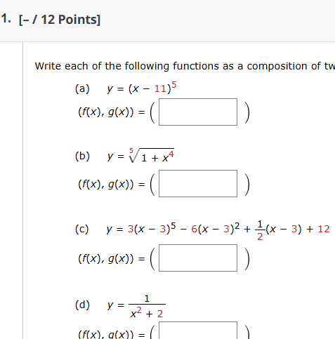

Example (like homework)
- If $f\left(x\right)=mx+b$, then find and simplify $f\left(f(x)\right)$.

- Small Challenge: If I told you that $f\left(f(x)\right)=9x+5$, then can you deduce the value(s) of $m$ and $b$

Domain and composition
Consider $f\left(x\right)=2x+5$ and $h\left(x\right)=\sqrt{x}$.
- Find the domain of $h\left(x\right)$.
- Find the domain of $h\left(f(x)\right)$.
- Find the domain of $f\left(h(x)\right)$

Any Observations?

Can you do this homework problem now?
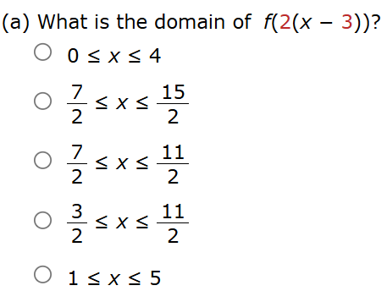
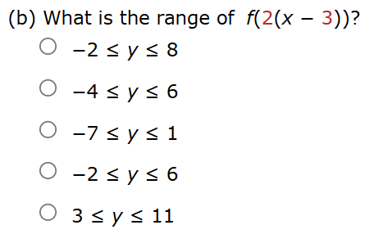

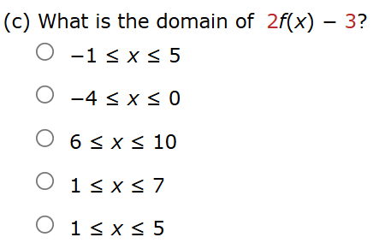
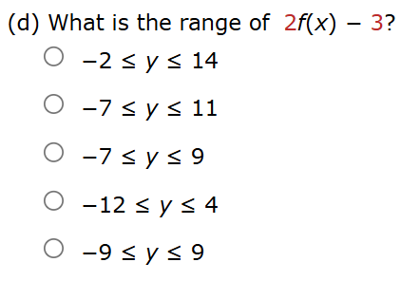

Composition and Multipart Functions
Example: $f\left(x\right)=3x-12$ and $g\left(x\right)=\left|x\right|=\left\{\begin{matrix}-x , if x<0; \\ x , if x≥0.\end{matrix}\right.$
Find the multipart rule for
- $f(g\left(x\right))$

- $g\left(f\left(x\right)\right)$

Example: $h\left(x\right)=x+5$ and $p\left(x\right)=\left\{\begin{matrix}x+10 , if x<-1; \\ x^{2} , if x≥-1.\end{matrix}\right.$

Find the multipart rule for
- $p(h\left(x\right))$

- $h\left(p\left(x\right)\right)$

Challenge Problem:
Find the multipart rule for
$\left|\left|x\right|-3\right|$

