**Ch 7: Quadratics *(continued)***

**Key Facts**

$y=ax^{2}+bx+c$

* $h=-\frac{b}{2a}$ x-coord. of vertex
* $x=\frac{-b±\sqrt{b^{2}-4ac}}{2a}$ roots (i.e. zeros)

Goal:

Optimization with quadratics.

***Entry Task Two Mechanical Problems***

1. Find the (x,y) coordinates of the vertex for $y=-5x^{2}+20x+30$.

And sketch a rough graph.

1. Try to set up part (b) of this homework problem…

*Example 1*: You have 500 feet of fencing and you want to build a cage with one wall in the middle as shown.

***Optimization Strategy***

* Draw/Label everything.
* What do we **want**?
* What are we **given**?
* Use what is given to give a one variable function for what you want!
  + If it involves a quadratic, then find the vertex and interpret.
  + If it is not a quadratic, then wait for Math 124.

How should you build it to maximize area?

*Example 2*: You run a petting zoo.

If you charge $8, you will sell 300 tickets/day giving a revenue of $2400 for that day.

If you charge $9, you will sell 280 tickets/day giving a revenue of $2520 for that day.

Assume the tickets sold is a linear function of price, x. And note that revenue is price times quantity.

How many tickets should you sell to maximize revenue?

(and *what is the max revenue?* and *what is the price?)*

[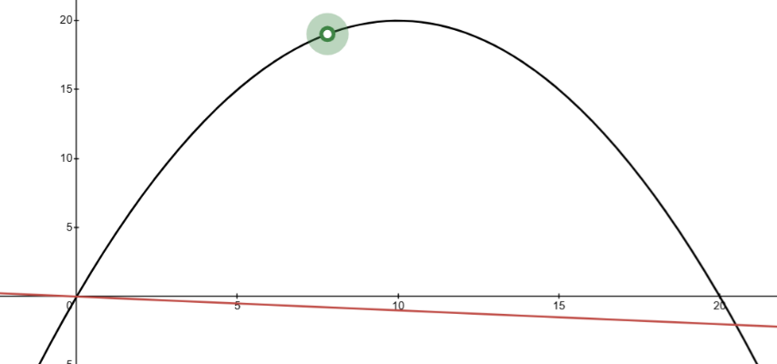](https://www.desmos.com/calculator/svjixeogiu)*Example 3*:

A ball is following the path given by $y=-\frac{1}{5}x^{2}+4x$. In addition, the ground is sloping downward $y=-\frac{1}{10}x.$ This is shown at right.

How would you find the following…

1. The highest y-value of the ball.
2. The location of the ball when it is farthest *above the sloping ground*.

[Link to desmos visual](https://www.desmos.com/calculator/svjixeogiu).

1. The location where the ball hits the sloping ground.

**Let’s look at the homework, can you identify what we “want” and what is “given”?**

**Problem 7.9**. Sylvia has an apple orchard. One season, her 100 trees yielded 140 apples per tree. She wants to increase her production by adding more trees to the orchard. However, she knows that for every 10 additional trees she plants, she will lose 4 apples per tree (i.e., the yield per tree will decrease by 4 apples). How many trees should she have in the orchard to maximize her production of apples?

**Problem 7.11**. A Norman window is a rectangle with a semicircle on top. Suppose that the perimeter of a particular Norman window is to be 24 feet. What should its dimensions be in order to maximize the area of the window and, therefore, allow in as much light as possible?

Label:

Want:

Given:

Label:

Want:

Given:

**Problem 7.16**. Sven starts walking due south at 5 feet per second from a point 120 feet north of an intersection. At the same time Rudyard starts walking due east at 4 feet per second from a point 150 feet west of the intersection. (a) Write an expression for the distance between Sven and Rudyard t seconds after they start walking. (b) When are Sven and Rudyard closest? What is the minimum distance between them?