**Entry Task on****“*polynomials*”**

A 20 inch by 50 inch piece of cardboard is going to be used to make a box.

The box will be made by cutting out four squares with side length x as shown.

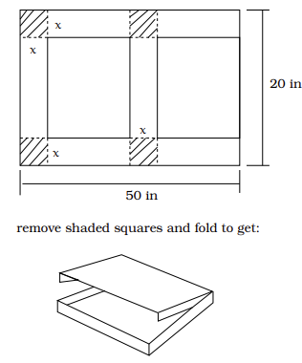

For both parts below find the function in terms of x.

1. Find the volume, V(x), of the resulting box
2. Find the exposed surface area, A(x)?

**Ch 7: Quadratics**

Goal: Learn about second degree polynomials, which are great for modeling the path of a thrown ball and for applied max/min problems.

$y=ax^{2}+bx+c$ (general form)

$y=a{\left(x-h\right)}^{2}+k$ (vertex form)

***Examples 1:*** Plot points and graph

$$y=x^{2}$$

**Key Facts**

* $h=-\frac{b}{2a}$ (x-coord. of vertex)
* $a>0 \underset{⇒}{}$ open upward (smile)
* $a<0 \underset{⇒}{}$ open downward (frown)
* $a=0 \underset{⇒}{}$ not a quadratic!

***Examples 2*:** Plot points and graph

$y=-2{\left(x+1\right)}^{2}+2$

***Completing the Square and the Vertex Derivation***

*Expanding $y=a{\left(x-h\right)}^{2}+k$*  gives $y=ax^{2}-2ahx+ah^{2}+k$

*Example*: Find $a, h$, and $k$ if given the general form

$$y=3x^{2}-2x+1$$

*0*

*Example*: Find $a, h$, and $k$ if given the general form

[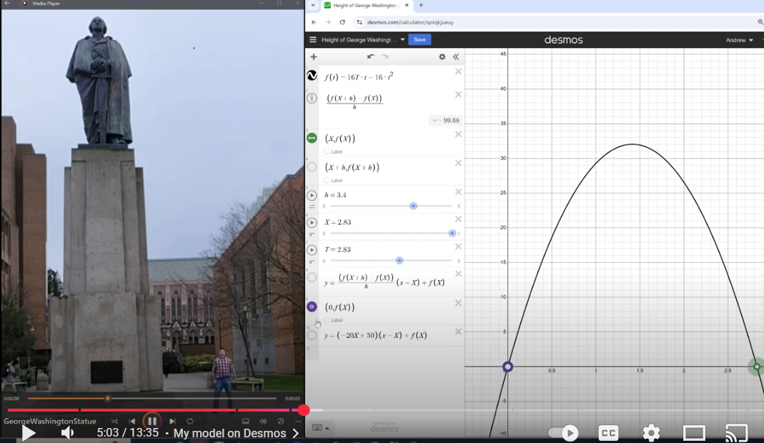](Video%20clip%20of%20me%20throwing%20a%20tennis%20ball)Example *(height of Washington Statue)*:

Find the t and y coordinates of the vertex of the following function

$$y=-16t^{2}+48t+6$$

Click for [video clip of throwing a tennis ball](https://youtu.be/07TDV5SgJT4?si=Xnv6iPNQeQhcGnB2&t=237)

**Parabola Summary & Basics**

If *a* is negative, the parabola opens downward.

For example: $y=-5x^{2}+20x+30$.

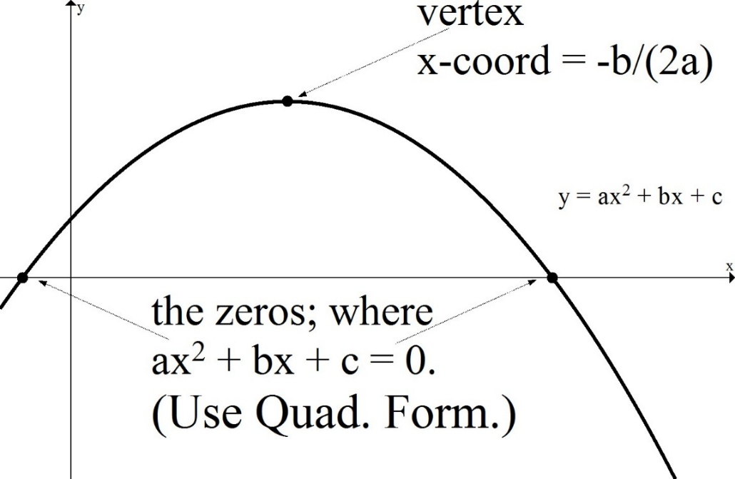

Note: A **quadratic equation** is an equation that can be written in the form

$ax^{2}+bx+c=0$.

The solution(s) are given by the *quadratic formula*

$$x=\frac{-b±\sqrt{b^{2}-4ac}}{2a}$$

If *a* is positive, the parabola opens upward.

For example: $y=2x^{2}+28x+4$.

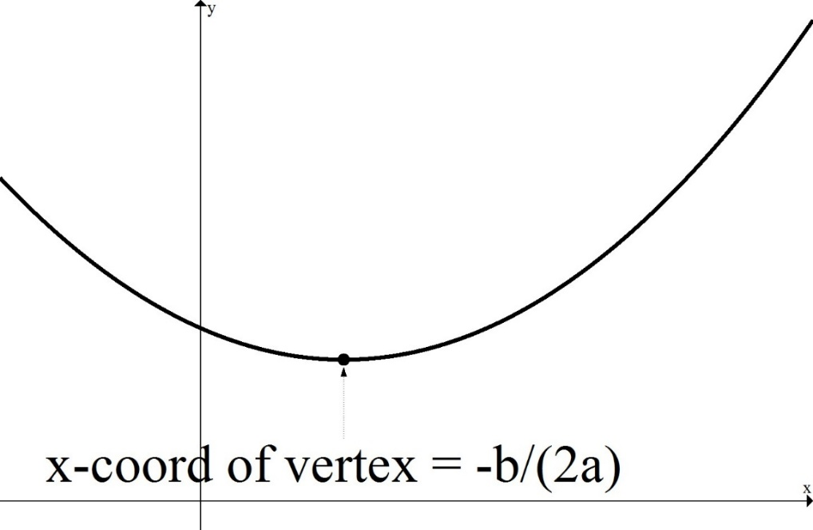

***Optimization Problems***

* Draw/Label,
* What do we want?
* What are we given?

*Example*: You have 500 feet of fencing and you want to build a cage with one wall in the middle as shown.

How should you build it to maximize area?

*Example*: You run a petting zoo.

If you charge $8, you will sell 300 tickets/day giving a revenue of $2400 for that day.

If you charge $9, you will sell 280 tickets/day giving a revenue of $2520 for that day.

Assume tickets sold is a linear function of price, x.

Find the formula for tickets sold base on x.

How many tickets should you sell to maximize revenue? (and *what is the max revenue?* and *what is the price?)*

*Example*: A ball is following the path given

by $y=-\frac{1}{5}x^{2}+4x$. In addition, the ground is sloping downward $y=-\frac{1}{10}x.$ This is shown at right.

How would you find the following…

1. The highest y-value of the ball.
2. The location of the ball when it is farthest above the sloping ground.

[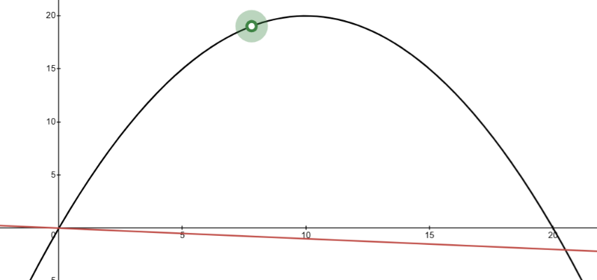](https://www.desmos.com/calculator/svjixeogiu)

[Link to desmos visual](https://www.desmos.com/calculator/svjixeogiu).

1. The location where the ball hits the ground.