**Ch 5: Functions and Graphs**

Goal: Function concept, graphs and notation

*Motivating Example:* Andy leaves his office in Padelford Hall on his way to teach in Kane Hall which is 2400 feet away.

Let *y* = *f*(*t*) be Andy’s distance from Padelford Hall in feet after t minutes.

Sketch a rough graph of each of the following functions…

1. Andy walks at a constant speed and get to Kane Hall in 10 minutes.
2. Andy walks at a constant speed for 5 minutes, gets halfway and is out of breath and stops for 2.5 minute, then decides to go back to his office walking twice as fast for 2.5 minutes.

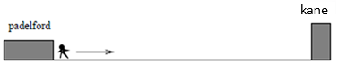

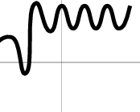**Terminology**

*Definition*: A **function** is a procedure for assigning a unique output for each allowable input. It has three parts:

1. $y=f\left(x\right)=$ `a rule’ (*a table, graph, expression or description*)
2. **Domain**: A set of allowable inputs.
3. **Range**: A set of outputs.

Example: Sketch a graph and give domain range

* $h\left(t\right)=$“height as a function of age”
* $g\left(x\right)="$ value of y in terms of x in the graph”

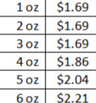

* $p\left(w\right)=$“price to send a package as a function of weight” (table given below)

***Functions from mathematical expressions***

***Example***:

Sketch and give the domain and range of

$$w\left(x\right)=\sqrt{x-2}$$

Note: In order to be a “function” it must have only one output for each allowable input to avoid ambiguity. Visually this means the graph passes the ***vertical line test*.**

*Examples from homework:*

Are any of these functions?

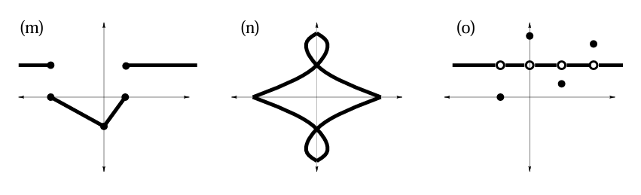

**Semicircles**

The graph of all point satisfying the equation

$x^{2}+y^{2}=9$ does not give a function!

Instead we way that this equation *implicitly* defines more than one function.

***Functional Notation***:

Example: $f\left(x\right)=4-x^{2}$

Compute or simplify the following…

1. $f\left(0\right), f\left(1\right),$ and $f\left(2\right)$
$2f\left(0\right)-3f\left(1\right)+7$

$f\left(2t\right)+3f\left(w\right)$

$f\left(x+h\right)$

2. $\frac{f\left(x+h\right)-f\left(x\right)}{h}$ (*completely simplify!*)

***Try Again***

Example: $g\left(x\right)={2x}^{2}-3x$

$$\frac{g\left(x+h\right)-g\left(x\right)}{h}= ?$$

Example: $w\left(x\right)=\sqrt{x-3}$ (*challenge*)

$$\frac{w\left(x+h\right)-w\left(x\right)}{h}= ?$$