**Ch 4: Linear Modeling**

**Chapter 4 (part 1) Key Facts**

* + where slope = $m=\frac{y_{2} - y_{1}}{x_{2}-x_{1}}$
  + parallel same slope
  + perpendicular negative reciprocal slope

Goal: Finding and using equations for lines

*Motivating Example:* The (average) sale price for a home in Seattle is given

|  |  |
| --- | --- |
| **YEAR** | **PRICE** |
| 1970 | $38,000 |
| 1990 | $175,000 |

Assume the newspaper in 1990 used a “linear model” based on this data to try to predict the home value in 2010.

What prediction did they get?

[*more data and visual*](https://www.desmos.com/calculator/yx6mz0dhvo)

**Derivation**

Think about the “condition” for what it means for a point $(x,y)$ to be on a line.

*What do all points on a line have in common?*

Given **ANY** two different points on the line

* $(x_{1},y_{1})$ and $(x_{2},y_{2})$

We define

$$slope=\frac{rise}{run}=m=\frac{Δy}{Δx}=\frac{y_{2}-y_{1}}{x_{2}-x_{1}}$$

*Key observation*

Now what can we say if $\left(x,y\right)$ is another point on the line?

*Example 1*: Find the equation of the line through the points (1,3) and (-2,5).

* What is the y-intercept of this line?

***Parallel Lines***: Two lines are parallel if they have the same slopes.

*Example 2*: Find the equation of the line through the point (-1,4) that is parallel to the line $y=\frac{7}{2}(x+2)+5$

***Perpendicular Lines***: Two non-vertical lines are parallel if they have the same slopes.

*Example 3*: Find the equation of the line through the point (2,3) that is perpendicular to the line $y-5=3(x-1)$

**Perpendicular lines have LOTS of applications** Here are two from homework…

* + Finding locations on a line “closest” to a given point.

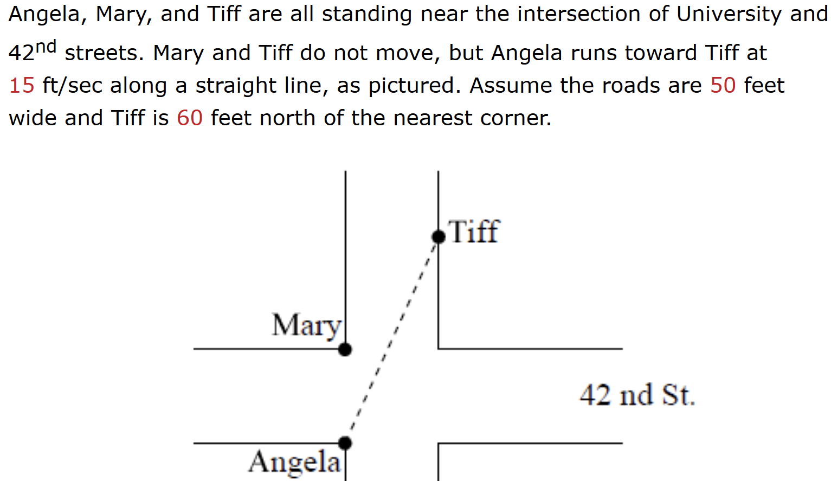

* + And finding tangent lines to circles.

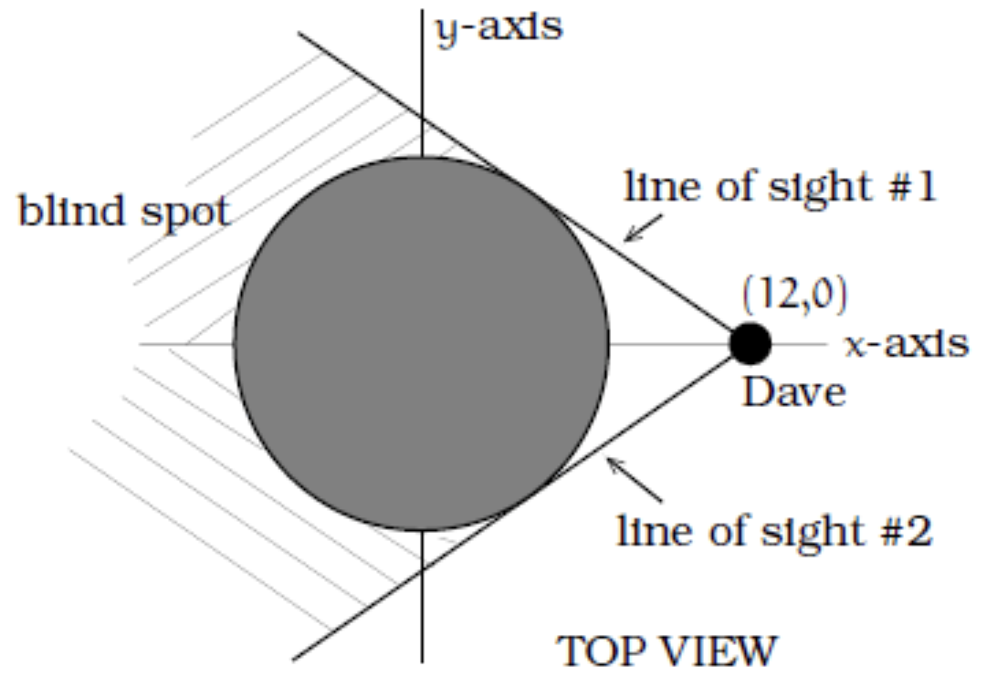

**Fact**: Quadratic Formula

Given a quadratic equation of

the form $ax^{2}+bx+c=0$,

we have

$$x=\frac{-b±\sqrt{b^{2}-4ac}}{2a}$$

*Example*:

Solve $3x^{2}+4x-1=7+x$

Putting it all together…

***Example***: A golf ball is located at the indicated position. The circular green has radius 30 feet. The ball is struck in a way that it travels at a constant speed of 10 ft/sec from its starting location to the right-most edge of the green (viewed from above).

1. Where does the ball enter the green?
2. When does it enter the green?
3. Where is it located when it is closest to the cup?

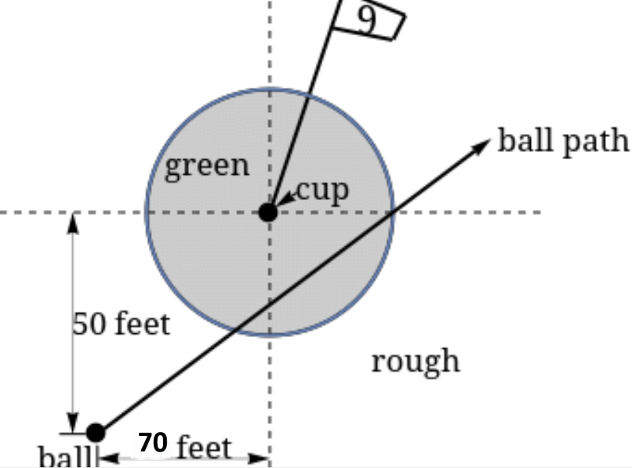

**Ch 4 (pt 2): Uniform Linear Motion**

**Chapter 4 (part 2) Key Facts**

For an object moving at a constant speed from $(x_{1},y_{1})$ at time $t=0$ to $(x_{2},y_{2})$ at time

* + and $v_{y}=\frac{Δy}{Δt}=\frac{y_{2}-y_{1}}{T }$

Goal: A small taste of parametric equations

*Example*: Penelope is at the point (1,0) and runs at a constant speed toward the point (7,4) (in feet). It takes her 2 seconds.

1. What is her speed?
2. Find parametric equations that give her location at time t second after leaving the point (1,0).

***Example***: Ron is standing 200 feet due west of the space needle waiting for Harry.

Harry is 200 feet south and 300 feet west of the space needle, then walks toward the space needle getting there in 5 seconds.

1. Find parametric equations for Harry’s location at time t seconds.
2. Find the linear equation for the path of Harry’s walk (in the form y = mx+b)
3. When is Harry closest to Ron.