**Ch 3: Three Simple Curves**

**Chapter 3 Key Facts**

* Horizontal Line: $y=k$
* Vertical Line: $x=h$
* Circle: ${\left(x-h\right)}^{2}+{\left(y-k\right)}^{2}=r^{2}$
  + where $(h, k)$ = center, $r$ = radius

Goal: Circles, horiz. lines and vertical lines

*Terminology and Conditions*

1. **Horizontal Lines**

Draw the collection of all points (x, y) such that y = 3 and x can be any number.

1. **Vertical Lines**

Draw the collection of all points (x, y) such that x = -2 and y can be any number.

***Example****: (Ch 3 Q5a)*

In the picture,

Edmonds is 8 miles north and 1 mile east of Ballard.

Kingston is 6 miles west of Edmonds.

A ferry leaves Kingston heading toward Edmonds at 12 mph.

After 20 minutes, the ferry turns heading south.

1. Impose a coordinate system with Ballard as the origin.
2. Give the horiz. and vertical lines of the ferry’s path.

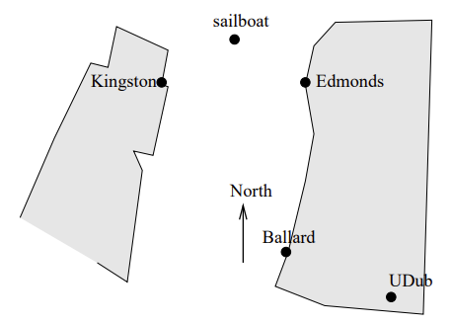

1. Circles

*Example*:

Give me a center point (h, k) = ( , )

Give me a radius =

Now write down the equation that says…

“the dist. from (x, y) to (h, k) equal r”

Follow-up questions:

* How could we give a condition for the points on the “interior” of the circle?

*Some mechanical questions*

*Example:*

Give the equation of the circle centered at (2, -5) with a diameter of 6.

* Is the point (1,1) on this circle?

*Example:*

Give an example of a circle that has radius 2 and goes passes through the point (4,5).

*Some related algebra (Completing the Square)*

Example:

Find the center and radius of the circle…

Example:

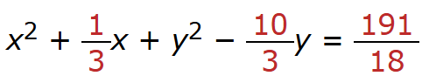Find the center and radius of the circle…

***Example****: (Ch 3 Q4)*

A ferris wheel has a radius of 50 ft. The center of the wheel is mounted on a tower 52 ft above the ground. Your friend is standing on a platform that is 60 feet above the ground and 100 feet along the ground from the center of ferris wheel.

At what location(s) will a rider on the ferris wheel be in line with the top of the platform?

***“Given-and-Want” Problem Solving***

1. Identify what we **want**

2. Identify what we are **given**

3. **Fact finding**: Label Unknowns; Write related formulas

4. **Solve**

***Building Your Own Problem-Solving Routine***

*You should be starting to make a note sheet with your “problem-solving” routine.*

*Here are two models I made up, but you should be building your own!*

***“V.E.T.S.” Problem Solving***

1. **V**isualize: Draw axes, label unknowns.

2. **E**quations: Equations for curves.

3. **T**ranslate: Convert words to math.

4. **S**olve: Find intersections, distances, anything you can.

Other notes:

* Check units at the start.
* Reread at the end, answer reasonable?
* We now can give equations for circles as well as horizontal and vertical lines.