Ch 20: Inverse Trig Functions
Goal: Define and use inverse trig functions.

Entry Task
Gavin’s (broken) oven has a temperature that behaves sinusoidally.
- At t=0: temp is 425°F and rising
- First max 450°F at t = 8.75 minutes
- First min 400°F at t = 26.25 minutes
- Find the sinusoidal model.
- Sketch the graph for 0–70 minutes.
- Consider the two questions:
  - What is the temperature at t = 20 minutes?
  - When is the temperature 440°F?

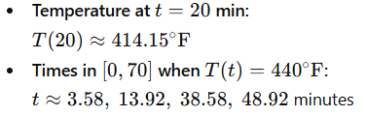

A motivating example
Find all solutions to $\sin\left(x\right)=\frac{1}{2}$.
Step 1: Draw y = sin(x) and the horizontal line y = ½
Step 2: Find the “principal solution” (closest to phase shift)
Step 3: Find the “symmetric solution” (next closest)
Step 4: Use the period to summarize the rest.

The inverse trig functions are defined to give the “principal solution”

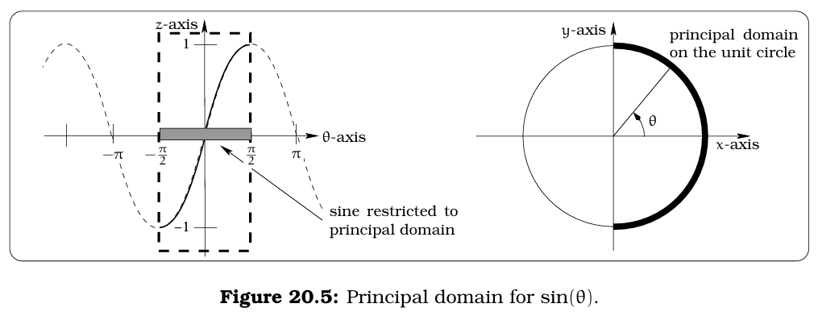

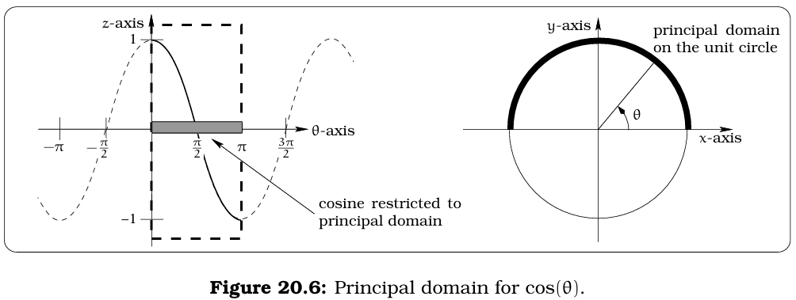

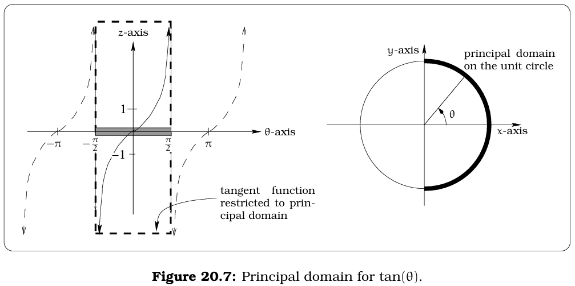

Solving Mechanics: Using your calculator, find the principal solution of the following equations (in radians):
$$1. 3tan(x)=4$$

$$2. 4cos(2x - 1)=1$$

$$3. sin(x)=3$$

- 3tan(x) = 4 → x ≈ 0.9273
- 4cos(2x − 1) = 1 → x ≈ 1.1591
- sin(x) = 3 → no solution
- e^(tan(x³)) = 10 → x ≈ 1.0510
- tan(sin(cos(x))) = 0.2 → x ≈ 1.3708
- sin²(x) = 0.09 → x ≈ 0.3047

$$4.{ e}^{\tan\left(x^{3}\right)}=10$$

$$5. tan(sin(cos(x))=0.2$$

$$6. \sin^{2}{(x)}=0.09$$

Okay, now how do we find other solutions?
Option 1: Graphical Reasoning Method
  - Find the principal solution.
  - Sketch a graph and find the nearest max/min.
  - Reflect horizontally for the symmetric solution.
  - Add the period for all solutions.
Example: Solve $3 sin\left(\frac{2π}{35}\left(t-10\right)\right)+4=5.$

First few solutions:

You try: Give all solutions to sin(x) = 0.6.

Option 2: Algebraic Method
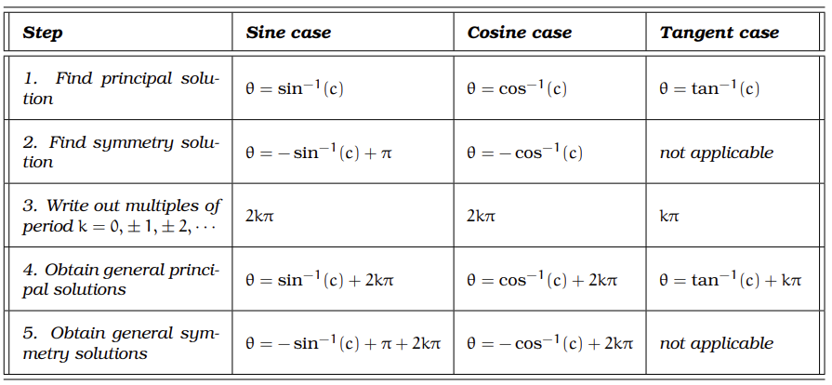

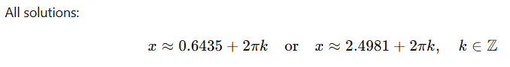
Full applied example: A weight hanging from a spring moves sinusoidally.
Lowest Point: 15 cm at t = 5 seconds.
Highest Point: 37 cm at t = 9.4 seconds.
During the first 20 seconds, how much time is the weight above 28 cm?

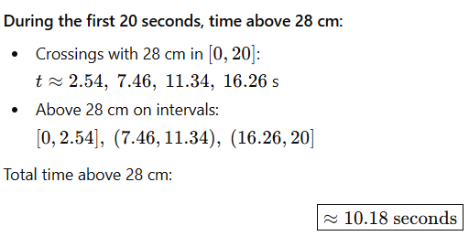

Another Example: Given $y=22 sin\left(\frac{2π}{18}\left(t-3\right)\right)+46$.
Find the first four positive values of t when this function equals 50.

