Ch 19: Sinusoidal Modeling
Goal: Modeling with sine waves. We will explore the parameters A, B, C and D for the model below.

The general sinusoidal model is given by

$$y=A sin\left[\frac{2π}{B}\left(x-C\right)\right]+D$$

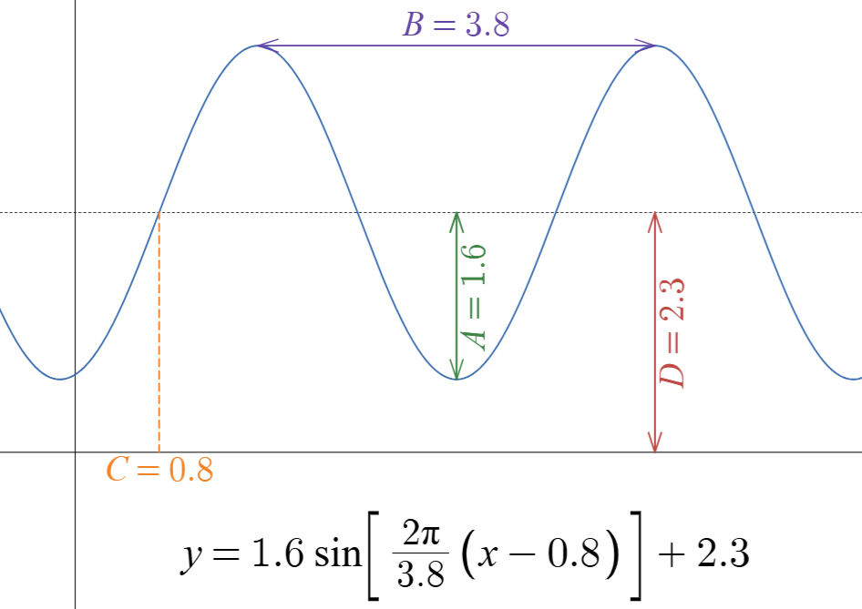

The graph above is a sneak peek at what these values.

And here is an interactive visual: https://www.desmos.com/calculator/kj5x696jbp

Motivation: There are a large number of applications, here are a few you will encounter regularly in your life including sound, light, mechanical, & signal processing.

Click here for a visual of a mechanical oscillation that you will see as an example in math and physics.

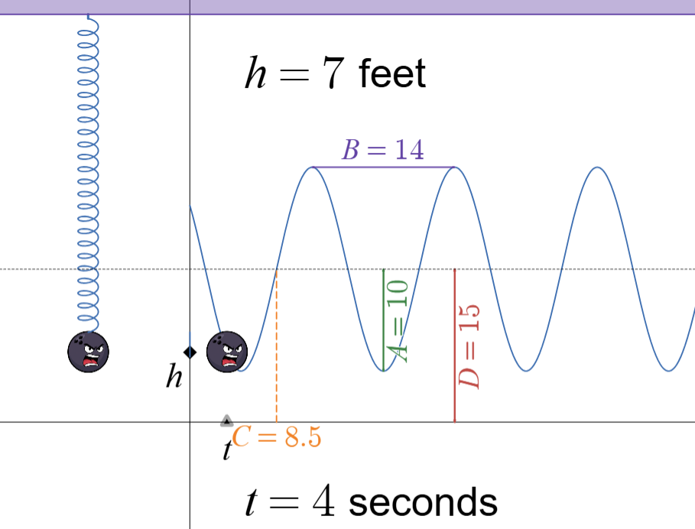

Finding D – the “mean” value of the wave

$$y=sin(x)+D$$

Q: What does “D” to the graph of y = sin(x)?

Q: How would you find D in the following graph?

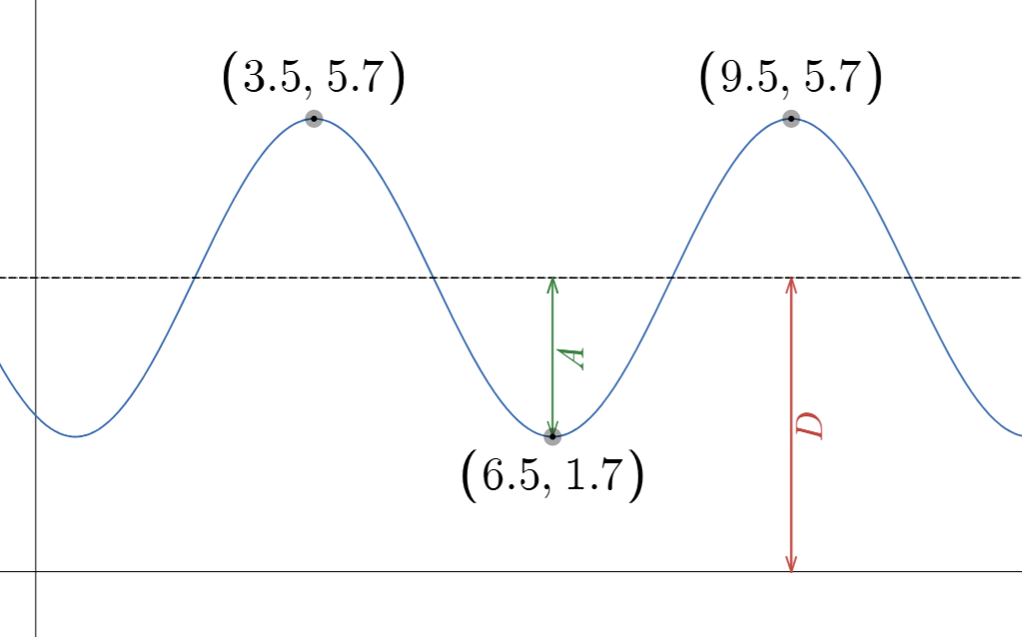

Finding A – the “amplitude” of the wave

$$y=A sin(x)$$

Q: What does “A” do to the graph of y = sin(x)?

Q: How would you find D in the following graph?

Finding B – the “period” of the wave

$$y=sin\left[\frac{2π}{B}x\right]$$

Q: What does “B” to the graph of y = sin(x)?

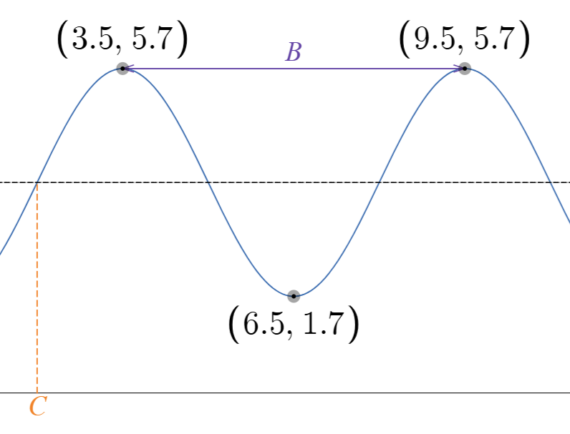
Q: How would you find B in the following graph?

Finding C – the “phase shift” of the wave

$$y= sin\left(x-C\right)$$

Q: What does “C” do to the graph of y = sin(x)?

Q: How would you find C in the following graph?

Summary: In the general sinusoidal model

$$y=A sin\left[\frac{2π}{B}\left(x-C\right)\right]+D$$

- $A=amplitude=\frac{max output - min output}{2}$
- $D=mean =\frac{max output + min output}{2}$
- $B=period =horiz. dist from peak-to-peak$
- $C=phase shift=x-coordinate of a peak-\frac{B}{4}$

You try:
Find the model given that the function has a peak at (3.1, 5.4) then a valley at (4.9, 2.6).

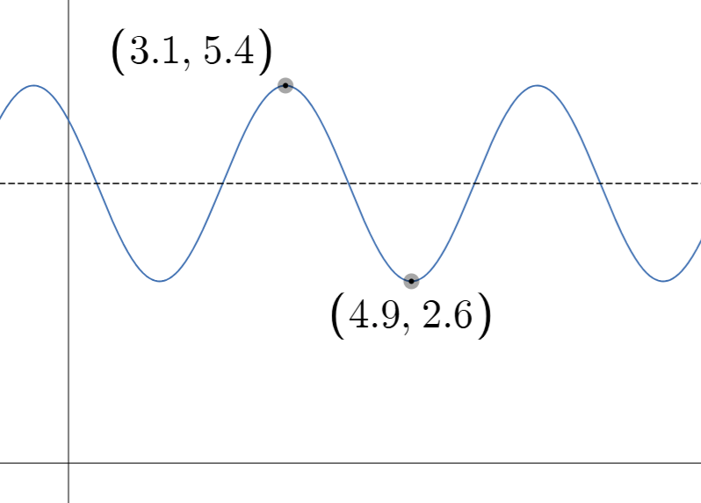

Tip: When reading homework and doing exam questions, I encourage you to think about the picture first!
Drawing a given wave

Example: Sketch a graph of $y=2 sin\left[\frac{2π}{3}\left(x-2\right)\right]+5$

Standard form note:
Recall, the order of transformations matters. If you want to use this model in this form, you must write it in this form.

Example: Sketch a graph of $y=4\left(sin(2x-6)+5\right)$

Other notes that might be of value of you.

Phase shift:
There are an infinite number of choices for the phase shift. It can be any value of x where the graph crosses the mean line and is increasing.

Period over 4 Trick:
The graph goes from mean line to peak to mean line to valley to mean line in a full wave cycle.
Each transition is a fourth of a period.

Wavelength:
The period is sometimes called the wavelength, they mean the same thing.

Frequency:
The inverse of the period is called the frequency which gives the number of waves per second.

