Ch 18: Properties and Graphs of Trig Functions

Goal: Learn the fundamental properties and graphs of sin(x), cos(x) and tan(x).

Entry Task: Think about the unit circle. What are the (x,y) values at the following angles…

- $θ= π/4$

- $θ= π/2$

- $θ= 2π/3$

What is the equation satisfied by all points on the unit circle?
Check that your points work in this equation?

What does this tell us about sin($θ$) and cos($θ$)?

Now let’s look at the unit circle, what other properties to you notice about the x and y coordinates? And what does that mean about sin(x) and cos(x)?

- Symmetry observations?

- Shifting observations?

- Repeating? (Periodicity)

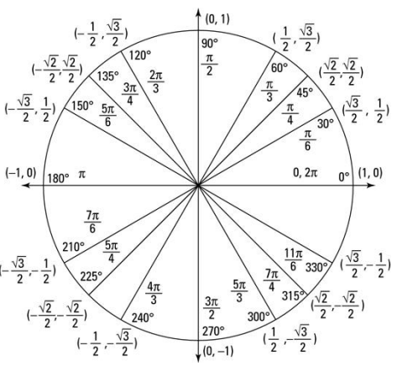

Follow-up: What can you say about $\tan\left(θ\right)$?

Tips for graphing trig functions:
- Use the range.
- Use the symmetry, periodicity, and shifting.
- Plot points
  - First, plot: $0, \frac{π}{2}, π, \frac{3π}{2}$
  - Then, plot: $\frac{π}{6}, \frac{π}{4}, \frac{π}{3}$

Example: Graph y = sin(x).

Example: Graph y = cos(x).

Example: Graph y = tan(x).

Tip: Write in terms of sin(x) and cos(x) and think of I like a rational function

Example: Graph y = sec(x).

Identities

A trig identity is an equation involving trig functions that is true for all possible inputs. There are many, many trig identities (entire books).

But the vast majority of the time, the main identity you need is this one…

- $\cos^{2}\left(x\right)+\sin^{2}\left(x\right)=1$

Let’s toy around with that identity
Example: If $\cos\left(θ\right)=\frac{1}{6}$ and the angle is in the first quadrant,
then what is $\sin\left(θ\right)$ and $\tan\left(θ\right)$?

Example (the “triangle trick”): If$tan\left(θ\right)=\frac{3}{4}$ and the angle is in the first quadrant, then what are ALL the other trig functions at this angle.

This page is optional but previous some identities that you’ll see in small bits in Math 124 and Math 125.

Half-Angle Identities
- $\sin^{2}\left(x\right)=\frac{1}{2}\left(1-\cos\left(2x\right)\right)$
- $\cos^{2}\left(x\right)=\frac{1}{2}\left(1+\cos\left(2x\right)\right)$
- $\cos\left(x\right)sin\left(x\right)=\frac{1}{2}sin\left(2x\right)$

Example (other “nice” values of trig):
What is $\sin\left(\frac{π}{8}\right)$ in exact form?

What is $\cos\left(\frac{π}{12}\right)$ in exact form?

Sum Identities
- $sin\left(A+B\right)=sin\left(A\right)cos\left(B\right)+cos\left(A\right)sin\left(B\right)$
- $cos\left(A+B\right)=cos\left(A\right)cos\left(B\right)-sin\left(A\right)sin\left(B\right)$

Example (more “nice” values of trig):
What is $\sin\left(\frac{π}{8}+\frac{π}{4}\right)$ in exact form?

Side Note: What to do if your triangle is NOT a “right”

Two useful facts:

Law of Cosines (a generalized Pythagorean theorem)

$$c^{2}=a^{2}+b^{2}-2ab\cos\left(θ\right)$$

Law of Sines (equal ratios)

$$\frac{a}{\sin\left(α\right)}=\frac{b}{\sin\left(β\right)}$$

