Ch 17: The Trig and Circular Functions
Goal: Learn how to find the (x,y) coordinates on a circle given an angle and radius.

Consider a right triangle with one angle $θ$.

We give the following names to the six ratios of the sides…

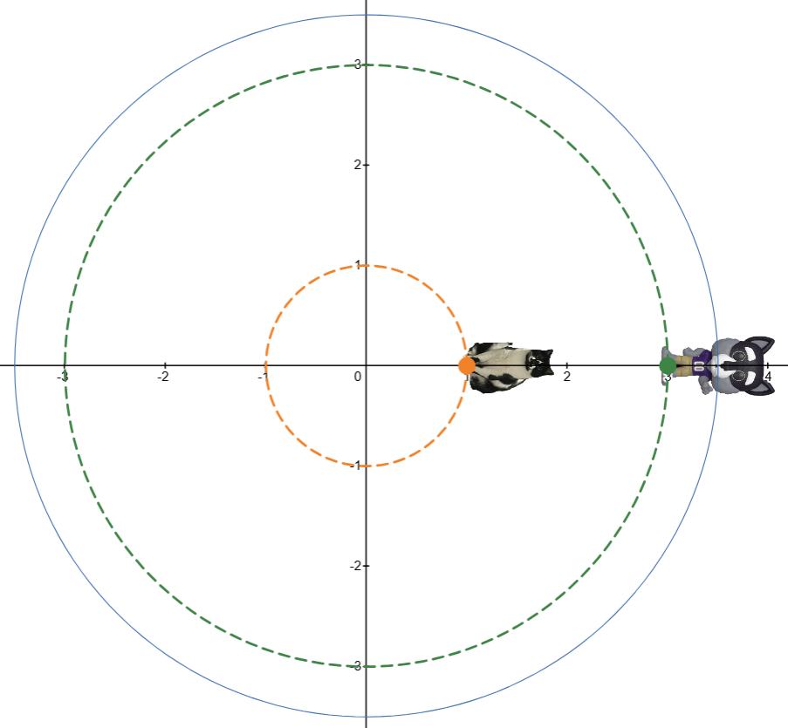

Animation: https://www.desmos.com/calculator/cr3jyzibfu

Fundamental Observation:
- The radius matters! You can’t go from linear speed to angular speed (or vice versa) without the radius.

Two ways to measure circular motion:

- Linear speed: $v = \frac{d}{t}$
  - $linear speed=\frac{distance}{time}$
  - unit examples:

- Angular speed: $ω = \frac{θ}{t}$
  - $angular speed=\frac{angle}{time}$
  - unit examples:

Conversion Notes:
- $1 revolution angle= 360° = 2π radians$
- $1 revolution dist =circumference = 2πr$

Example: The wheels of a car are turning at 200 RPM.
- Convert to radians/min and degree/min.

- If the radius of the tire is 3 feet, find the linear speed of the edge of the tire (note: this is the same as speed of the car).

Summary and Key Formulas
Given an object going around circle at a constant speed, we label
- $r=\text{radius} = distance of object from the center$
- $θ=\text{angle rotated}$
- $t=time$
and we label and compute…
- $arc length\text{ = s }=θr$
- $linear speed\text{ = v }=\frac{s}{t}$
- $angular speed\text{ = }ω =\frac{θ}{t}$

Q: One of these formulas MUST have $θ$ in radians.
Do you remember which one?

The fundamental formula relating linear and angular speed can be obtained by putting these equations together, try it…

Side Comment on the “Name” of this Formula:
This formula doesn’t have a formal math name as far as I know, so I am taking suggestions.

Here are some of my bad naming attempts:
“Spin-to-Speed Converter” “The Angulinear Speed Formula”
“Speed Exchange Program” “Wheelationship Formula”
“You spin me right round formula” “Round-round get around formula”

Engineering/Physics names:
“Tangential Velocity Formula” “Linear-Angular Velocity Relationship”
“No-Slip Condition” “Gear Ratio Law”

Quick Example:
A bicycle is moving at 30 mph. A reflector in the tire spokes makes 5 revolutions per second.
What is the radius of the wheel?

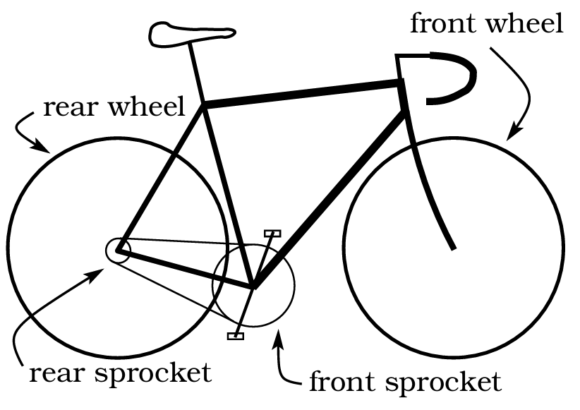

Belt and Wheel Problem Key Facts:
- Same center (or axle) implies same angular speed.
- Connected by a belt (or chain) implies same linear speed.
- If using radians, then $v=wr.$

Example: For the bicycle shown…
Belt and Wheel Problem Key Facts (again):
- Same center (or axle) implies same angular speed.
- Connected by a belt (or chain) implies same linear speed.
- If using radians, then $v=wr.$

- radius of the wheels = 30 inches
- radius of the rear sprocket = 4 inches
- radius of the front sprocket = 8 inches
How many revolutions per minute of the pedals will make the bike go 35 mph (36960 in/min)?

Some belt and wheel systems you may have seen besides a bike:

A car

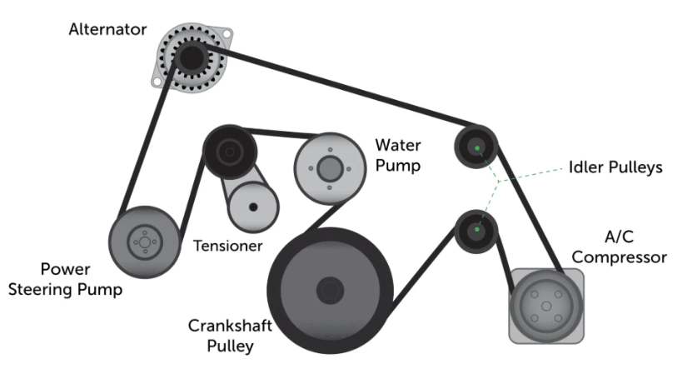
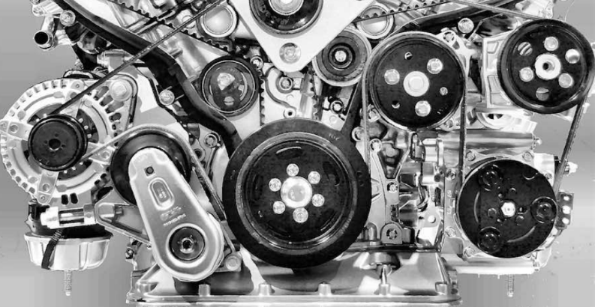

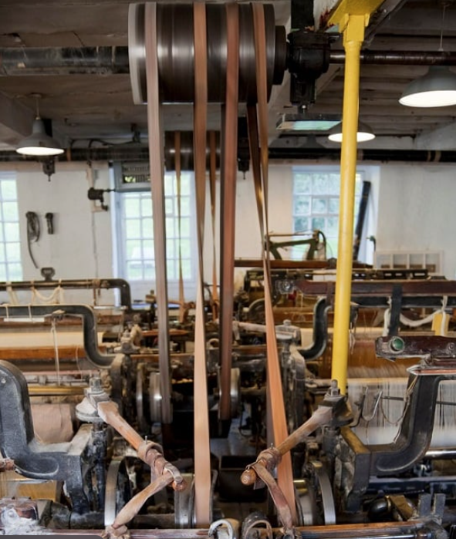
A factory

Inside the “Big Ben” clock
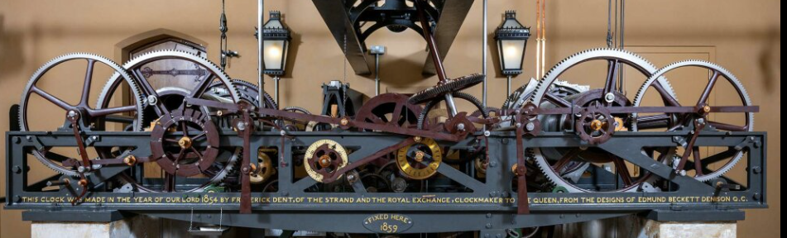

An Escalator


Legos


From a motor sales website:
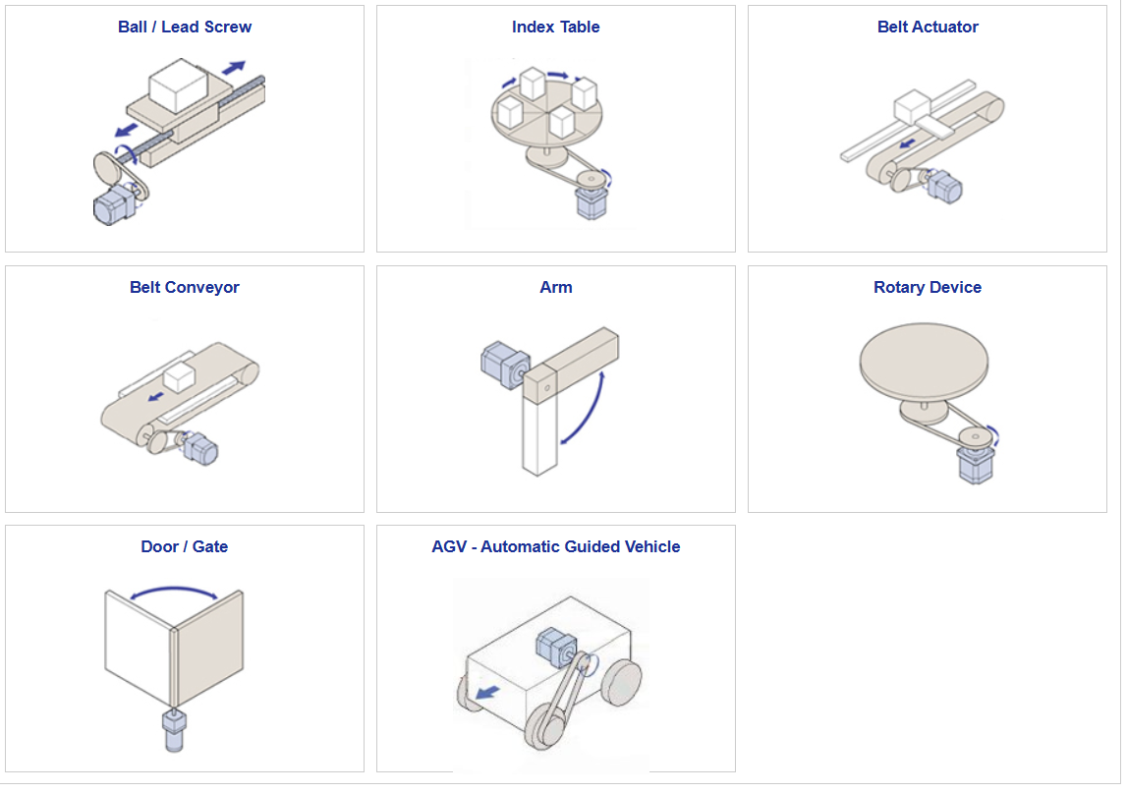

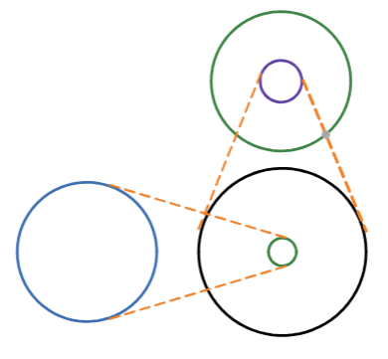
Another example:
You are given the following information:
A: r = 10 in, v = 10,000 in/min
B: r = 2 in
C:
D: r = 3 in
E: r = 10 in, w = 20,000 rad/min

What is the radius of C?

