Ch 17 (part 2): Circular Motion
Key Fact:
If (x, y) is a point on the circle $x^{2}+y^{2}=r^{2}$ and $θ$ is the angle measured in standard position,
then $x=r cos\left(θ\right)$ $y=r sin\left(θ\right)$

Entry Task:
Harry is standing on the easternmost edge of a circular track with radius 40 feet.

Harry rotates 10 degrees per second counterclockwise.

- Where will he be in…
  - 5 seconds?
  - 9 seconds?
  - 1 minute?

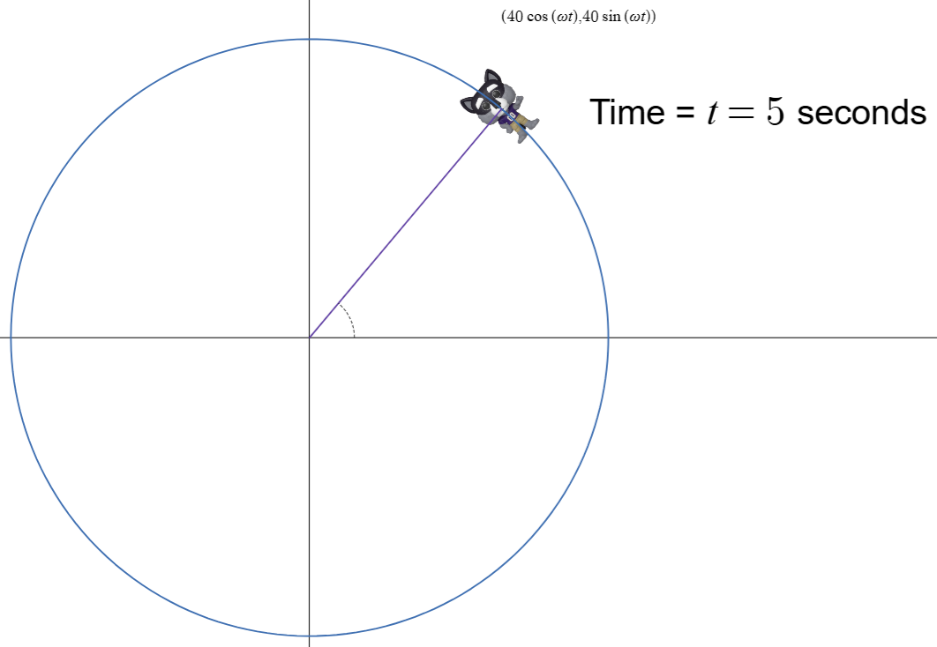

https://www.desmos.com/calculator/x0ta8dra9h

Idea: Find the angle and plug in

In many applications that typically involves finding

- $θ_{0}=$ starting angle
- $ω =$angular speed (in matching angle & time units)
- $t =$time
Then we compute:
$$θ=θ_{0}+ωt$$

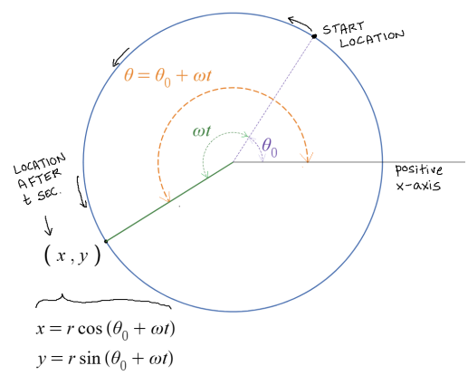

Example:
Penelope starts at the southernmost edge of a merry-go-round of radius 8 feet and is rotating counterclockwise at 2 rad/sec.

Assume the center of the merry-go-round is the origin and south is the negative y-axis.

- Find the general formula for Pen’s location, (x(t),y(t)).

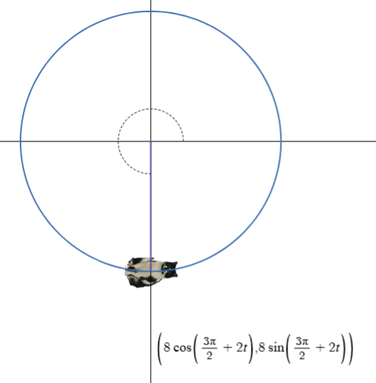

https://www.desmos.com/calculator/u0gik5czgc
- Where will Pen be located in 3 seconds?

Let’s play consider different angle situations:

Example 1: Radius is $r=1$mile.
Starting angle is 0.5 radians.
Objects travels at a constant speed counterclockwise and ot takes 4 minutes to complete a lap.
Give the equations for motion…

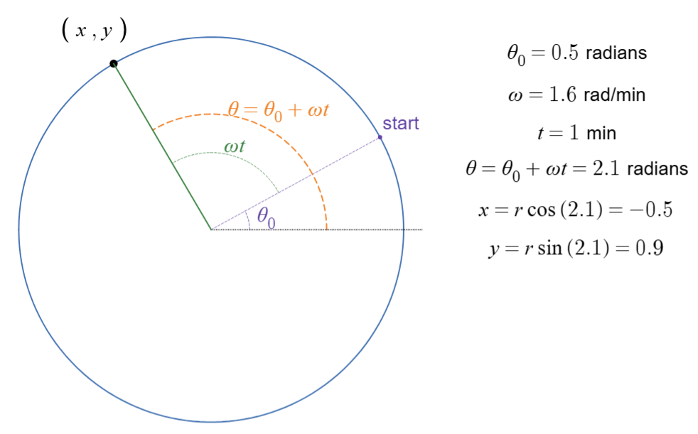

Example 1 Animation: https://www.desmos.com/calculator/stpfocn3if

Example 2: Radius is $r=1$mile.
The angular speed is 1.2 rad/sec counterclockwise.
From the starting position it takes 3 seconds to get to the northernmost point.
What is the initial angle?

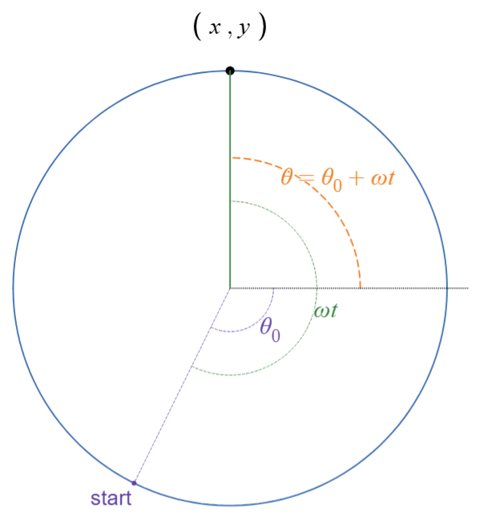

Example 3: Radius is $r=1$mile.
Lilo starts at the easternmost point. Lilo rotates clockwise at 0.6 rad/min.
Stitch starts at the northernmost point and goes counterclockwise. He is rotating 4 times after than Lilo.

Find the (x,y) location where they meet.

