Ch 15: Measuring Angles
Goal: Radians, Degrees, what is $π$, area and arc length of a wedge

Before we start, a check in on chapter 14…

Entry Task: Problem 2 from Ch 14 HW (algebra challenge)
Find the linear-to-linear function whose graph passes through the points (1, 1), (6, 2), and (30, 5).

- Do you know how to start this?
- Do you have a solving strategy?
- Can you do it in exact form?
- If the problem asks for the horizontal asymptote, can you find it?

Ch. 15 Angles
Motivation
Imaging Olaf it waking around a circular track.
- How do we describe the “angle” he forms?
- How far has he traveled based on that “angle”?
- What is the area of the wedge based on that “angle”?

Definition
An angle is the union of an initial ray and a terminal ray (you must specify which is which).

Standard Position
Given a coordinate system, standard position refers to…
- Origin is the “vertex”
- Positive x-axis is the initial ray
- Positive angle $⇔$ counterclockwise
Negative angle $⇔$ clockwise

Two methods for measuring (degree and radian)
Degree Method
Take a circle, great it into 360 equal slices
1 slice = 1 degree = 1°
Examples: Draw several examples of degrees…

Note: If we need even finer slices, we cut up a degree into “minutes” and “seconds” as follows:
1 degree = 60 minutes = 60’
1 minute = 60 seconds = 60”
Example: What is 7° 13’ 44” in degrees?

Arc Length and Degrees
An arc is the edge of a circle that is swept out by an angle.
Key observations
- Length around entire circle = circumference =
- Length of arc = “fraction of circle” $∙$“circumference”

- Area of the entire circle =
- Area of a wedge = “fraction of circle” $∙$“area”

General Formula
For a wedge of a circle of radius r made by angle $θ$ degrees?

Arc Length =

Wedge Area =

Example: A circle has radius 10, find the arc length and area…
…for a 90° angle.

…for a 30° angle.

Radian Method
Q: How can we change the number of slices to make the arc length formula as “nice” as possible?

A:

General Formula
For a wedge of a circle of radius r made by angle $θ$ radians?

Arc Length =

Wedge Area =

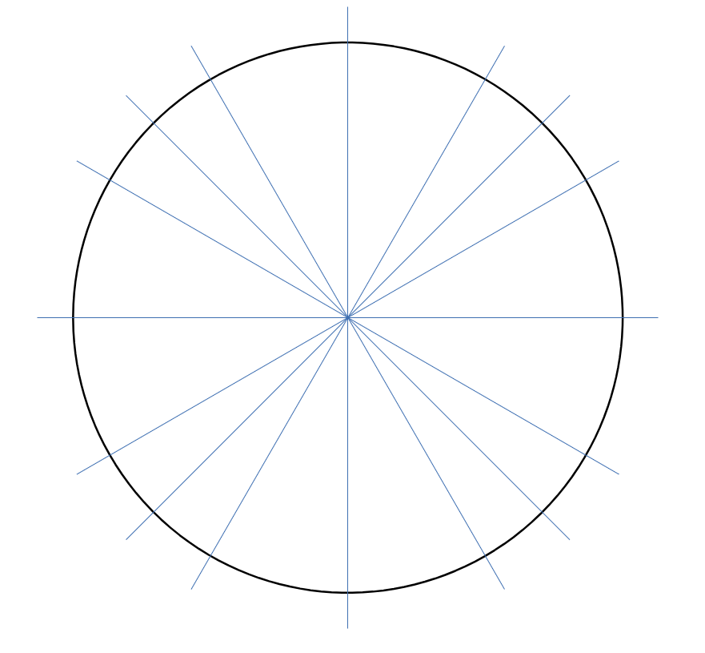
Radian Basics
2π radians = 360 degrees
π radians = 180 degrees
You can use this as a conversion.

It will be vital for your success in future quarter to know by memory the angles you get when you subdivide quarters of the circle into half and thirds.
In other words, can you fill in the following angles in standard position in degrees and radians?

Homework notes: Here are screenshots of some of the HW
