Ch 13: Moving Functions Around –
 | Formula | Effect |  | Formula | Effect
 | $$y=f(x)+k$$ | Up by k |  | $$y=f(x–h)$$ | Right by h
 | $$y= –f(x)$$ | Flip vertically |  | $$y=f(–x)$$ | Flip horizontally
 | $$y=a f(x)$$ | Multiply y by a |  | $$y=f(bx)$$ | Multiply x by 1/b

Shifting, Dilating and Reflecting

Entry Task: Try to draw these graphs…
- Draw the graph of $f\left(x\right)=\left|x\right|$.

- Draw the graph of $y=f\left(x-1\right)$.

- Draw the graph of $y=f\left(x\right)-2$.

- Draw the graph of $y=-f\left(x\right)$.

- Draw the graph of $y=-3f\left(2(x-1)\right)$.

If multiple operations appear use
- my $\left(x_{old},y_{old}\right)$ to $\left(x_{new},y_{new}\right)$method and plot points (I’ll show you now!).

- Or use “standard form” (dilating comes first):
  - $y=af\left(b\left(x-c\right)\right)+d$
- Or replace in order like the book.

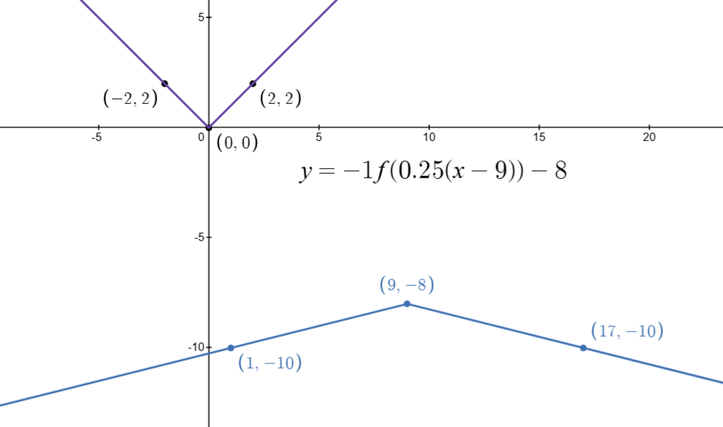

https://www.desmos.com/calculator/d15ic8semm

Example: Shifting and Dilating Quadratics
Consider
$$y=f(x)=x^{2}$$
What do the following look like…
- $y=f(x+2)$

- $y=-f\left(x\right)+3$

- $y=-3f\left(\frac{1}{2}x\right)$

- $y=-3f\left(\frac{1}{2}\left(x-12\right)\right)+17$

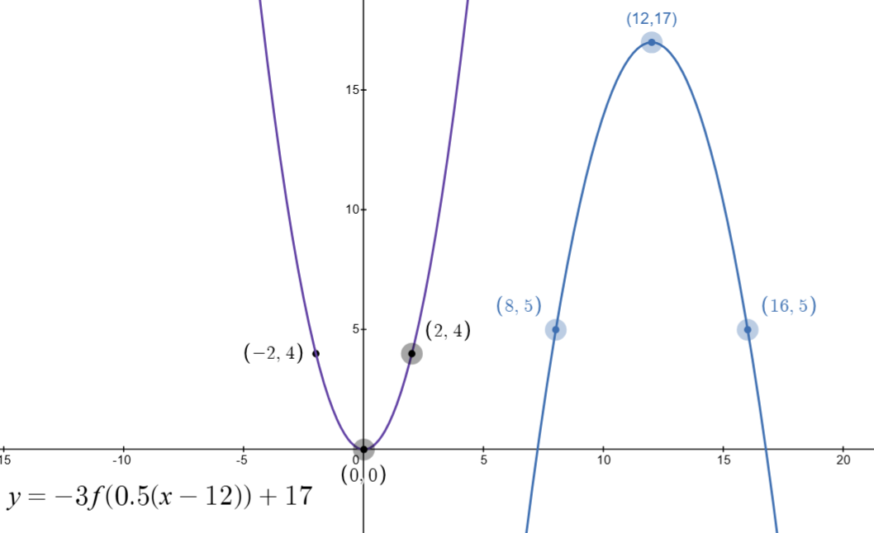
Here is a visual of that last example…
$$y=-3f\left(\frac{1}{2}\left(x-12\right)\right)+17$$

https://www.desmos.com/calculator/smlcsrhrle

Example: Shifting and Dilating Exponentials
Consider
$$y=f(x)=2^{x}$$
What do the following look like…
- $y=3f(x)$

- $y=f\left(-x\right)+3$

- $y=-3f\left(x-5\right)+4$

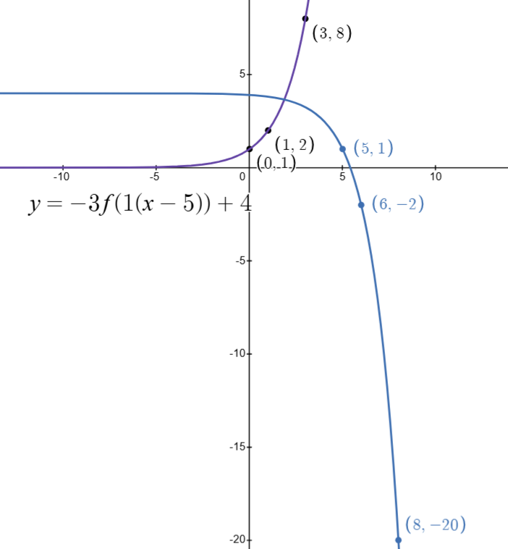

Example: Shifting and Dilating Lines
Consider
$$y=f\left(x\right)=x$$
What do the following look like…
- $y=2f\left(x-3\right)+4$

- $y=-3f\left(x+2\right)+1$

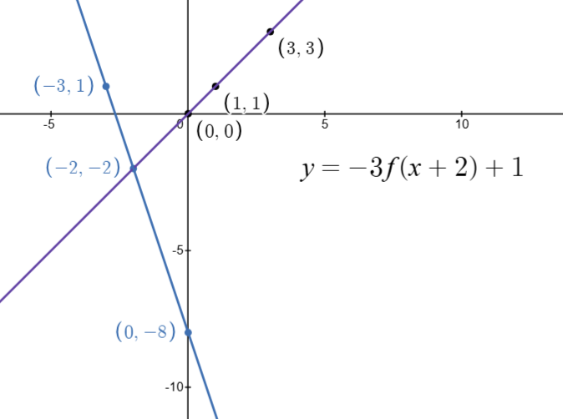

https://www.desmos.com/calculator/ifvwyzkpl3

Example: Shifting and Dilating Circles
Consider
$$x^{2}+y^{2}=4$$
What do the following look like…
- ${(x-5)}^{2}+{(y+3)}^{2}=4$

- ${(2(x-6))}^{2}+{(y-4)}^{2}=4$

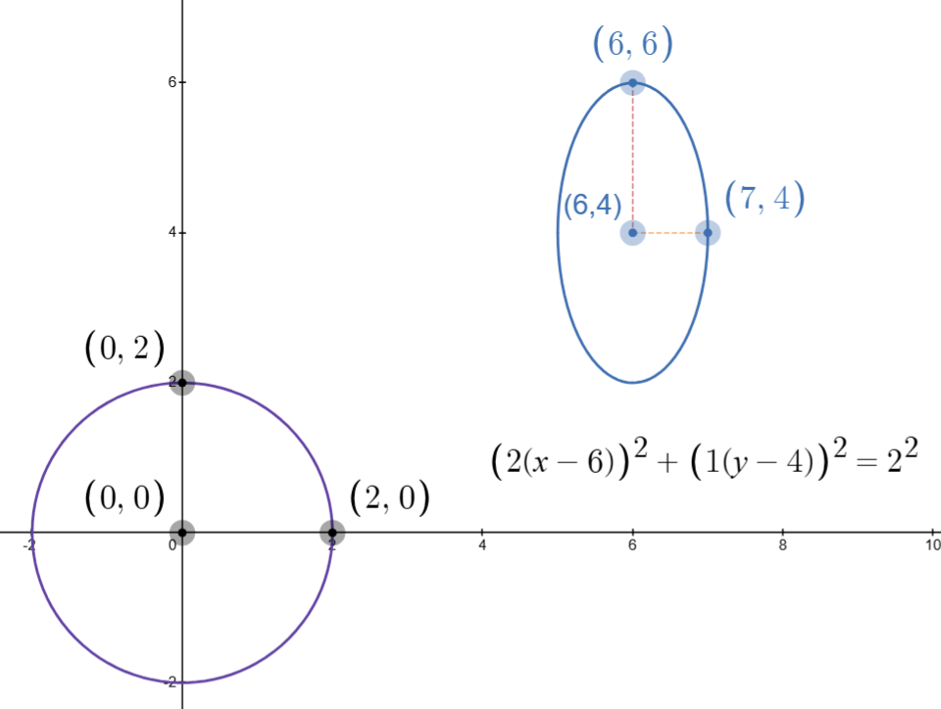

https://www.desmos.com/calculator/av3kc9wjoe

