Ch 11: Modeling Recap plus $y = e^{x}$

Goal: Learn the number $e$. Review the concept of modeling.
Entry Task: (Conroy Fall 2011 Exam 2)
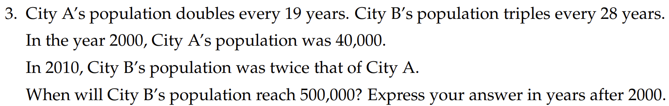

Read and plug in the given info to the models, then stop...
- City A: $y= a{⋅b}^{t}$

$y=a{ e}^{rx}$ is a special case of our exponential model
$a$ is still the y-intercept and ${b=e}^{r}$
$r>0$ gives exponential growth
$r<0$ gives exponential decay

- City B: $y= a{⋅b}^{t}$

Some Graphs and Examples (get your calculator out)
$y=a{ e}^{rx}$ Note: $a$ is still the y-intercept and ${b=e}^{r}$
Example 1: Let $a=5$ and $r=0.03$, then what does the graph look like?

Example 2: If $a=100$ and $r=-0.05$, then what does the graph look like?

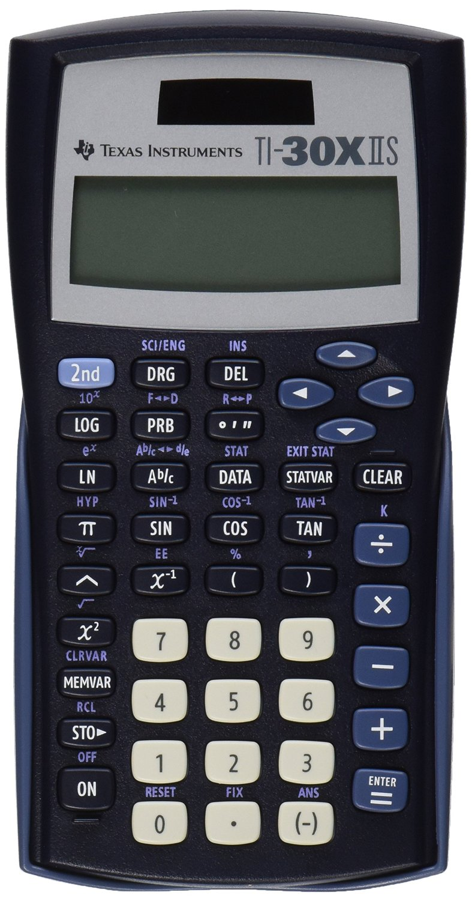

A peek at Ch 11 HW, can you do this now?
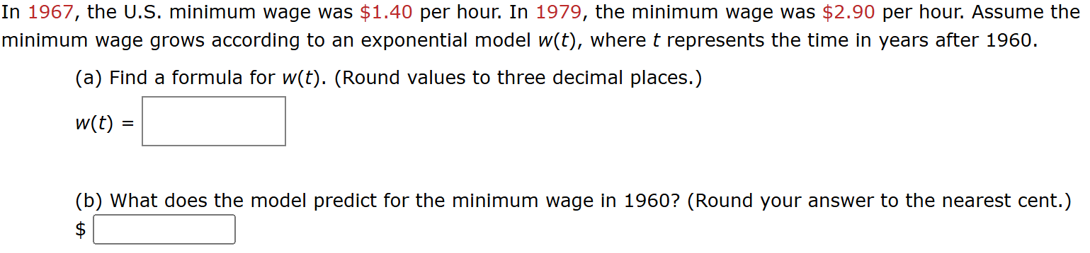

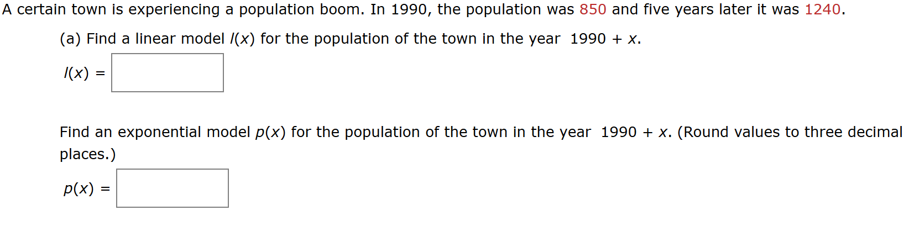
How about this one?

How about this one? (yes that is almost all of chapter 11!)
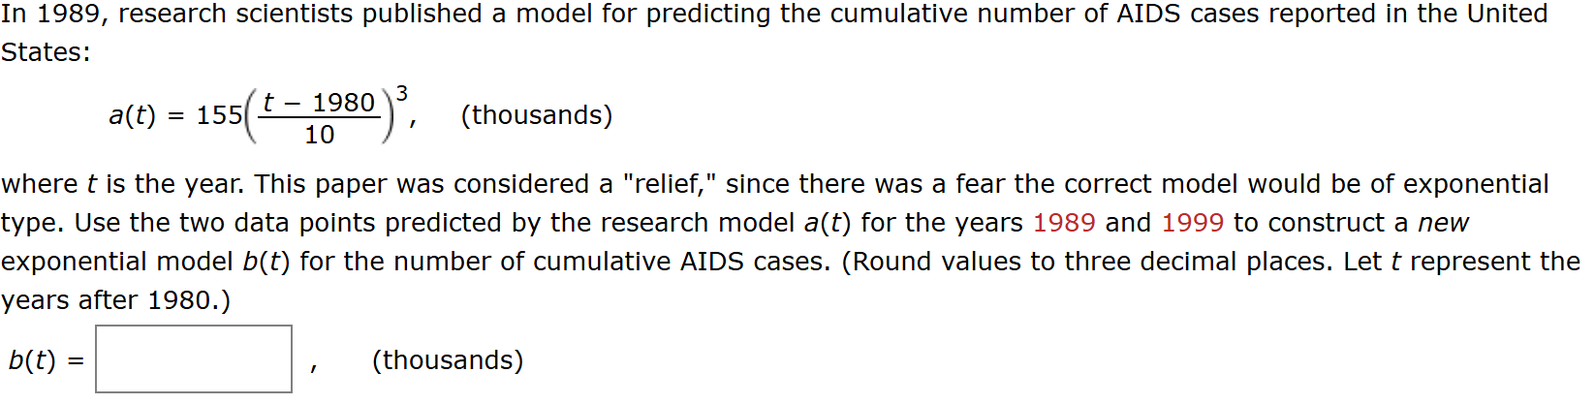

The symbol “e” appears in many applications.
Here is one that gives you a chance to play around with $e^{x}$ while introducing you to some special functions.

Example: Consider the two functions
$f\left(t\right)=\frac{e^{t} + e^{-t}}{2}$ and $g\left(t\right)=\frac{e^{t} -{ e}^{-t}}{2}$

- Plot several points and try to graph these functions

- Algebra challenge: Expand and completely simplify
$${\left(f\left(t\right)\right)}^{2}-{\left(g\left(t\right)\right)}^{2}$$

Note:
- $x^{2}+y^{2}=1$ is a circle. (We know that one)
- $x^{2}-y^{2}=1$ is a called a hyperbola.
The functions $\frac{e^{t} + e^{-t}}{2}$ and $\frac{e^{t} -{ e}^{-t}}{2}$ have funny names, they are called hyperbolic cosine and hyperbolic sine and are often given the function names:
$cosh\left(t\right)=\frac{e^{t} + e^{-t}}{2}$ $sinh\left(t\right)=\frac{e^{t}- e^{-t}}{2}$

I personally find $y=cosh\left(x\right)$ to be a very interesting function. The curve is makes is called a catenary and you see them every day!

Impose a coordinate system so that the picture is symmetric about the y-axis and the roadway coincides with the x-axis. The hanging cable constant is a = 500 and h = 0. Use the model and the picture below
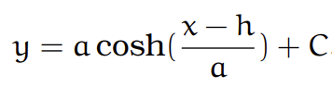

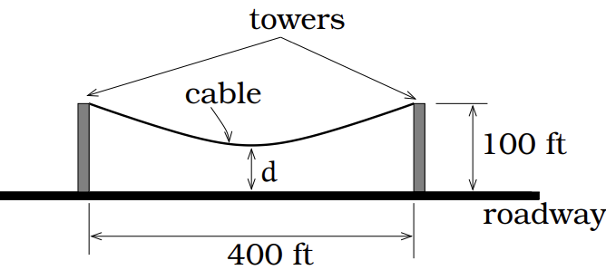

Find the minimum distance from the cable to the road.

Some background on e (do NOT need to know for exam)

Compounding Interest
We say interest is compounding if it is computed on the entire balance (principal and previous interest).

If $P$ is the starting amount (principal) and r is the decimal annual rate, compounded n times a year, then a bank would use the formula:
$$F=P{\left(1+\frac{r}{n}\right)}^{nt},$$

Example: You invest $5000 at and annual rate of 3%
$$F=5000{\left(1+\frac{0.03}{n}\right)}^{n t}$$

 | n | Balance one yr.
semi-annual | 2 | $5151.12500
quarterly | 4 | $5151.69595
monthly | 12 | $5152.07979
Daily | 365 | $5152.26632
Hourly | 87605 | $5152.27241
every minute | 525600 | $5152.27267
every second | 3153600 | $5152.27267

The value this is approaching what is called the value from continuous compounding. And it is also given by
$$F=Pe^{rt}$$
$$F=5000e^{0.03(1)}≈\$5152.27267$$

Some history, just for fun (again do NOT need for exam)
