Ch 10/11: Exponential Functions and Models
Key Ideas in Chapter 10 (Exponential Model)
$y=ab^{x}$ , where $a =$ “y-intercept” and $b =$“base” (or “multiplier”)
$b>1$ gives exponential growth
$0<b<1$ gives exponential decay

Goal: Graph and find exponential functions.

Entry Task:
  - Compute the following (no calculator):
$$2^{2}2^{3}=$$

$$(4^{1/2})^{3}=$$

$$9^{-1/2}=$$

$$\frac{20}{5}⋅\frac{15}{2^{3}}⋅\frac{1}{30} =$$

Note any “rules” you observe…

  - Simplify/Rewrite
$$x^{2}x^{3}=$$

$${(3^{x})}^{4}=$$

$$4^{-x/2}=$$

$$\frac{6}{2^{-3x-1 }}=$$

Can you do this homework now?
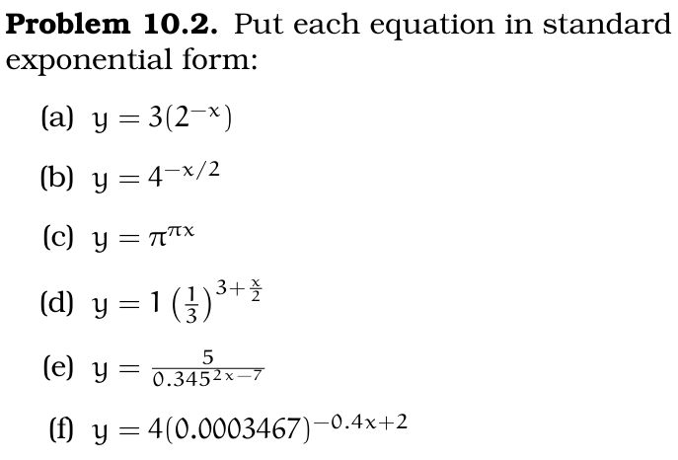
“standard form” means $y=ab^{x}$

Exponential Functions and Graphs
Example 1: Let $y=f\left(x\right)=5{⋅3}^{2x}$
- What is a and what is b?
- Sketch a graph.

Example 2: Let $y=g(x)=6{⋅2}^{-x-1}$
- What is a and what is b?
- Sketch a graph.

Finding the model
Example 1: (from Fall 2017 Final Exam)
- In 2008 the population of a town was 1200.
- In 2012 the population was 1414.
Give an exponential model for the population, $f\left(t\right)=ab^{t},$ where t is years since 2008 (i.e. take $t = 0$ in 2008).

Example 2: (from Winter 2018 Ostroff Midterm 2)
You placed some plums in an icebox.
- 10 hours from now, the plums will be 11° Celsius.
- 22 hours from now, the plums will be 5° Celsius.
Give an exponential model for the temperature, $p\left(t\right)=ab^{t},$ of the plumbs t hours from now.

Doubling, Tripling, & Percentage change
Key fact: Percentage change is unaffected by the initial value.
Example 1:
- The population of Rabbitown doubles every 3 months.
- The initial population (now) is 50 Rabbits
Give an exponential model for the population, $R\left(t\right)=ab^{t}$

Example 2:
- The population of Squirrelville triples every 10 months.
- The initial population is unknown.
Find the base in the exponential, $S\left(t\right)=ab^{t}$

Changes as percentages
Example 3:
Your lab has 10 grams of plutonium that has been sealed and stored away since 1984.
In 2004, it was measured that 80% of the sample remained (i.e. it had decayed by 20%).
Give an exponential model for the mass of plutonium in terms since 1984, $m\left(t\right)=ab^{t}$

Follow-up:
How many grams of plutonium will there be in 2034?

Next time: Chapter 11…
We will talk about the special base
$$e≈2.71828182…$$
For now,
- sketch a graph of $y=e^{x}$ and
- sketch a graph of $y=e^{-x}$.

Both of those are example of exponential functions and you have the tools to sketch a rough graph now. Those two graphs are important to know as you go into Math 124.

