6.2 Volumes Using Cross-Sectional Slicing
Consider solids for which we can find a formula for the cross-sectional area.

Entry Task: What solids do you get when you rotate the following regions around the x-axis?
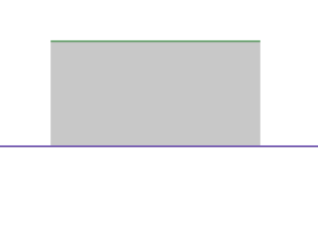
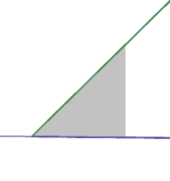
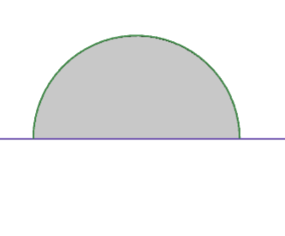

What about this region about the y-axis…
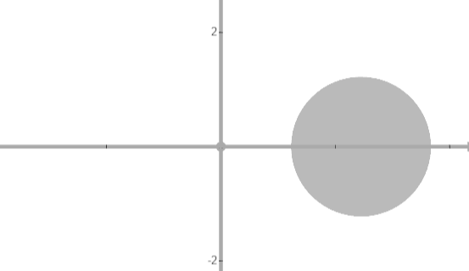

https://www.desmos.com/3d/3f1jcxyahq https://www.desmos.com/3d/lypwxsa0im

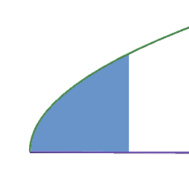
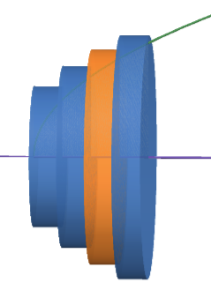
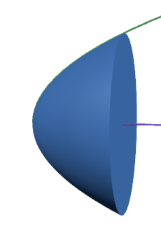
Another Example:

https://www.desmos.com/3d/ejury8aswi

Main Concept:
Find the general formula, A(x_{i}), for the area of a cross-sectional slice at x_{i} then…

$Volume of one slice≈A\left(x_{i}\right)∆x$
$$Total Volume ≈\sum_{i=1}^{n}{A\left(x_{i}\right)∆x}$$
$$Exact Volume=\lim_{n→∞}{\sum_{i=1}^{n}{A\left(x_{i}\right)∆x}}$$

Volume using cross-sectional slicing
- Draw region.
Cut perpendicular to rotation axis.
Label x if cut crosses x-axis.
Label y if cut crosses y-axis.
Label everything in terms this variable.

- Formula for cross-sectional area?
disc: Area = π(radius)²
washer: Area = π(outer)² - π(inner)²
square: Area = (Height)(Length)
triangle: Area = ½ (Height)(Length)
Fill in using your labels.

3. Integrate the area formula.
$$Volume =\int_{a}^{b}{A\left(x\right)dx}$$

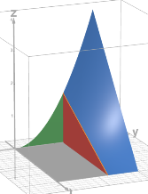
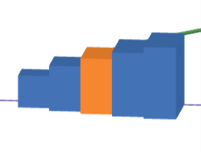

Example 1: Consider the region, R, bounded by $y= \sqrt{x}$, y = 0, and x = 1.
Find the volume of the solid obtained by rotating R about the x-axis.
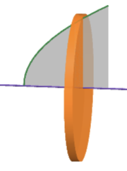

https://www.desmos.com/3d/ejury8aswi

Example 2: Consider the region, R, bounded by $y= \sqrt{x}$, y = 0, and x = 1.
Find the volume of the solid obtained by rotating R about the y-axis.
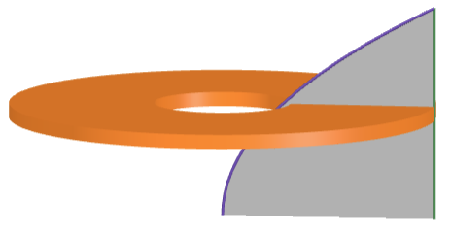

https://www.desmos.com/3d/ejury8aswi

Example 3: Consider the region, R, bounded by $y= \sqrt{x}$, y = 0, and x = 1.
Find the volume of the solid obtained by rotating R about the vertical line x = -2.

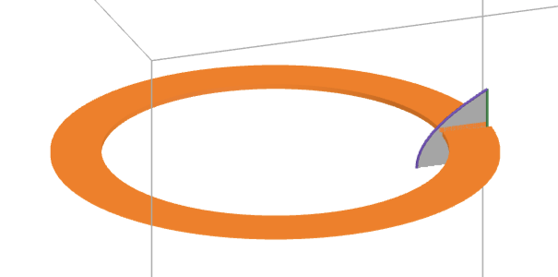

Example 4: (an old final and HW)
Find the volume of the solid shown.
The cross-sections are squares.

Example 5: (from HW)
Consider the region bounded by
$$y=3\sqrt[4]{x} , x=0 and y=3.$$
Find volume of the solid obtained b rotating this region around the line x = 1.

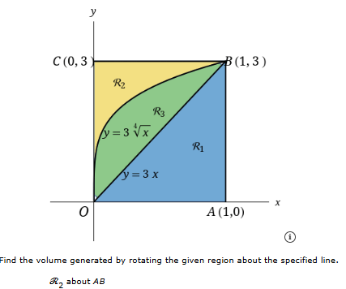
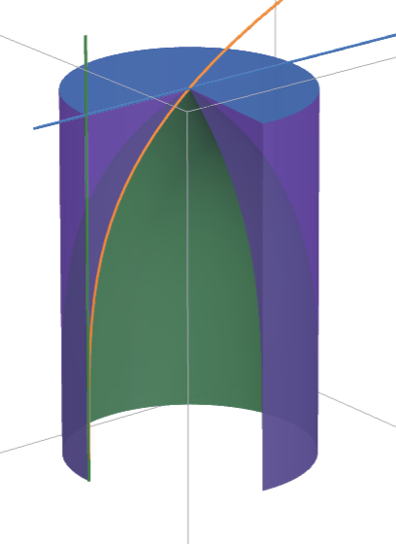

https://www.desmos.com/3d/ii5lmygkyx

Summary (Cross-sectional slicing):
- Draw Label
- Cross-sectional area?
- Integrate area.

This method has a major limitation:
6.2 method about x-axis, must use dx.
6.2 method about y-axis, must use dy.

What if the regions is rotated about the x-axis and we need to use dy?
(or about y-axis and we need dx?)

In these cases, 6.2 “Cross-sectional slicing” won’t work!

We need another method. That is what we will do in 6.3.

