Ch 6: Basic Integral Applications

6.1 Areas Between Curves

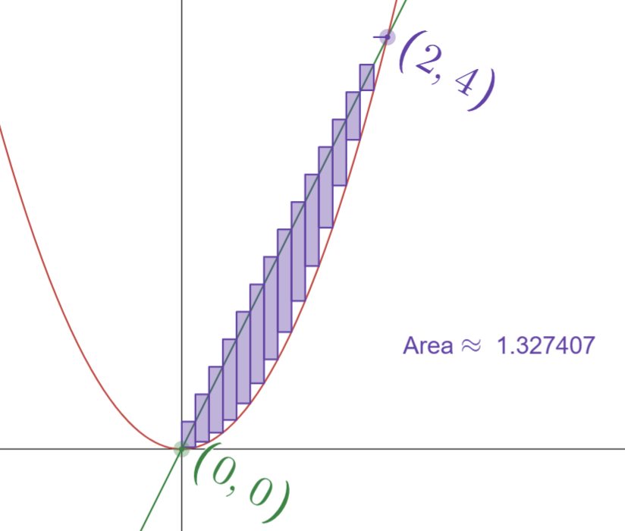
https://www.desmos.com/calculator/aqnmxj1ozz

$$Area=\lim_{n→∞}{\sum_{i=1}^{n}{(f\left(x_{i}\right)-g\left(x_{i}\right))∆x}}$$

Example 1: Find the area bounded between $y = 2x$ and $y = x^{2}$.

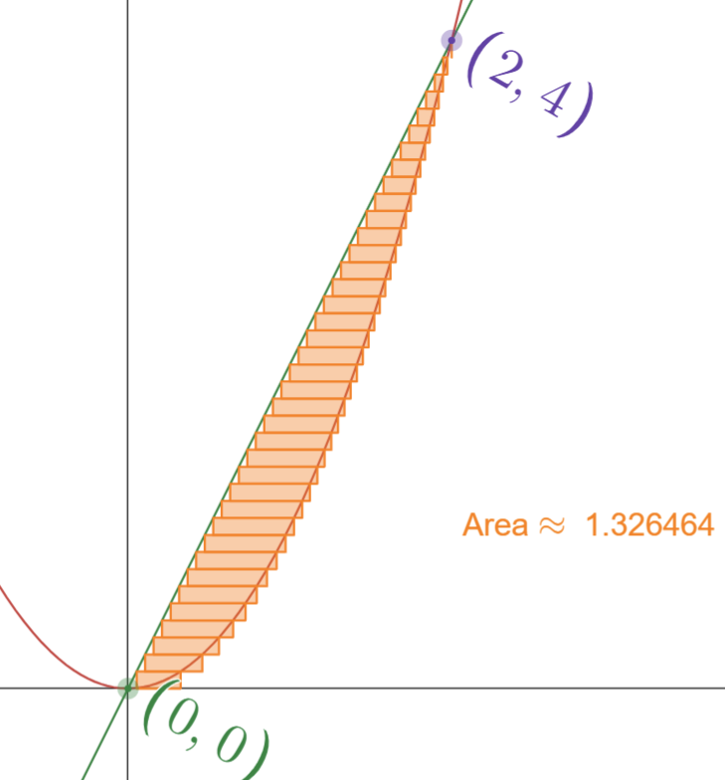
https://www.desmos.com/calculator/aqnmxj1ozz

$$Area=\lim_{n→∞}{\sum_{i=1}^{n}{(f\left(y_{i}\right)-g\left(y_{i}\right))∆y}}$$

Example 1 (again): Find the area bounded between $y = 2x$ and $y = x^{2}$.

Summary: The area between curves
- Draw picture, find intersections.
- Choose dx or dy. Get everything in terms of the variable you choose.
- Draw a typical approx. rectangle.
- Set up as follows:
$$Area= \int_{a}^{b}{(TOP-BOTTOM) dx}$$

$$Area= \int_{c}^{d}{(RIGHT-LEFT) dy}$$

Example 2:
Set up an integral (or integrals) that give the area of the region bounded by
x = y² and y = x – 2.

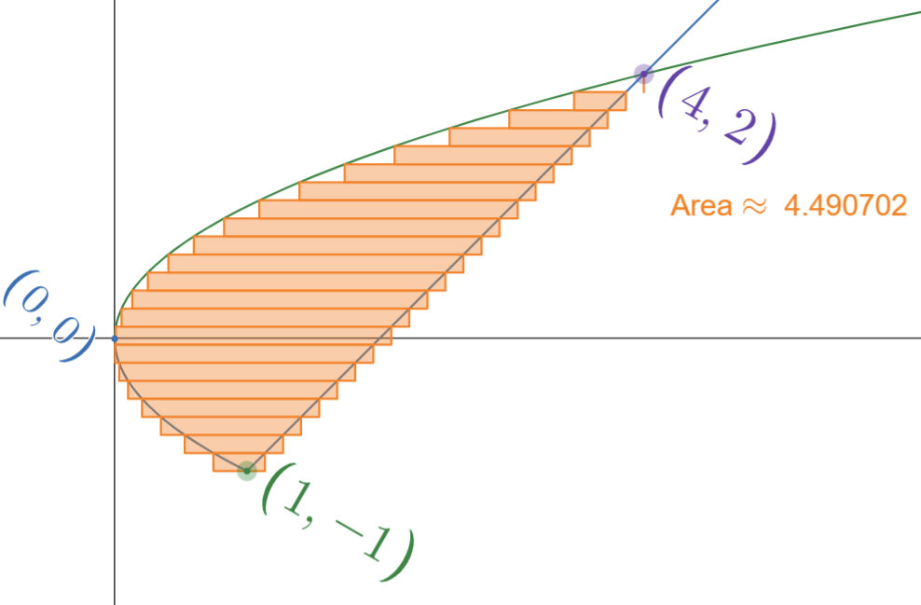

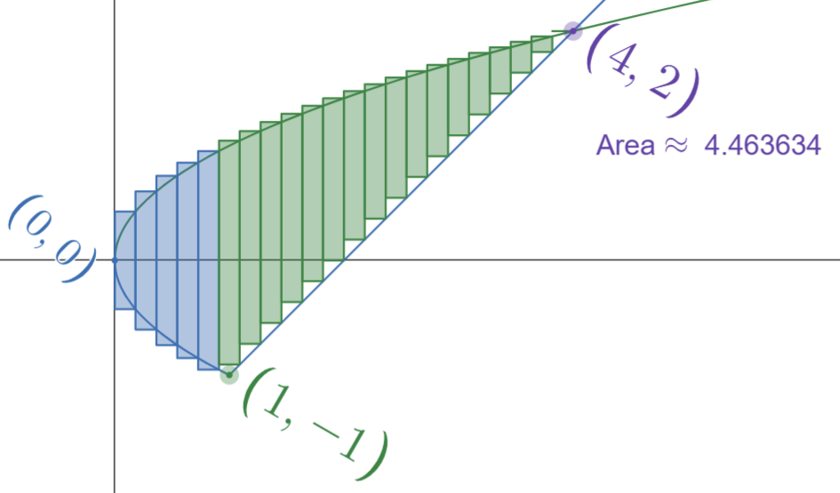

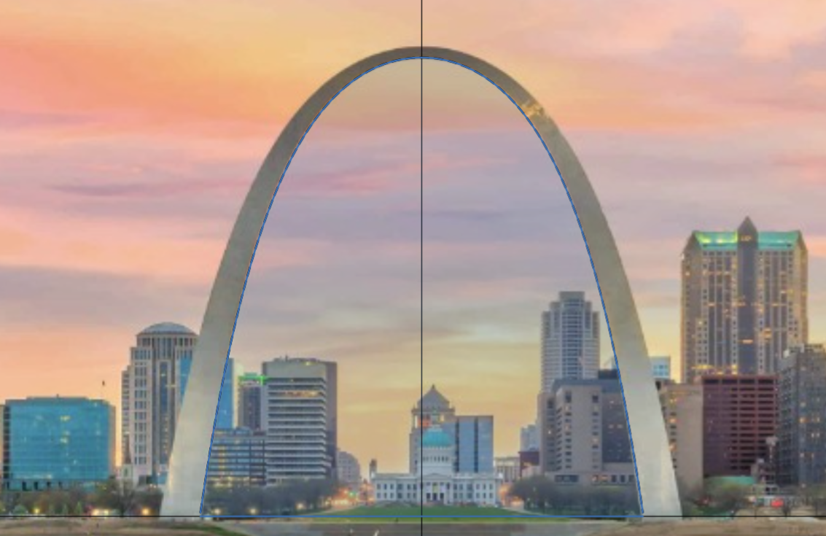
“Fun” examples to try on your own:
- The gateway arch is approximately an inverted catenary given by the equation:
$f\left(x\right)=690-34\left(e^{\left(-0.01x\right)}+e^{\left(0.01x\right)}\right)$
What is the area under the gateway arch?

- Find the total area between the “satchel” curves given by
$4y=x^{2}+x\sqrt{4-x^{2}}$ and $4y=x^{2}-x\sqrt{4-x^{2}}$

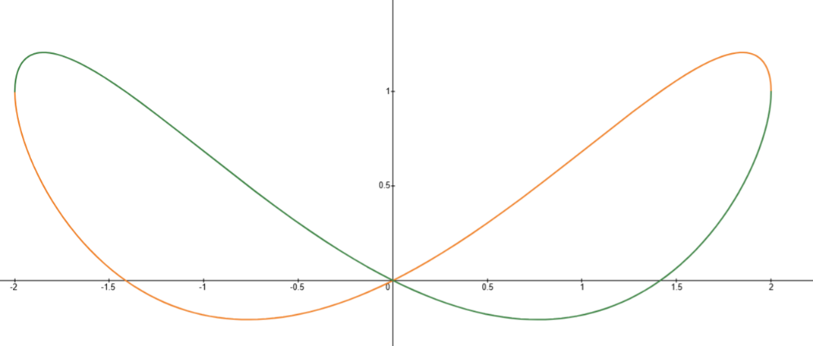

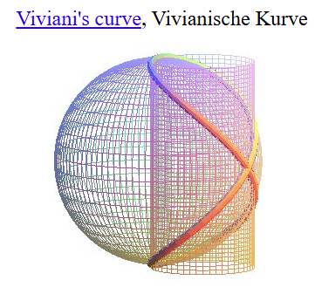
This is what the side view of the intersection of a cylinder and sphere looks like.
More info here (as well as a gallery of other curves)

Set up an integral for the total positive area of the following regions:
