5.4 The Indefinite Integral and
Net/Total Change

Net Change and Total Change
An object is moving on a straight line:
$s(t) =$ ‘location at time t’
$v(t) =$ ‘velocity at time t’
positive $v(t)$ means up/right
negative $v(t)$ means down/left

The FTOC (part 2) says
$$\int_{a}^{b}{v\left(t\right)dt}=s\left(b\right)-s(a)$$
We also call this the displacement.

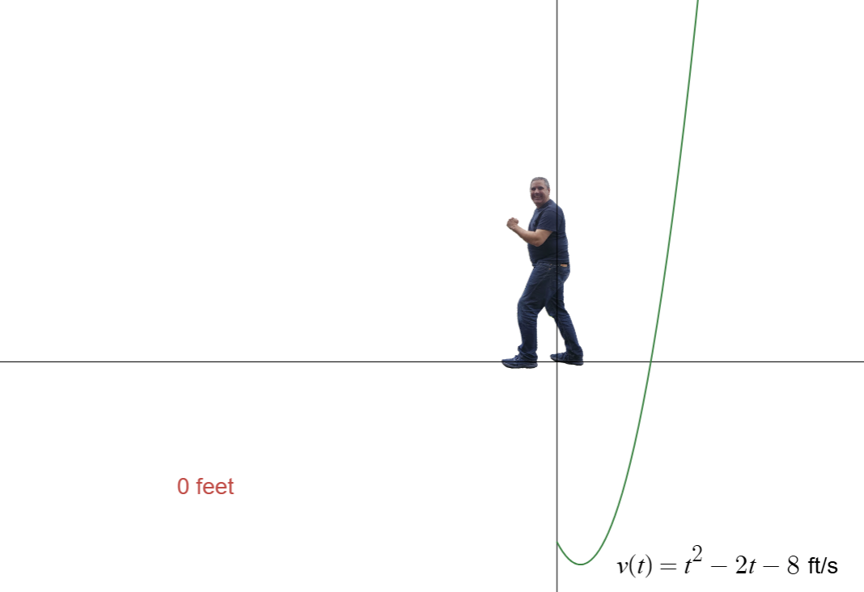

Entry Task:
Let $v\left(t\right)=t^{2}-2t-8$ ft/sec.
Compute displacement from t = 0 to t = 6.

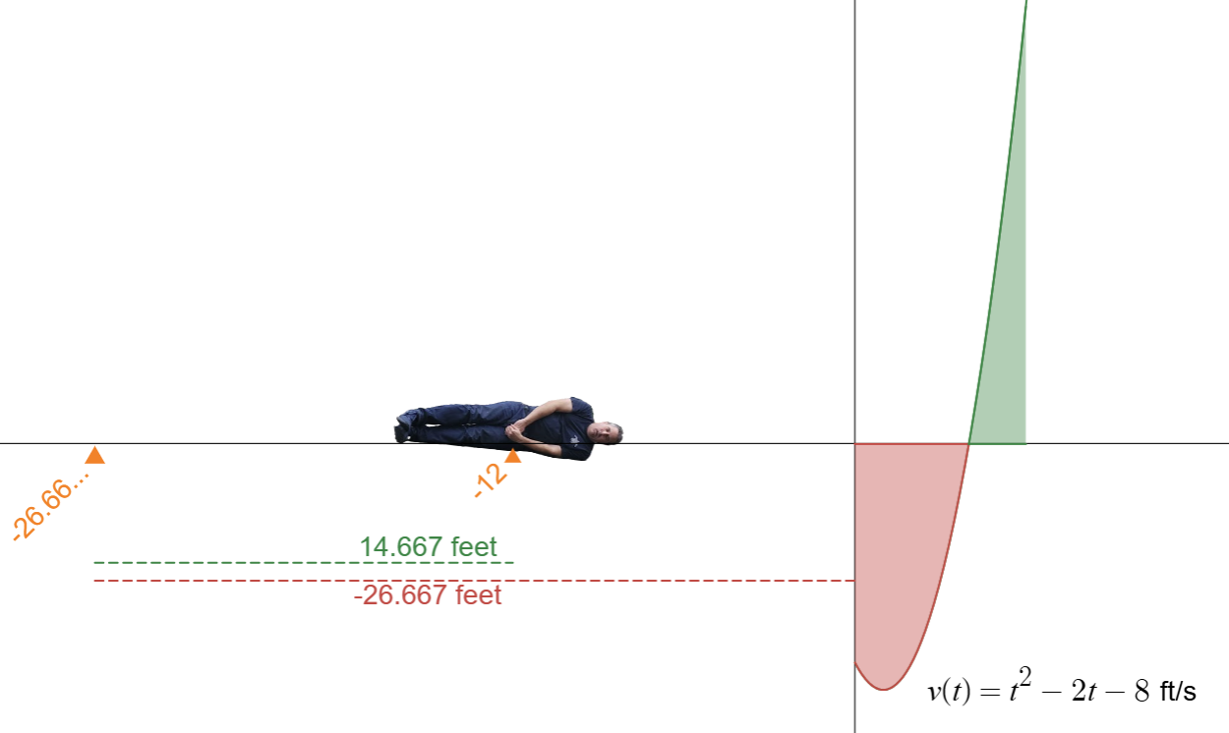
We define total change in dist. by
$$\int_{a}^{b}{|v\left(t\right)|dt}$$
which we compute by
- Solving $v(t) = 0$ for $t$.
- Splitting up integral.
- Adding together as positive numbers.

Example:
Let $v\left(t\right)=t^{2}-2t-8$ ft/sec.
Compute the total distance traveled
from t = 0 to t = 6.

Visual: https://www.desmos.com/calculator/d42lbkvcfh

A brief pause to discuss integration methods.

Examples (by simplifying we can do these):
$$1. \int{{6e}^{x}+4x-5\sqrt{x} dx}$$
$$2. \int{\frac{\sqrt{x}-3x}{x}dx}$$
$$3.\int{\frac{cos⁡(x)}{1-\cos^{2}\left(x\right)}dx}$$

We cannot do now, but can later in term:
$$\int{{xe}^{3x}dx} \int{\cos^{3}\left(x\right)dx}$$
$$\int{x\sin{(x^{2})}dx } \int{\frac{x^{2}-x+6}{x^{3}+3x}dx}$$
$$\int{\frac{3}{x-2\sqrt{x}}dx} \int{\frac{\sqrt{x^{2}-1}}{x^{2}}dx}$$

We will “never” do:
$$\int{e^{x^{2}}dx} \int{ln(x)cos(x) dx}$$
$$\int{\frac{1}{{x+e}^{x}} dx} \int{sin(x^{3}) dx}$$

  - The Substitution Rule

Example 1 - Warm Up:
- What is the derivative of $y={\left(1+x^{4}\right)}^{11}$?

- Can you guess the integral…

$$\int{x^{3}{\left(1+x^{4}\right)}^{11} dx}$$

The Substitution Rule:
If we write u = g(x) and du = g’(x) dx, then
$$\int{f\left(g\left(x\right)\right)g^{'}\left(x\right)dx=\int{f\left(u\right)du}}$$

Observations:
- We are reversing the “chain rule”.
- We must see:
“inside” = a function inside another
“outside” = derivative of inside

Here is a visual:
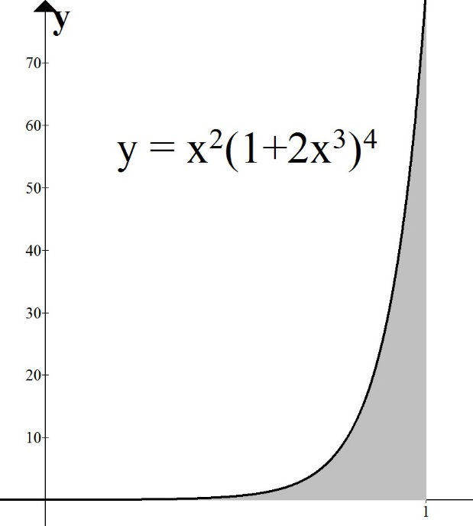

$$\int_{0}^{1}{x^{2}{(1+2x^{3})}^{4}dx}$$

Let $u = 1+2x^{3}$.
Change everything in terms of u.

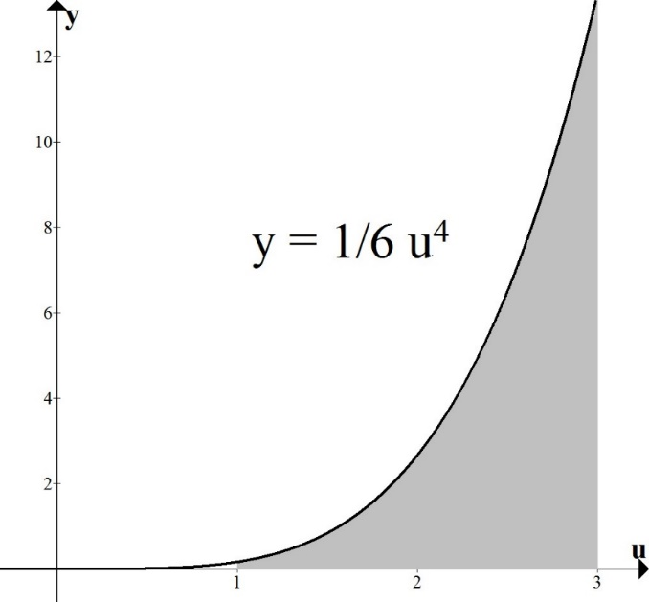

$$\int_{1}^{3}{\frac{1}{6}u^{4}du}$$

Aside: What is really happening
(you do not need to write this)
-----------------------------------------------------
Recall:
$$\int_{a}^{b}{f\left(g\left(x\right)\right)g^{'}\left(x\right)dx=\lim_{n→∞}{\sum_{i=1}^{n}{f\left(g\left(x_{i}\right)\right)g'(x_{i})∆x}}}$$

If we replace u = g(x), then we are “transforming” the problem from one involving x and y to one with u and y.

This changes everything in the set up.

The lower bound, upper bound, widths, and integrand all change!

Recall from Math 124 that
$$g^{'}\left(x\right)=\frac{du}{dx}≈\frac{Δu}{Δx}$$
(with more accuracy when $Δx$ is small)
----------------------------------------------------

----------------------------------------------------

Thus, we can say that
$$g^{'}\left(x\right)Δx≈Δu$$

In other words, if the width of the rectangles using x and y is $Δx$, then the width of the rectangles using u and y is $g^{'}\left(x\right)Δx$.

And if we write $u_{i}=g(x_{i})$, then
$$\int_{a}^{b}{f\left(g\left(x\right)\right)g^{'}\left(x\right)dx=\lim_{n→∞}{\sum_{i=1}^{n}{f\left(g\left(x_{i}\right)\right)g^{'}\left(x_{i}\right)∆x}}} \\ =\lim_{n→∞}{\sum_{i=1}^{n}{f\left(u_{i}\right)∆u}}$$
$$=\int_{g(a)}^{g(b)}{f\left(u\right)du}$$

------------------------------------------------

Example 2:
$$\int_{2}^{3}{x^{2}e^{x^{3}} dx}$$

Advice on picking u = ?

Example 3: Try u = inside
$$\int{x cos(\sin{(x^{2})) cos(x^{2})}dx}$$

Example 4: Try u = denominator
$$\int_{0}^{1}{\frac{x}{x^{2}+3} dx}$$

Example 5: May need to simplify first
$$\int{\tan\left(x\right)dx}$$

What to do when “old” variable remains
Example 6:
$$\int{x^{3}\sqrt{2+x^{2}} dx}$$

Example 7:
$$\int{\frac{x^{7}}{x^{4}+1}dx}$$

