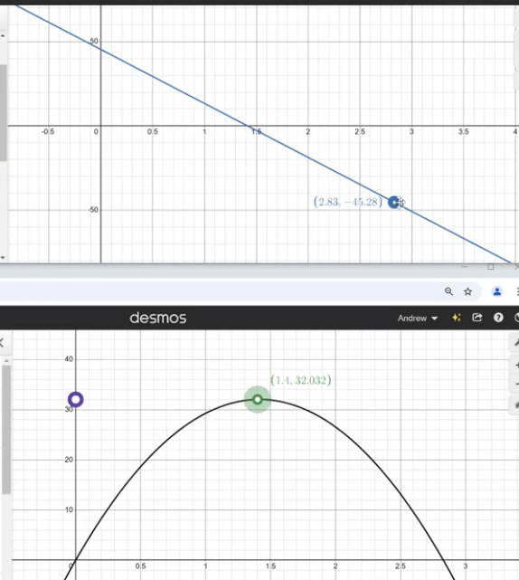
Closing Tues: HW 4.9, 5.1
Closing Thur: HW 5.2, 5.3

4.9 Antiderivatives (continued)
Entry Task:
Assume gravity provides a downward acceleration of 32 ft/s².
A ball thrown straight at t = 0 sec
and returns to your hand at t = 3 sec.
Find the height of the ball above your hand.

In other words, solve the initial value problem:
$h^{''}\left(t\right)=-32, h(0) = 0, h(3) = 0$

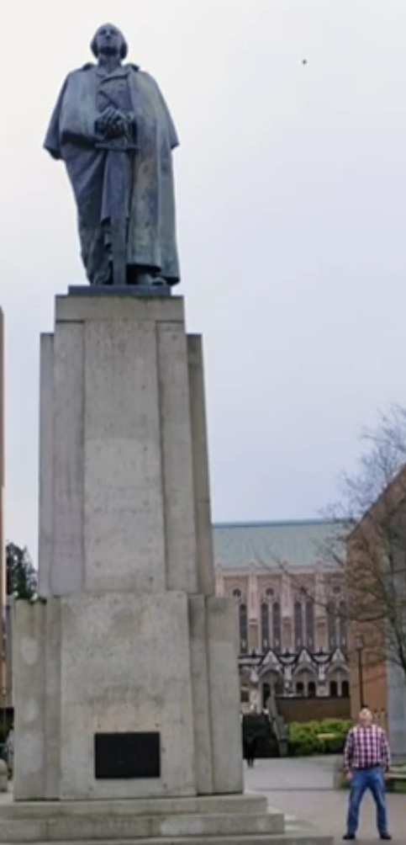

Clip: https://youtube.com/shorts/iqj3byvqLmc?feature=share
Details: https://www.youtube.com/watch?v=07TDV5SgJT4
5.1 Defining Area (Riemann sums)
Calculus is based on limiting processes that “approach” the exact answer to a rate question.

In Calculus I, you defined
f’(x) = `slope of the tangent at x’
$$=\lim_{h→0}{\frac{f\left(x+h\right)-f(x)}{h}}$$

In Calculus II, we will see that antiderivatives are related
to the area `under’ a graph
$$=\lim_{n→∞}{\sum_{i=1}^{n}{f({x_{i}}^{*})∆x}}$$

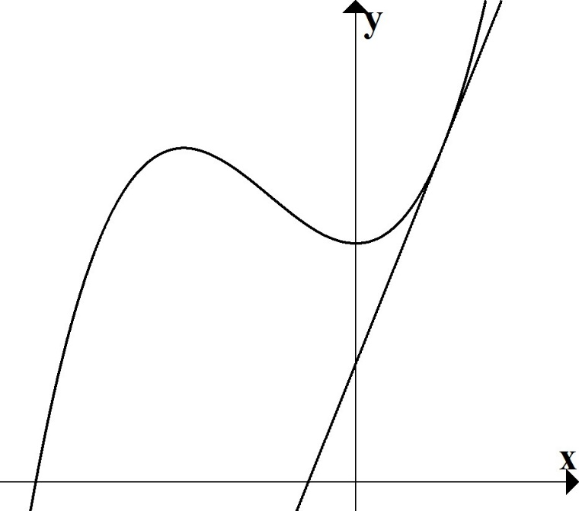

Calc. I
Visual:

Calc. II
Visual:

Riemann sums set up:
We build a procedure to get better and better approximations of the area “under” $f\left(x\right)$.

- Break into n subintervals.
$∆x= \frac{b-a}{n}$ and $x_{i}= a+i∆x$

- Draw n rectangles.
Area of each rectangle = (height)(width) $={f(x}_{i}^{*})∆x$

- Add up rectangle areas.

You do:
Approx. the area under $f\left(x\right)=x^{3}$ from
x = 0 to x = 1 using n = 3 subdivisions and right-endpoints to find the heights.

I did this again with 100 subdivisions, then 1000, then 10000.

Here is a summary of my findings:

General Pattern: (right-endpoint)
For $f(x) = x^{3}$ on x = 0 to x = 1 with “n” subdivisions…

$∆x=\frac{1-0}{n}=\frac{1}{n}$ , $x_{i}=0+i\frac{1}{n}=\frac{i}{n}$
$$Height=f\left(x_{i}\right)=x_{i}^{3}={\left(\frac{i}{n}\right)}^{3}$$
$Area=f\left(x_{i}\right)∆x=x_{i}^{3}∆x={\left(\frac{i}{n}\right)}^{3}\frac{1}{n}$

Adding up the rectangle areas
$$Sum=\sum_{i=1}^{n}{x_{i}^{3}∆x}=\sum_{i=1}^{n}{{\left(\frac{i}{n}\right)}^{3}\frac{1}{n}}$$
$$Exact Area=\lim_{n→∞}{\sum_{i=1}^{n}{{\left(\frac{i}{n}\right)}^{3}\frac{1}{n}}}$$

Another Example:
Using sigma notation, write down the general Riemann sum definition of the area from x = 5 to x = 7 under
$$f\left(x\right)=3x+\sqrt{x}$$

$$∆x=\frac{b-a}{n}=$$
$$x_{i} = a + i ∆x=$$
$$\lim_{n→∞}{\sum_{i=1}^{n}{f\left(x_{i}\right)∆x= }}$$

Important Application Note

Velocity/Distance & Reimann Sums
When velocity is a constant:
Distance = Velocity · Time

Example:
You are accelerating in a car. You get the following measurements:
t (sec) | 0 | 0.5 | 1.0 | 1.5 | 2.0
v(t) (ft/s) | 0 | 6.2 | 10.8 | 14.9 | 18.1

Estimate the distance traveled by the car traveled from 0 to 2 seconds.

Same idea!

 | Low Estimate | High Estimate
0 to  0.5 | 0 $\frac{ft}{s}⋅$0.5 s = 0 ft | 6.2 $\frac{ft}{s}⋅$0.5 s = 3.1 ft
0.5 to  1.0 | 6.2 $\frac{ft}{s}⋅$0.5 s = 3.1 ft | 10.8 $\frac{ft}{s}⋅$0.5 s = 5.4 ft
1.0 to  1.5 | 10.8 $\frac{ft}{s}⋅$0.5 s = 5.4 ft | 14.9 $\frac{ft}{s}⋅$0.5 s = 7.45 ft
1.5 to  2.0 | 14.9 $\frac{ft}{s}⋅$0.5 s = 7.45 ft | 18.1 $\frac{ft}{s}⋅$0.5 s = 9.05 ft
Total | 15.95 ft | 25 ft

All we are doing is multiplying and adding. The units of
$$\sum_{i=1}^{n}{f\left(x_{i}\right)∆x}$$
will be units of f(x) times units of x.
5.2 The Definite Integral

Def’n:
We define the definite integral of f(x) from x = a to x = b by
$$\int_{a}^{b}{f\left(x\right)dx= \lim_{n→∞}{\sum_{i=1}^{n}{f\left(x_{i}\right)∆x}},}$$
where $∆x= \frac{b-a}{n}$ and $x_{i}= a+i∆x.$

Basic Integral Rules:
$$1. \int_{a}^{b}{c dx=\left(b-a\right)c}$$

$$2. \int_{a}^{b}{f\left(x\right)dx}+\int_{b}^{c}{f\left(x\right)dx}=\int_{a}^{c}{f\left(x\right)dx}$$

Examples:
$$1. \int_{4}^{10}{5 dx=}$$

$$2. \int_{0}^{3}{x^{2}dx}+\int_{3}^{7}{x^{2}dx}=$$

Basic Integral Rules (continued):
$$3. \int_{a}^{b}{cf\left(x\right) dx}=c\int_{a}^{b}{f\left(x\right)dx}$$

and

$$\int_{a}^{b}{f\left(x\right)+g\left(x\right) dx}=\int_{a}^{b}{f\left(x\right)dx}+\int_{a}^{b}{g\left(x\right) dx}$$

$$4.\int_{b}^{a}{f\left(x\right)dx}=-\int_{a}^{b}{f\left(x\right)dx}$$

Examples:
$$3. \int_{0}^{4}{5x+3 dx=}$$

$$4.\int_{3}^{1}{x^{3}dx}=-\int_{1}^{3}{x^{3} dx}$$

Note on quick estimates (HW 5.2: 10,11)
$$m(b-a) ≤\int_{a}^{b}{f\left(x\right)dx≤} M(b-a)$$

Example: Consider the area under
f(x) = sin(x) + 2
on the interval x = 0 to x = 2π.

- What is the max of f(x)? (label M)
- What is the min of f(x)? (label m)

- Draw one rectangle that completely contains all the shaded area?
- Draw one rectangle that is completely inside the shaded area?
What can you conclude?

