Entry Task: Derivative Warm-Up
Assume
$$h\left(t\right)=15-12e^{-0.1t}\cos\left(2t\right)$$
gives the height in cm of a bowling ball on the end of an oscillating spring after t seconds.

What is the velocity at $t=\frac{3π}{4}$?

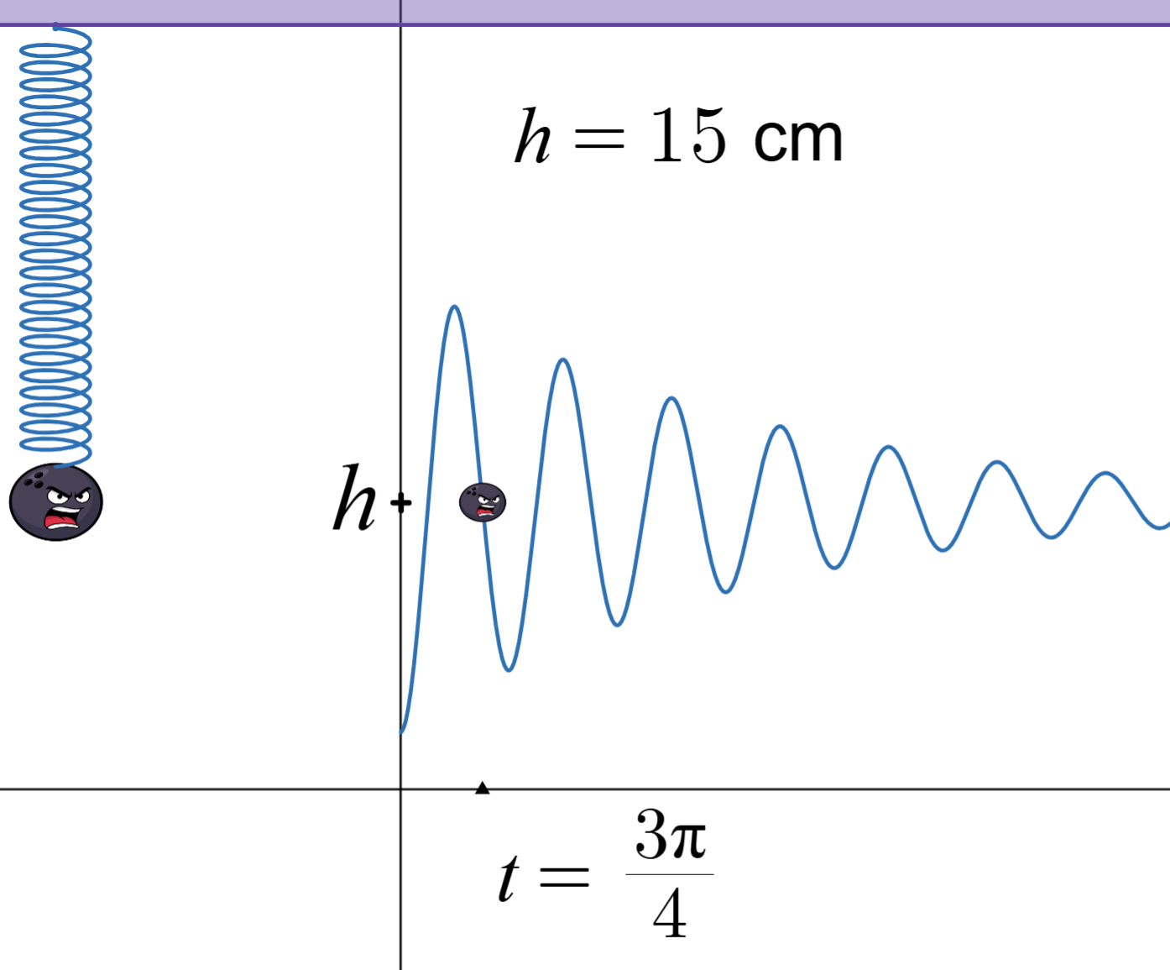
Animation: https://www.desmos.com/calculator/zsram9rvhb

4.9 Antiderivatives
Def’n: If g(x) = f’(x), then we say
g(x) = “the derivative of f(x)”, and
f(x) = “an antiderivative of g(x)”
Example:
Give an antiderivative of
$g(x) = x^{2}$.

Examples (you do):
Find the general antiderivative of
- $f\left(x\right)= x^{6}+\sqrt{x}$
- $g\left(x\right)=\cos\left(x\right)+\frac{1}{x}+e^{x}+\frac{1}{1+x^{2}}$
- $h\left(x\right)=\frac{x-3x^{2}}{x^{3}}$

Initial Conditions
There is no way to know what “C” is without additional information. Such information is called an initial condition.
Example: $f’(x) = e^{x}+ 4x$ and $f(0) = 5$
Find $f(x).$

Example: $f^{''}\left(x\right)=15\sqrt{x}$, and
$f(1) = 0$, $f(4) = 1$
Find $f(x).$

Example: Assume I stand next to statue and throw a ball straight up. Assume that gravity provides a constant downward acceleration of 32 ft/s².

Let f(t) denote the height of the ball (in feet) above my hand at t seconds after it is thrown.

The ball leaves my hand at t = 0, reaches the top of the statue, and returns to my hand at t = 3 seconds.
Use calculus to determine the height the statue above my hand.

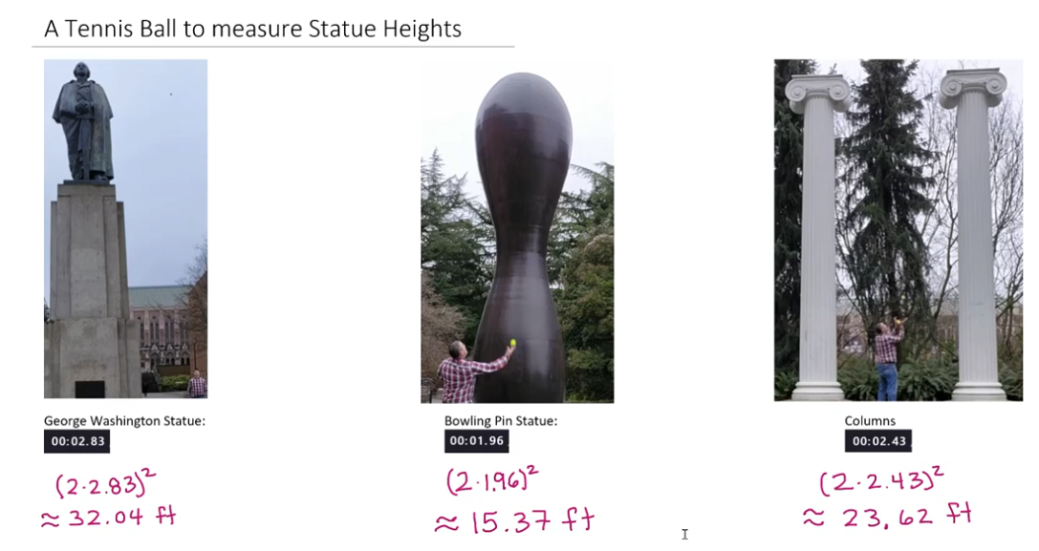
Video of me measuring statue heights: https://www.youtube.com/watch?v=07TDV5SgJT4

Preview of next class
5.1 Defining Area
Calculus is based on limiting processes “approaching” the
exact answer to a rate question.

In Calculus I, you defined
f’(x) = `slope of the tangent at x’
$$=\lim_{h→0}{\frac{f\left(x+h\right)-f(x)}{h}}$$

In Calculus II, we will see that antiderivatives are related
to the area `under’ a graph
$$=\lim_{n→∞}{\sum_{i=1}^{n}{f({x_{i}}^{*})∆x}}$$

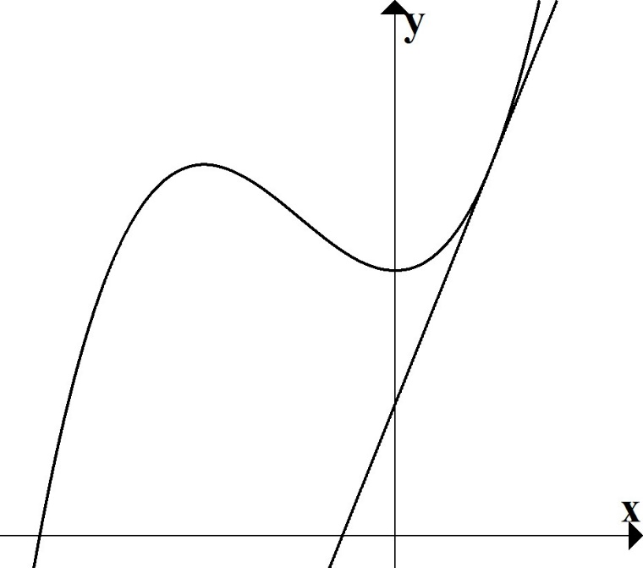

Calc. I
Visual:

Calc. II
Visual:

Riemann sums set up:

A procedure to get approximations of the area “under” $f\left(x\right)$.

- Break into n subintervals.
$∆x= \frac{b-a}{n}$ and $x_{i}= a+i∆x$

- Draw n rectangles.
Area of each rectangle = (height)(width) $={f(x}_{i}^{*})∆x$

- Add up rectangle areas.

